Epsom and Walton Downs Habitat Management Plan
2023 – 2028
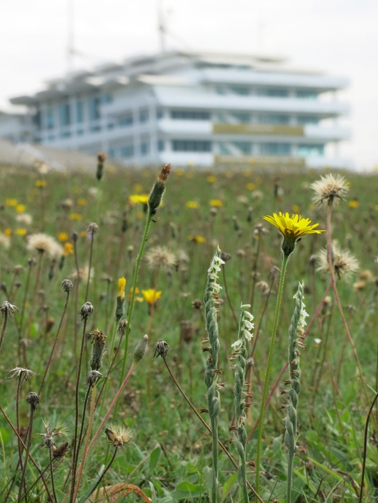
WRITTEN BY SARAH CLIFT

COUNTRYSIDE TEAM
EPSOM & EWELL BOROUGH COUNCIL
Contents
ACKNOWLEDGEMENTS 3
EXECUTIVE SUMMARY 4
INTRODUCTION 5
STAGE ONE – DESCRIPTION 5
1.1 Introduction 5
1.2 Location 5
1.3 Land Tenure and Associated Statutory Requirements 5
1.4 Local Designations 6
1.5 Reasons for SNCI selection 6
1.6 Photographic Coverage 6
1.7 Summary Description 6
1.7.1 Physical 6
1.7.2 Biological 7
1.7.3 Cultural 8
STAGE TWO – EVALUATION AND OBJECTIVES 10
2.1 Criteria for Evaluation 10
2.2 Identification/Confirmation of Important Features 16
2.3 Ideal Long-term Management Objectives for Nature Conservation 17
2.4 Rationale 18
2.4.1 Hedgerows 18
2.4.3 Mixed deciduous woodland 20
2.4.4 Veteran and Mature Trees 26
2.4.5 Grasslands 26
2.4.6 Scrub 37
2.4.7 Ponds 39
2.4.8 Surveying and Monitoring 39
2.4.9 Biodiversity and Landscape 43
2.4.10 Site intepretation 44
2.4.11 Volunteering Opportunities 44
2.5 Identification of Operational Objectives and Outline Prescriptions 45
STAGE THREE – PRESCRIPTION 47
Financial, labour and equipment contraints 47
Sustainable Management 47
Volunteering Opportunities 47
Prescription Table 48
MAPS 55
REFERENCES AND BIBLIOGRAPHY 64
APPENDICES 65
1). SNCI Report 65
2). Species list 74
Bryophyte records 74
Vascular plant records 74
Invertebrate records 81
Molluscs and Oligochates (Slugs, Snails and Earthworms) 81
Arachnids (Spiders, Mites and Ticks) 82
Lepidoptera - Butterflies 82
Lepidoptera – Moths 83
Coleoptera (Beetles) 84
Diptera (True Flies) 88
Hemiptera (True Bugs) 90
Hymenoptera (Bees, Wasps and Ants) 90
Orthoptera (Grasshoppers and Crickets) 91
Odonata (Dragonflies and Damselflies) 92
Other Invertebrates 92
Reptiles 92
Birds 92
Mammals 94

ACKNOWLEDGEMENTS
There have been a number of people who have been involved in the writing of this management plan. Thanks go to the following individuals:

Peter Howarth - Epsom & Ewell Borough Council
Stewart Cocker - Epsom & Ewell Borough Council
Sam Whitehead - Epsom & Ewell Borough Council
Ashlie Williams - Epsom & Ewell Borough Council
Peter Murray - Epsom & Ewell Borough Council
Trevor Gray – Epsom & Ewell Borough Council
Simon Durrant – Jockey Club
Nigel Whybrow – Jockey Club
Conor Morrow – Lower Mole Partnership
Helen Cocker – Lower Mole Partnership
Sean Grufferty – Downlands Partnership
Bill Downey – Butterfly Conservation
Ann Sankey – Surrey Botanical Society

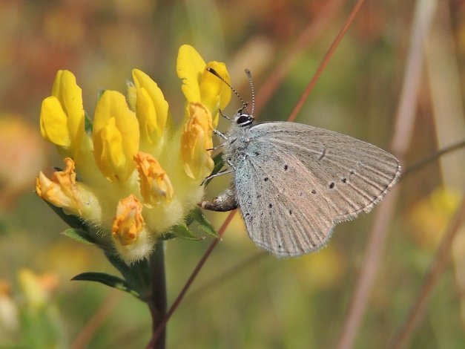
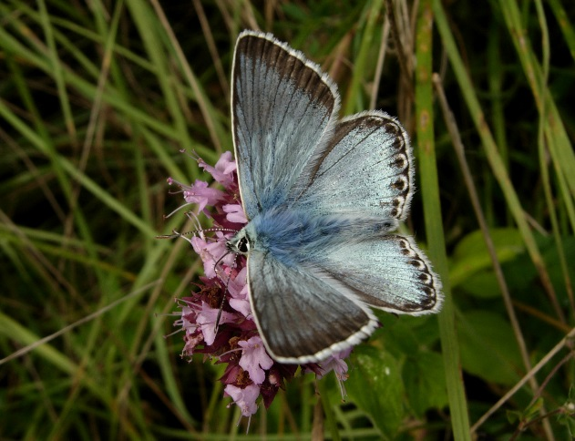
Chalk Hill Blue - Polyommatus coridon Small Blue - Cupido minimus

EXECUTIVE SUMMARY
Epsom and Walton Downs is an extremely important site for wildlife and contributes hugely to the biodiversity value of Epsom and Ewell and beyond. It contains the nationally and internationally important habitat of chalk grassland and is home to rare plants and animals such as Round-headed Rampion, Chalk Eyebright, Bastard Toadflax, Juniper, Small Blue Butterfly and Skylarks to name a few. It is vital to actively manage the chalk grassland to ensure this special habitat is not lost, as so much has already across the country through lack of management, scrub encroachment and habitat fragmentation. Such fragments of plants and animal communities that were once common throughout the Downs are now extremely rare and threatened by a range of land use changes. Its rarity gives this habitat a special value. The combination of plants and animals found here are effectively irreplaceable if damaged.

Over the last 5 yrs, of the previous management plan, work has focused on continuing the restoration and maintenance of chalk grassland in the area known as Juniper Hill and over the years, scrapes have been created within this grassland along with Sherwood Grassland, with the aim of enhancing chalk grassland species and the fauna that relies on these plants. However, there is so much potential to do more if resources could be found. There are areas of chalk grassland being lost to scrub, which will be lost if not managed. Managing the chalk grassland needs to move from being something the that is fitted in if possible, to becoming a priority job with time directly allocated for it. Management of the Downs has to be more proactive towards habitat management and the special Biodiversity found within. A key focus of this management plan is to try to find practical ways to ensure the successful management of chalk grassland across the whole site and ensure its conservation.

There are three main objectives which should be achieved within the 5 years of this management plan
- Draw up a project plan to reintroduce grazing on Juniper Hill.
- Cut and collect arisings from key chalk grassland areas.
- Actively try and set up an Epsom and Walton Downs Volunteer Group to compliment the volunteer work already happening on site.

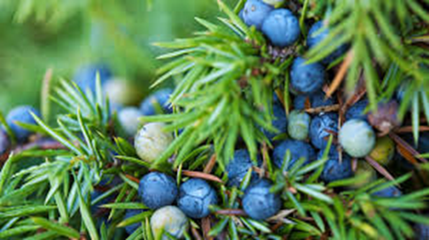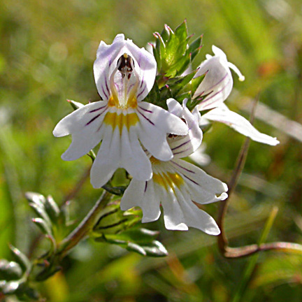
Juniper – Juniperis communis Chalk Eyebright - Euphrasia pseudokerneri

INTRODUCTION
The Countryside Team were asked to update the Epsom and Walton Downs Five Year Management Plan. The past management plans were reviewed and numerous meetings and discussions were had with the Downskeepers and site managers to come up with the prescriptions outlined within this management plan. The site was surveyed during the months of June and July 2020 to assess the habitats’ current status and potential. This management plan focuses on the site’s habitat management and the enhancement of its biodiversity value particularly its habitats and species of principal importance as outlined in the Natural Environment and Rural Communities Act.

STAGE ONE – DESCRIPTION

Introduction
Epsom & Walton Downs has been made famous by The Derby, considered to be the greatest flat race in the world. The racetrack, associated gallops for training the racehorses and hack riding areas make up a large part of Epsom Downs. To the north, Epsom Downs Golf Course makes up another large section (the management of which is not discussed in this plan but sits alongside it). Although these two organisations take up a large part of Epsom & Walton Downs, there is still a significant area that is publicly accessible and allows people access to wide-open vistas across Epsom & Walton Downs including woodland, meadows, chalk grassland, hedgerows and extensive views across London. These important habitats are managed for wildlife and public access and make up an important part of the biodiversity resource for Epsom & Ewell.

Location
Epsom & Walton Downs are situated on the dip slope of the North Downs just south of Epsom town on the southern boundary of the Borough of Epsom and Ewell in Surrey. The grid reference for Epsom Downs is TQ 218582 and Walton Downs is TQ 220574. It is included in the OS Explorer 146 covering Dorking, Box Hill and Reigate.

Land Tenure and Associated Statutory Requirements
The Downs are private land owned by Epsom Downs Racecourse and managed by the Epsom and Walton Downs Conservators through an Act of Parliament. The Conservators’ principal obligations are to enable the training of the 160 racehorses (this may increase by 50-70 after the development of Downs House) and associated staff that currently use the gallops up until noon every day, to preserve the Downs in their natural state of beauty, to maintain the public’s right of access and to ensure that the various users respect each other’s rights and the Downs environment. Membership of the Conservators is prescribed by the Epsom & Walton Downs Regulation Act 1984. Their membership is formed of Epsom and Ewell Borough Councillors (6 Members), Jockey Club Racecourses (3 Members) and the Horserace Betting Levy Board (1 Member). It is supported by officers of the Borough Council, and its Clerk is the Chief Executive of the Borough Council.

The Natural Environment and Rural Communities (NERC) Act 2006 currently includes a duty on public authorities to have regard to the conservation of biodiversity. The new Environment Act has amended this duty so that there is an expectation on public authorities to look strategically at their policies and operations from time to time (at least every 5 years) and assess what action they can take ‘to further’ the conservation and enhancement of biodiversity. They must also have regard to the relevant Local Nature Recovery Strategies, Species Conservation Strategies and Protected Sites Strategies, as part of the consideration. The production and implementation of a management plan will be a key part of adhering to this duty.

Local Designations
A borough wide review of Sites of Nature Conservation Importance (SNCI) was carried out in 2013. As a result of this review, the whole of the Epsom and Walton Downs was assessed as being SNCI quality. This was confirmed by the local sites partnership and adopted by Epsom and Ewell Borough Council. SNCIs are considered material considerations in planning decisions.

It is also within the North Downs Natural Area (more information available from Natural England) and is within the greenbelt. The site is also included in the Surrey Biodiversity Opportunity Area (BOA) ND04: North Downs; Epsom Downs to Nonsuch Park. The aim of the Biodiversity Opportunity Areas (BOAs) is to establish a strategic framework for conserving and enhancing biodiversity at a landscape scale. BOAs identify the most important areas for wildlife conservation in Surrey and each include a variety of habitats, providing for an ‘ecosystem approach’ to nature conservation across and beyond the county. Therefore, the management work detailed in this report could be seen to provide a landscape link within the overall BOA network. Although not a statutory designation, BOAs are protected under Epsom and Ewell’s Local Plan and are material considerations in planning applications.

The southern half of the site (Walton Downs) is also designated as an Area of Great Landscape Value, which is considered to be of high landscape quality with strong distinctive characteristics. It makes it particularly sensitive to development. The primary objective of this designation is conservation and enhancement of the landscape quality and individual character.

Reasons for SNCI selection
The whole of Epsom and Walton Downs was designated a SNCI in 2013, due to the presence of species rich chalk grassland. The National Vegetation Classification communities found are CG3 Bromus erectus grassland, CG4 Bryachypodium pinnatum grassland, CG2a Festuca ovina-Avenula pratensis grassland. There is an area of ancient woodland as outlined in the review of ancient woodland inventory for Surrey. Juniper is found in the area of Juniper Hill Grassland. The site also has a population of the Small Blue butterfly, which is on list A of butterflies of importance in Surrey.
The full SNCI report can be found in Appendix 1.

1.6 Photographic Coverage
Aerial photographs taken in 2003, 2009, 2011, 2013, 2016 and 2019 are held by EEBC. More recent aerial photographs of the site are available online from Google Maps, Apple Maps and Bing Maps.

Summary Description

Physical

1.7.1.1 Geology
The geological map relevant for this area is Sheet 286 Reigate printed in 1978. The entire area is Upper Chalk. The 1983 Soil Survey of England and Wales ‘Soils of England and Wales Sheet 6 – South East England soil map’, published 1983, describes the resulting soil type as a brown rendzina called Andover 1. This is a shallow well-drained calcareous silty soil over chalk and found on slopes and crests.

1.7.1.2 Topography
The lowest point on Epsom & Walton Downs is approximately 85m in the south-west rising to 150m in the north-east. This gives a gentle to moderate west facing slope. There is a moderate to steep south-east facing slope over Walton Downs.

Biological

1.7.2.1 Priority Habitats
The importance of the site is indicated by the fact the site includes Hedgerows, Lowland Calcareous Grassland and Lowland Mixed Deciduous Woodland, which are Habitats of Principal Importance in England under the Natural Environment and Rural Communities Act. See Map 3. Full habitat classifications can be found at https://jncc.gov.uk/our-work/uk-bap-priority-habitats/

Hedgerows
There are three hedgerows found on Epsom Downs one of which is a species-rich hedgerow running between Langley Vale Copse and The Warren Woodland (Ancient Woodland). It is a mix of at least 16 different species including, shrubs, climbers, and canopy trees of Oak and Ash spaced along the length. The other two are mainly regularly clipped hedgerows but provide good linear habitat.

Lowland Calcareous Grassland
There are extensive areas that remain as Chalk Grassland. Working from north to south they include the Derby Stables Grassland, Langley Vale Road Grassland, part of the Traveller Grassland, Epsom Downs West Grassland leading round in to Pony Hill Grassland, Sherwood Grassland, Walton Downs Grassland, Southern Boundary Strip and Juniper Hill.

The grassland of Juniper Hill is of particular importance. This grassland is considered to be one of the best of its type in Surrey in terms of its species diversity, including several rarities, in a relatively small area. Only its small size prevented it from being a Site of Special Scientific interest (SSSI). It is regarded by the Epsom and Ewell Local Biodiversity Action Plan working group as a top priority to conserve and enhance. The comparison of aerial photographs from 1949 and 2013 shows the large extent of the loss of the grassland and encroachment by scrub and surrounding woodland.

Walton Downs Grassland is also very important with species such as Chalk Eyebright, and Round Headed Rampion. Derby Stables grassland contains orchids such as the Bee Orchid and Autumn Ladies Tresses. The rest are rich with interesting species and extremely valuable. The management recommendations for these areas are essential for the maintenance and restoration of this internationally important habitat.

Lowland mixed deciduous woodland
There are 7 woodlands found on the Downs, The Warren Woodland being designated Ancient Woodland. The main canopy species are Oak and Ash and all generally contain a mix including Field Maple, Sycamore, Hazel, Beech, Birch, Cherry, Hawthorn Blackthorn, Buckthorn and Holly with field layers of varying species diversity, often including large areas of Bramble and Ivy. The Warren Woodland (Ancient Woodland) contains a significant area of diverse ground flora associated with Ancient Woodland

1.7.2.2 Other important habitats
Veteran/mature trees
Large trees were noted within Beech Wood and The Warren Woods. It should be a priority to map veteran or near veteran trees across the site and ensure they have specific management plans to maintain and increase their longevity.

Grassland
The majority of the Downs is made up of grassland, which is publicly accessible and also consists of gallops and rides for horses. Given that the geology is chalk, all of it has the potential to be chalk grassland if not already. Within the site are the floristically interesting and varied areas of grassland such as the Warren Meadows East and West, The Triangle, and Gorse area leading in to the Tattenham Corner Gallop/Hack ride margin. Also within Middle Hill and The D, there are areas of upright brome, indicative of chalk grassland. If these areas were managed differently, their biodiversity value will increase along with the diversity of species within the sward.

Scrub
Scrub is a very important habitat for birds, small mammals, reptiles and invertebrates and is found in linear patches running between Beech wood to Walton Rd, along Mitchell’s Hack (AKA Pony Hill), to the north of Sherwood grassland, and amongst Walton Downs Grassland. It is made up of hawthorn, blackthorn and buckthorn in the main.

1.7.2.2 Species groups
These important habitats within Epsom and Walton Downs support a wide variety of plant and animal species, including a wide range of plants including some rare chalk grassland species, fungi, lichens, bryophytes, birds, mammals, a wide range of invertebrates, and reptiles, including 25 priority species as identified in the Natural Environment and Rural Communities (NERC) Act.

1.7.3 Cultural
1.7.3.1 History and Archaeology
The following is taken from ‘The Epsom and Walton Downs – A strategy for their management and use’ by D Smith (1993): ‘The Epsom Grandstand Association was founded in 1828 when it obtained a 90 -year lease of an acre of the Downs for the purpose of building a stand from the then Lord of the Manor. In the 1960s the Association became a subsidiary of United Racecourse Limited and in 1969 the Horserace Betting Levy Board, through its wholly owned subsidiary Metropolitan and Country Racecourse Management and Holdings Limited, acquired the freehold interest of Epsom Downs.’

Mr Stanley Wootton purchased Walton Downs from the Epsom Grandstand Association on 5th July 1926 and also acquired a lease of part of Epsom Downs as winter training gallops. The 1936 Act empowered Mr Wootton to train racehorses on Walton Downs and to grant leases or licences to train horses there. In 1969, Mr Wootton granted a lease of Walton Downs to the Horserace Betting Levy Board for the Period of 999 years at a peppercorn rent in order to secure the future of the Downs for the purpose of training racehorses in Epsom. In 1970 a Management Trust was formed to administer these training gallops, known as the Epsom and Walton Downs Training Ground Board (TGMB) which comprises representatives from the Betting Levy Board, Epsom Racecourse Trainers Association, the Borough Council and the County Council. The area is managed by the Epsom and Walton Downs Conservators, whose primary duty is ‘to maintain the natural beauty and diversity of the Downs… and the relationship between the various users .’

Common Rights no longer exist, but subject to the 1984 Act, the public are entitled to access for free air and exercise. Racehorses use the site and local public can ride out on the Downs. The Downs are very popular with the public for walks. Dog walking, kite flying, model aircraft flying are amongst the many activities permitted by the Bylaws.

Cultural significance is provided through archaeological features on the Downs. Documentation from Dr D Bird, Principal Archaeologist at Surrey County Council reveals that several Roman artefacts have been found. For example pottery found during WWII close to Downs House and a Roman coin from 3rd Century, Constantine period found in 1925. South of Tattenham Corner a Roman coin from the 4th Century, Claudius II was found in 1937. Around Buckles Gap and to the east, 11 round barrows from the Bronze Age or Saxon burial mound were shown on a 17th Century map and Early Iron Age pottery has been found. 19th Century coal tax posts are found along the boundaries. These are points where tax was paid on coal being brought into London. Dr Bird summaries by saying ‘There is enough evidence here from finds to show that there will have been prehistoric and Roman Period settlement in this area, and I expect that there will be surviving earthworks.’

1.7.3.2 Public Access and Recreation
There are numerous activities for people to get involved in on the downs. Horse riding, dog walking, kite flying, flying model aeroplanes (coordinated by Epsom Downs Model Aircraft Club www.edmac.org.uk), walking, cycling, jogging, and looking for wildlife to name a few.
There are a number of on-site car parks present. One is located just south of The Hill, two at Tattenham Corner and others along Grandstand Road. The nearest railway station is at Tattenham Corner Station. The Rights of Way comprise of several footpaths and bridleways. There are also numerous desire lines through the woodlands and grasslands. See map 2.

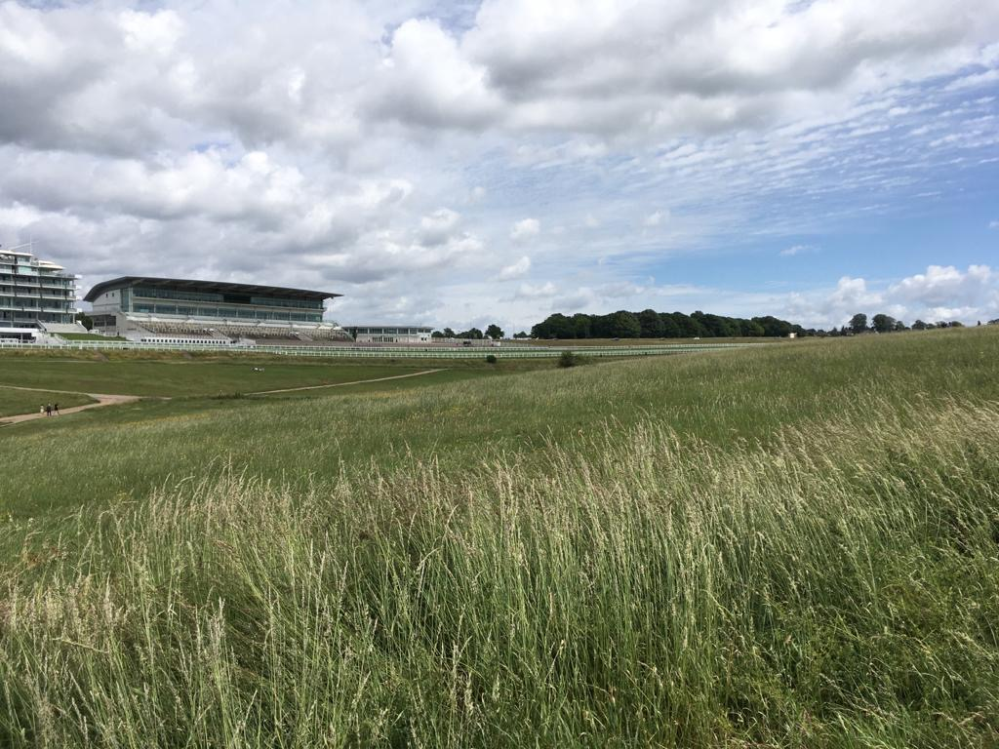
A view across Epsom Downs towards the Grandstand

STAGE TWO – EVALUATION AND OBJECTIVES

2.1 Criteria for Evaluation
Size
The total area covered by Epsom & Walton Downs covers 177 hectares (437 acres). This represents a substantial area of open space within a predominately urban context and represents a significant proportion of the County’s chalk grassland resource.

Naturalness
In parts areas have been reseeded, fertilisers used and development taken place. Car parks have been built as well as roads and buildings associated with the racecourse. Due to the close proximity of residential houses, there are a number of garden escapees, non-native species and invasive plants
However, other areas such as Juniper Hill are excellent examples of unimproved chalk grassland that have remained in this state for hundreds of years. There are several species of plants researched by Terry Wells and Francis Rose which were thought to be restricted to turf, undisturbed for at least 130 years. These include Squinancywort, Dropwort, Burnet-saxifrage, Horseshoe Vetch, Chalk Milkwort and Bastard-toadflax, all of which are found here.

Diversity and Rarity
Over 300 plant species have been recorded and a similar number of fauna. Whilst a great deal of the site is devoted to gallops and hacks on the racecourse, it also includes a variety of habitats such as unimproved calcareous grassland, rough semi-improved calcareous grassland, secondary woodland with associated scrub and hedgerows.

Over the years, surveying has been carried out across the site, a summary of which is below. A full species list can be found in Appendix 2. However, aside from the butterfly recording at Juniper Hill as part of the Butterfly Conservation Monitoring Scheme and botanical recording as part of writing the management plans, all records are quite old.

Bryophytes (Mosses and Liverworts)
A total of 26 species have been recorded at present, which were spotted whilst surveying plants as part of writing the management plans. This is an area of wildlife surveying that could be improved.

Vascular plants
388 species have been recorded in total. (Many thanks to Ann Sankey for sharing records held by Surrey Botanical Society.) This is a lower number than other sites in Epsom and Ewell but is probably due to lower recording effort. 350 species are recorded in Horton Country Park Local Nature Reserve, 455 at Nonsuch Park and around 500 at Epsom Common Local Nature Reserve.

Juniper found on Juniper Hill is a NERC priority species. In Southern counties, Juniper is in a critical state of decline with evidence of habitat fragmentation. There are only 5 known sites in Surrey, these declines and losses can be attributed to the cessation of appropriate management, scrub encroachment and increased habitat fragmentation.

Within Juniper Hill Grassland and Walton Downs Grassland, three Nationally Scarce plant species reside. They are Bastard-toadflax, Chalk Eyebright (also a NERC species) and Round-headed Rampion.

Native English Bluebells are found in good numbers carpeting the ground in spring, within The Warren Woodland (Ancient Woodland) in particular. The British Isles and especially Southern England is a strong hold for bluebells, compared to other countries in Europe. Confined to chalk grassland is the Fragrant Orchid found on Juniper Hill and last recorded in 2013.

Invertebrates
The Invertebrate survey carried out in 2007 focused on surveying different habitat types within Juniper Hill, Walton Downs Grassland, The Triangle and Sherwood Grassland. At Juniper Hill surveying efforts were focused on the herb-rich chalk downland, scrub/woodland edge habitat, woodland rides, decaying wood and bare earth scrapes. Within Walton Downs Grassland, the survey focused on the tall vegetation (esp. Pastinaca sativa), scrubby chalk grassland and track-edge erosion. Lastly it also looked at the rank grassland and scrub where The Warren Woods and The Triangle meet and also within Sherwood Grassland.

118 species of which 7 are classed as rare or notable species including one beetle, one fly, four bees/wasps and one grasshopper were recorded. In addition, there were 13 local species found, whose distribution is restricted to chalk grassland. Of the invertebrate species that have been recorded here over the years, not just in 2007, two are Notable Na species, 18 are Notable Nb species, one is a Red Data Book (RDB) 3 and a further 6 are in other RDB categories. Other records associated with chalk grassland are the Rufous Grasshopper, Roman Snail and Orange-tailed Clearwing as well as some hoverflies and bees.

In addition, Juniper Hill is on the Invertebrate Site Register as grade B (for the Juniper) and grade C. This register was developed to raise the profile of invertebrate conservation. They can be site based or taxon based. Grade B is given when a site is judged to be regionally important and a possible candidate for SSSI. Grade C sites are potentially important sites but have insufficient information on which to judge.

Molluscs and Oligochaetes (Slugs, Snails and Earthworms)
14 different species have been recorded so far but there has been no survey carried out which has particularly focused on these groups of animals. Further surveying would likely reveal more species found on site.

Arachnids (Spiders, Harvestmen, Mites and Ticks)
7 species have been found during the invertebrate survey carried out in 2007 but the survey was not focused on this group of animals.

Lepidoptera
- Butterflies - this is probably the best recorded animal across Epsom and Walton Downs. A butterfly transect route is walked annually, once a week from April to September and is part of Butterfly Conservation’s Butterfly Monitoring Scheme. There have been recent records of 35 different species and there are 2 historical records of Purple Hairstreak and Wall Brown dating back to 1905. Of the 35, 7 are NERC priority species. Of particular concern are Small Blue and Chalkhill Blue. Due to its rapid local decline at the end of the twentieth century, the Small Blue is given High Priority in Butterfly Conservation’s Regional Action Plan. This butterfly is declining nationally and by 2000 only about 15 populations remained in Surrey. At Epsom and Ewell, it survives in 5 or 6 small areas where the larval food plant Kidney Vetch is found. Since 2002, conservation work on Epsom Downs has created patches of more suitable habitat and the butterfly has responded by colonising these. Further information on the conservation that has taken place on site, is included in the respective management compartment information, found later in this management plan.
- Moths – 27 species have been recorded but most date back to the 60s, 80s and 90s. 4 of these are NERC priority species. A few date from the more recent 2007 invertebrate survey but this would definitely be a group of animals to focus further surveying on.

Coleoptera (Beetles)
A total of 205 species have been recorded, most of which date back to the 90s. As with moths, this would be a priority group to focus on for further surveying work.

Diptera (True flies)
50 species recorded with records dating back to 2007 and 80s and 90s.

Hemiptera (True bugs)
15 species recorded all from the 2007 survey.

Hymenoptera (Bees, Wasps and Ants)
55 species recorded, mainly from 2007 and some from the late 90s.

Orthoptera (Grasshoppers and Crickets)
7 species have been recorded mainly from 2007 and some from 1998 and 2002.

Odonata (Dragonflies and Damselflies)
6 species have been recorded but these are mainly very old records dating from 1905. Only one was noted in the 2007 survey, the Common Darter.

Other invertebrates
1 Dermaptera (Common earwig) 2007, 2 Isopods (woodlice) 2007, 2 Mecoptera (Scorpion flies) 98 and 07, and 3 Neuroptera (Lacewings) 1998.

Herptiles
- Reptiles – Common Lizard has been recorded which is a NERC priority species and is protected under UK law.
- Amphibians – None have been recorded and as there are no water bodies on site, it is not a priority group to survey. However, there may well be some on the margins of the site where residential roads back on to the Downs and garden ponds may support a population.

Birds
In total, 50 species have been recorded. 11 are considered NERC priority species, 11 are on the RSPB red list of conservation concern and 8 are on the amber list. These records date mainly from the early 2000s from the Downskeeper’s general bird surveying which they aimed to undertake every 5 years. The Downs were separated in to recording compartments, which were then walked every 3 weeks throughout the year. Birds seen were noted with comments as to whether they were seen on site, just heard or flying over.

The mosaic of habitats provides breeding and feeding habitat for a number of declining bird species such as Skylark. A transect used to be walked annually to record Skylark locations. The route was walked once a month between April and July and behaviour marked on a map to indicate whether the birds were seen in flight, on the ground or circling. The last records date back to 2006. Due to Skylarks being ground nesting birds, it is very important to ensure the grass cutting regime is carried out very carefully and in accordance with their needs.

Bird box surveys were also carried out. There were 5 types being used, Standard Tit, Great Tit, Treecreeper, Kestrel and open fronted boxes often used by Robins. More recently a Barn Owl box was installed. Records date back to 2006 as to whether the nest boxes were being used and by what species. It is likely that some of these boxes will now be in a state of disrepair.

Mammals
There are 8 records of relatively common mammal species such as fox, rabbit and squirrel, dating back to 2002. There are also anecdotal reports mentioning seeing Common Pipistrelle bats.
The Surrey Dormouse Group, in 2018, positioned 50 Dormice boxes within the Warren Woodland due to the fact it looked like perfect habitat for them. The boxes were last checked earlier in 2021 and still found no signs of dormice. As the boxes have been up for two and a half years, Surrey Dormouse Group has decided to cease checks.
Dormice boxes and tubes were also positioned in Southern Boundary Strip, which are monitored by The Epsom and Ewell BC Countryside Team. No evidence of Dormice has been found but the boxes were used by wood mice.
There are also records of Bank Vole and Weasel, seen by the Downskeepers during their duties.

Fragility
When the grassland of the downs was assessed in the summer of 2014 it was found that they were not in a favourable condition. The main grass areas of the site failed due to the herb:grass ratio being too low, too few positive indicator species and too frequent occurrence of negative indicator species. Some of the areas failed due to too high a frequency of scrub, which results from lack of habitat management.

Without some degree of conservation management, habitats will eventually lose their biodiversity. The woodlands by their very nature do not require such regular management to maintain and enhance their biodiversity. Grassland on the other hand does require regular management or it will soon be invaded by undesirable species such as coarse grasses that will out-compete finer grasses. Then scrub species such as Hawthorn and Blackthorn will begin to arrive and eventually it turns into woodland (Natural Succession). Whilst a mosaic of habitats is desirable and scrub is extremely important, this should not be to the detriment of valuable unimproved calcareous grassland so very rare in this County. The priority for management should be for the areas with most potential, namely Juniper Hill and Walton Downs Grassland.

Visitor pressure can also affect the habitats, either through trampling, disturbing wildlife, fires, litter and other anti-social behaviour. It is very important that paths are maintained to encourage people to stay on the tracks and keep them away from sensitive areas.

Invasive species such as Canadian Goldenrod could pose a threat to grassland habitats and Turkey Oak to the woodlands. Where invasive species are found it is important to eradicate them as soon as possible.

Light pollution will affect the site from the nearby roads and street lights. This will affect night flying moths and other invertebrates. In addition, noise and air pollution from the roads will have an influence. Atmospheric pollution may also be contributing to changes in species composition with particular regard to the spread of Tor grass on Juniper Hill and on Walton Downs. There has been some research that indicated nitrogen oxide from the burning of fossil fuels is a contributing factor in the increase.

The climate is predicted to change dramatically over the next 50 - 100 years. It is thought that South East England will see warmer weather, with hotter summers and winters less severe. These changes and change in precipitation will mean the loss of cold loving species and a gradual shift in habitat north. Monitoring systems will help to recognise these changes and enable changes in management techniques.

Typicalness
The rough semi-improved calcareous grassland, secondary woodland and associated scrub is typical of the Upper Chalk in this region. However, the areas of exceptional species rich calcareous grassland, the open nature and large size of the site is less usual and offers more potential for nature conservation than is usual.

History of Biological recording
There have been a number of ecologists employed by the Conservators in the past, including Barry Goldsmith who was the Botanical Recorder on behalf of the Conservators and prior to this it was Peter Moore.

The Nature Conservancy Council (NCC) surveyed the site in 1988 as part of the ‘Chalk grassland survey’. Surrey Wildlife Trust (SWT) surveyed the site for the Sites of Nature Conservation Importance (SNCI) project during 1998, of which 3 SNCIs were selected on Epsom & Walton Downs and all of Epsom Golf Course was designated as a SNCI. More recently in 2013 the whole of Epsom and Walton Downs was designated by the Surrey Local Sites Partnership as SNCI, following a review of the Borough’s SNCI carried out by Peter Howarth (EEBC Countryside Officer (Ecologist)), the report of which can be seen in Appendix 1. Further botanical recording has taken place as part of writing the site management plans and Surrey Botanical Society has spent time on site over the years.

Martin Ellis and other members from Surrey & SW London Butterfly Conservation collected transect records for many years. Graham Collins an invertebrate specialist has also recorded in the area for several years. More recently, the regular Butterfly Conservation Transect was resurrected in 2016 and is walked by Peter Brown. The transect takes in Walton Downs Grassland, Juniper Hill and Juniper Hill Glade (the little glade to the South of Juniper Hill, which borders the farmland to the south) once a week from April to September every year and has built up a good picture of the butterflies using this area.

An invertebrate survey was carried out in 2007, which focused on the major groups of British insects: Coleoptera (beetles), Diptera (flies), Hemiptera (bugs and leaf hoppers), Hymenoptera (bees, wasps, ants etc), and Lepidoptera (butterflies and moths), but other groups were noted if seen. It was undertaken between July and early September 2007 and focused predominantly on open habitats, including Juniper Hill, Walton Downs Grassland, the Triangle and Sherwood Grassland. In addition, beetles were studied over a three-year period on a grass compost heap on the racecourse during 1993 -1995 inclusive. Ian Menzies has also provided further beetle records.

Apart from the butterfly recording, all surveys are very old and worthy of repeating if resources can be found. Information on Fungi and Lichen is missing completely.

Position in an Ecological Unit
In a local context the site is set in a large open area. Nationally it is within the North Downs Natural Character Area, which supports nationally significant calcareous grassland. It also forms part of Surrey’s North Downs Biodiversity Opportunity Area, which links Epsom and Walton Downs to the South and Nonsuch Park in the North via Epsom Downs Golf Course, farmland and Priest Hill and Howell Hill Surrey Wildlife Trust Nature Reserves. Links should be sought to connect these important areas to deliver landscape scale protection of biodiversity. Epsom and Walton Downs are situated on the edge of the Surrey Hills Area of Outstanding Natural Beauty (AONB) and within the Area of Great Landscape Value (AGLV). Natural England is currently (2021) reviewing the boundary of all AONBs. Any opportunities for all or part of Epsom and Walton Downs to be considered for inclusion should be taken. Locally it forms an important part or the Borough’s Green Infrastructure.

Potential Value
There have been declines and losses of important Chalk Grassland areas, which can be attributed to the cut back of appropriate management, scrub encroachment and increased habitat fragmentation. In addition, changing priorities and difficulties in funding are to blame. However, there is great potential for restoring this area for nature conservation and enhancing its value for landscape, public access and heritage.

Chalk grassland is one of the richest habitat in terms of diversity, but it is being lost at an alarming rate nationally and is also become highly fragmented. Today, areas of chalk downland that survive in Surrey are scattered across the Downs.

There are 12 Sites of Special Scientific Interest (SSSI) within the Downs Natural Area of Surrey, 9 of which have a chalk grassland component which go some way to protecting the chalk grassland resource of Surrey. However, important areas exist outside the SSSI’s, which have potential for enhancement, including Epsom Golf Course, Juniper Hill and Walton Downs Grassland. In past management plans, it has been noted that Juniper Hill is worthy of SSSI status but its size and fragmentation would prevent it from becoming one. There is potential to look at the Woodland and Grassland component of Epsom and Walton Downs along with Epsom Downs Golf Course and potentially combined, they could be put forward to be considered for SSSI status.

Careful management of the unimproved calcareous grassland, taking further control of the encroaching scrub and Tor grass and suitable management of the woodland, would enhance the site. This would enhance the biodiversity, helping to safeguard important species such as the Small Blue butterfly population.

Intrinsic Appeal
The site is highly valued as an important and well-used recreational facility where people can take part in a range of activities such as walking, dog walking, horse riding, fly kites and model aeroplanes or just sit and enjoy the magnificent views.

Factors Affecting Management
Under-resourced nature conservation management is the major factor influencing the vegetation changes over Epsom & Walton Downs, allowing scrub encroachment onto internationally important unimproved calcareous grassland. Generally, there has been a lack of livestock grazing as a result of changing agricultural practices and economic pressures have had a significant effect on the chalk grass resource of the North Downs.

Financial resources will also affect any management, as the proposed habitat management will incur costs. The continued work on Juniper Hill is essential and therefore continued annual financial support for the Lower Mole Partnership and its volunteers by EEBC is essential. Better use of volunteers could offer a way of managing the site generally. Nearby sites such as Epsom Common and Horton Country Park Local Nature Reserves use regular volunteer input, which is a vital tool in managing their habitats. It is suggested to consult with Lower Mole Countryside Partnership, Epsom and Ewell Countryside Team, Butterfly Conservation and Woodland Trust to see if they can offer help in setting up an Epsom and Walton Downs Volunteer Group. Using outside contractors for larger parts of the management must also be considered.

2.2 Identification/Confirmation of Important Features
Site Features | National Importance | Regional Importance | Local Importance
- Habitats  Hedgerows  Lowland mixed deciduous woodland  Veteran/mature trees  Grasslands  Scrub |  | * | *  *  *  *
- Species groups  Plants – Chalk Eyebright and Juniper are NERC species. Bastard Toadflax, Round Headed Rampion and Chalk Eyebright are nationally scarce.  Kidney vetch is the foodplant for the Small Blue Butterfly.  Bird assemblage  11 NERC species  11 Red List  8 Amber Listed  Invertebrates  Butterflies - 7 NERC priority species including Small Blue  General assemblage – notable, Red Data Book species and chalk specialists. Assemblage found on Juniper Hill is regionally important. | * | *  *  *
- Culture and amenity  Public recreation  Educational opportunities  Historical, landscape and cultural features | * | * | *

2.3 Ideal Long-term Management Objectives for Nature Conservation
- Enhance the biodiversity of the site as a whole, including better links between habitats.
- Manage grassland for nature conservation and to encourage diversity associated with the chalk grassland.
- Manage the woodland and hedges for both nature conservation and access (where not harmful to wildlife), enhancing biodiversity where possible by creating a diverse age and structure.
- Retain where possible a variety of decaying wood in the woodlands and encourage wood decay to enhance overall biodiversity.
- Manage the scrub for nature conservation by creating age structure and controlling dominance over other habitats.
- Control undesirable species of plants to maintain and enhance biodiversity of site.
- Continue the collection of records for the site by commissioning a variety of ecological surveys. Share information with local record centre.
- Encourage grounds maintenance contractors to undertake good management practice to assist nature conservation. Increase awareness of the biodiversity value of the site.
- Encourage and support local wildlife groups and conservation volunteers. Identify and prioritise staff time to support a regular group.
- Promote and support the work carried out by volunteers, particularly the Lower Mole Partnership.
- Protect the historic landscape in accordance with the Area of Great Landscape Value requirements.
- Interpret the site’s biodiversity and historical importance to the public.
- Continue to work with all stakeholders
- Investigate possibilities for further designations such as Local Nature Reserve or Site of Special Scientific Interest or inclusion within the Surrey Hills Area of Outstanding Natural Beauty.

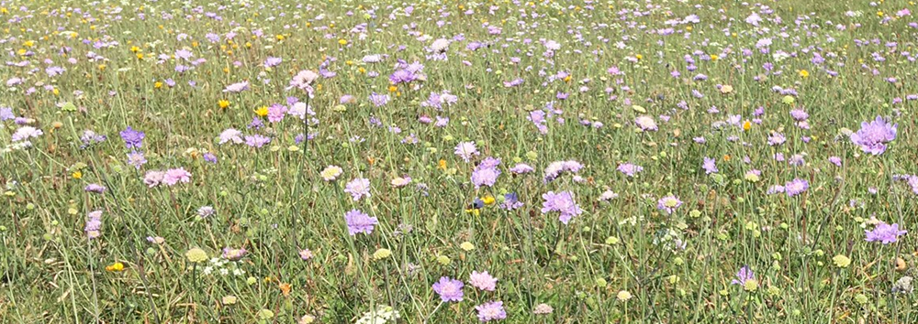

2.4 Rationale
The tables below contain information on all the habitat management compartments, with a description of the current habitat status, current management regime, and future management prescriptions. The compartment numbers correspond to those found on Map 1, the Habitat and Compartment map. Some of the descriptions have not changed since the last management plan written by Peter Howarth, c2014 which were very thorough and remain accurate, so these have been used again. The species listed use scientific and common names, along with the abundance in some circumstances, using the DAFOR system. This is a way of describing the abundance of a plant and uses the following key: Dominant, Abundant, Frequent, Occasional, Rare.

2.4.1 Hedgerows
General principles:
- Hedges provide shelter and create microhabitats and the longer, larger and denser it is, the more benefits it provides for wildlife such as birds, bats and other mammals. Connectivity is very important and in managing hedgerows, gaps should be avoided where possible.
- Regular annual trimming prevents flowering and berry production, reducing valuable food for birds and mammals.
- If cutting with a tractor and side arm, ideally a maximum of one third of the length of any given hedge should be managed in a single year. The hedge should be cut on rotation over three to five years depending on the size of the hedge. However, when alongside paths, there may be a need to cut more regularly.
- If the hedgerows become larger lines of scrub banks, they should be scalloped into the centre, in sections. Preferably this should be done by hand using volunteers rather than machinery. Each section should be roughly 20m or so and then 20m should be left before another scalloped section begins. This way you create age structure but retain the length of the hedge. On the opposite side, the scalloped section should be opposite a section that is not cut. This results in a zig-zag shape if viewed from above.
- Cutting and trimming should take place preferably in winter, ideally January, and never during the main nesting season of March to August. This minimises the risks of nests being destroyed and food supplies being reduced. Autumn trimming removes valuable seeds and berries. Most of the berries of Hawthorn and Blackthorn, for example, tend to be on the outermost twigs and cutting these before they are eaten means depriving birds of an important food source.
- Ground cover at the base of a hedge should be retained over winter for ground-nesting birds.
- Planting in hedge gaps should be undertaken during the winter, when the ground is not frozen and some moisture is available. It is suggested that the species used include Hawthorn, Blackthorn, Buckthorn, Holly, Dogwood, Guelder Rose, Field Maple and Hazel. Fencing and protection may be required. If vandalism is a problem then use less conspicuous spiral guards.
- Mature trees in hedgerows, including dead ones, should be left in-situ (wherever public safety constraints permit) as potential nest sites, with consideration being given to erecting nest-boxes in suitable trees lacking large enough holes.
- It is always worthwhile considering planting native broad-leaved trees to become standard trees and fill suitable gaps in hedgerows. These should ideally be unevenly spaced. It is suggested that distances between them should exceed 8m to 9m. Even when trees stretch just a few metres above the main body of a hedge they are used by birds as song-posts.

Epsom Lane North Hedge (1)
Description – This hedge is mainly composed of Hawthorn, with some Dog Rose, Ivy, Blackthorn and Sycamore. There are extensive areas where the main hedge trees have died and the dead branches are just covered in Ivy. There is also the odd gap along the hedge line. At the Southern end, there have been flooding issues.
Comments on past management – It has been regularly trimmed. The flooding issue was dealt with by mounding up the ground to block water running in off the road and the vegetation has grown back and filled the gap. This should be monitored regularly to ensure water does not flood in again as it was causing erosion of the adjacent footpath.
Future management – The northern half of this hedge is the responsibility of EEBC and the southern half is the responsibility of the Training Board. The entire length of the hedge should continue to be rotationally trimmed over 2-3 yrs in winter, to ensure it does not encroach on to the path, following the general principles outlined above. Plant up gaps with local/UK provenance trees (to help ensure biosecurity).

Hedge north of Juniper Hill (2)
Description – This hedge extends northwards from the top of Juniper Hill Woodland and is composed of mainly Blackthorn, Hawthorn and Ivy.
Comments on past management – This has been trimmed regularly to prevent encroachment on to the path.
Future management – The hedge needs to be rotationally trimmed over 2-3 yrs, in winter, to ensure it does not encroach on to the path, following the general principles outlined above.

Langley Vale to Warren Hedge (3)
Description – This hedge links Langley Vale Copse and Warren Woodland (Ancient Woodland) and is a small stretch of species rich hedge. It is composed of abundant hawthorn, occasional Buckthorn, rare Bramble, Dog Rose, Wild Privet, Spindle, Holly, Wayfaring Tree, Dogwood, Hazel, Blackthorn, Yew, Sycamore. There was also the occasional larger tree mainly Oak and Ash. Also covering some of the trees and scrub were the climber Ivy and Clematis.
Comments on past management – This is cut back when necessary, to ensure the path is not encroached upon.
Future management – It should be divided in half and only one half cut each time. Each half should be cut every 2-3 yrs, to allow for flower and berry production. Standard trees should be replaced by natural succession or planting with local/UK provenance trees. The Ash trees need to be monitored for presence of Ash Dieback and removed if necessary on a risk-based approach based on public safety considerations.

Create new hedge
Along the path between Epsom Lane North Hedge and the Hedge north of juniper Hill, there are bushes periodically spaced along the track including Hawthorn, Dogwood and Elder. It would be advisable to plant up between these bushes, either along the farmland boundary edge (advisable as this would then remove the need for the barbed wire fence, which has caused damage to horses in the past) and create a new hedge. Not only would this be good for wildlife but it would also provide a sight barrier for horses and ensure they do not gallop in to the farmland. It could be possible to approach the Tree Advisory Board for assistance with this project. Permission from the farmer would need to be sought if planting along their boundary. Liaison with the Training Board and Epsom Downs Racecourse will also be needed as this section lies within their area of responsibility.

2.4.3 Mixed deciduous woodland
General principles
- The overall aim is to create a more diverse woodland structure both in terms of its vertical structure and in terms of age. A woodland should have a canopy (taller trees), understorey (smaller trees/shrubs, which can grow in shadier conditions), field layer (flowers, grasses) and ground layer (mostly mosses). It should also contain plants of different ages, as animals need woodland in all its successional stages. Management should seek to maintain a continuous supply of young growth and protect and enhance mature features such as veteran trees and decaying wood. This can be achieved by opening up the woodland in targeted locations by coppicing or thinning, creating glades, creating rides, managing ride edges and the perimeter edge of the woodland, or by halo releasing mature specimens.
- Suitable trees should be selected to become the next veterans.
- Ivy growing on trees is a very important part of the woodland ecosystem. The foliage and flowers provide food, the stems and evergreen foliage are used for hibernating insects as well as bats and other wildlife and this outweighs any damage it may do to the tree.
- Avoid damage to wood banks & other historical features.
- Woodland operations should adhere to the UK Forestry Standard and only 5m³ can be felled in any one calendar quarter unless a felling license is agreed with the Forestry Commission.

Decaying Wood
- Decaying wood is an extremely important habitat type within a woodland ecosystem, and yet is often the most overlooked. It allows much-needed nutrients back into the soil through decomposition. Lying wood decomposes from the outside in and dead standing wood decays from the inside out and both provide considerable opportunities for saproxylic (deadwood) invertebrate specialists and other wildlife. A combination of lying and standing decaying wood should be retained. Public safety needs to be considered of course so standing dead wood should be kept away from footpaths.
- During thinning operations, dangerous trees posing health and safety risks will have to be cut down. However, if safe to do so, tree surgeons should be asked to monolith some trees in the thinning programme by cutting off the branches and leaving the trunk upright. Ideally, they should be broken or cut jaggedly to mimic a natural break. Artificial bat hibernaculums could be cut into the trunk as well. If this is not possible then the trunk should be cut down and left on the ground in situ. The bigger the better as the trunks are buffered from drying out and the greater the number of organisms it will support. If this proves impracticable then the branches and trunk should be cut and stacked into habitat piles to rot down.
- Tree protection zones should be considered to keep the public away from an area where a tree might fall to allow it to die naturally.
- Tight as well as loose habitat piles provide different conditions. Leave the logs as large as possible to deter vandals moving them or setting fire to them or wire them together with steel wire. If possible, some of the log habitat piles should be put just under the ground and the turf replaced, which will provide habitat for invertebrates such as stag beetles. Covering log piles with woodchip resulting from woodland work can also create this habitat.
- Ring barking (deep and wide) can be considered as part of thinning works, to provide additional decaying wood. Any actions should first be fully assessed for health and safety implications. Tree surgeons could also be asked to make holes in live standing trees to initiate rot and drill holes in forks and crowns to increase water retention.
- Root plate and stumps from fallen trees should be retained for solitary bees and wasps and other invertebrates, unless it constitutes a safety hazard.

Woodland edge creation/management
- Woodland edge is an extremely important part of a woodland ecosystem. A gradation of habitat between short to longer grass, to scrub, to woodland is very important, particularly for birds and invertebrates.
- This can be achieved on Epsom Downs by pushing back the edge of a woodland by 10-20 metres (either from the outer perimeter of the woodland or along paths and tracks within the woodland) and managing the regrowth on rotation. Do not allow it to grow back to the height it was and encourage/plant species such as Hawthorn, Blackthorn, Dogwood, Guelder Rose, Field Maple, Privet etc.
- Woodland edge should be managed by scalloping to create a wavy, longer edge, in roughly 10-20 m sections, up to 10m deep. Alternate sections should be cut. Once these sections have grown back (5-10yrs), the adjacent, non-cut sections can then be cut. This ensures a good age structure.
- Having a variety of age classes will result in supporting the greatest variety of wildlife.
- Habitat piles should be created as mentioned above or should be disposed of by burning or chipping. Due to the urban nature of the site, any fires used to dispose of vegetation should be taped off clearly to warn members of the public.

Minimum Intervention
- Allowing a woodland to develop naturally and be subject to natural processes is also important to allow within a site. Having a variety of management adds to the variety of habitats a site can support and in turn, the variety of wildlife. For example, some of the rare woodland bats prefer a woodland that is dense with less glades/rides etc.
- Minimum intervention concentrates on tree safety works and removal of non-natives.

Non-native/Invasive species
- Non-native species should be removed and treated to prevent them growing back. Sycamore should be kept as part of the woodland composition, particularly due to the threat Ash Die Back poses to the composition of our woodland (see Threats below).

Timing of work
- Woodland work is best carried out during November to February, when the trees are dormant and to avoid the bird-nesting season (March to August) and unsuitable times for bats and other important wildlife. If ground conditions are an issue and would result in damage to paths, woodland work can start in September but no earlier to avoid disturbance to birds.

Threats
- Ash die back/ Chalara fraxinea is a fungal disease, which kills Ash trees. There is Ash within the woodland on the Downs, some of the trees are impacted. It is recognised that it is not financially viable to deliver a robust plan to manage the effects of Ash Dieback but a risk-based approach to managing trees affected will be taken. There are areas that are of high and medium priority are either along roadsides, next to adjacent housing or along main footpaths. Where trees are lost to Ash Dieback, replanting in these locations, where appropriate, will be prioritised as part of the tree planting plans.
- Oak Processionary Moth also poses an issue for the management of the woodland within the site. If large infestations occur, it can pose a threat to the tree itself through defoliation. However, currently the main concern is for human health, due to the toxic nature of the hairs of the caterpillars, resulting in rashes if they come in to contact with skin, or breathing problems if inhaled. The current policy is to survey the oak trees during the nest building season (June and July) and remove those which are head height (2m) or below, or are in a dangerous location e.g. above a bench. The cost implications of nest removal and or preventative spraying will need to be planned for.
- Other tree diseases have not been discovered as yet but care should be taken to look out for them e.g. sudden oak death.

Beech Wood (4)
Description - This area is a mosaic of woodland and scrub, with canopy trees concentrated within the centre of the woodland with mature scrub surrounding them. The scrub areas include areas of dense Blackthorn with a herb layer consisting of Bluebell and Wood Anemone in the spring and also Dogs Mercury, Ivy, Bramble, Bracken Honeysuckle and Ground Elder. It also has areas of mixed scrub made up of Hazel, Blackthorn, Crab Apple, Elder, Buckthorn Field Maple, Cherry, Spindle, Dogwood, Wayfaring tree and local dominant Holly and Privet. The herb layer here was also dominated by Dogs Mercury and Ivy with rare Lords and Ladies. Also within the wood, near where the hack rides meet and the south west corner was an open area with abundant Common Nettle, Bramble, Willowherb sp, goats beard, thistle sp Wood Mellick and Large Bindweed.
The more central woodland swathes include English and Turkey Oak, Beech, Sycamore, and some Ash. In some areas there is a good Hazel understorey.
Alongside the path was a grassy margin made up of Chalk False Brome, Cocksfoot and False Oat Grass with Burnet Saxifrage, Wild Basil, Rest Harrow, Common Field Scabious, Yarrow, Wood False Brome, Hoary Ragwort Black Knapweed, Hogweed. Whilst surveying there was an abundance of butterflies due to the good woodland edge habitat.
There are some large veteran or near veteran Oaks and Beech trees in the woodland.
The Elders support abundant epiphytic bryophytes including Orthotrichum affine, Zygodon Conoides, Cryphaea heteromalla and uncommon Metzgeria temperata.
Comments on past management – Tree safety works and ride side management to allow good access for horses and walkers.
Future management – Maintain good woodland edge and create more by scalloping sections of vegetation along the paths on rotation. Push back 10 m in places and manage the regrowth on rotation. Where suitable, coppice the areas of hazel to create glades and age structure. If using a tractor flail to push back vegetation from the rides, follow up with a chainsaw to neaten edges. Sharp stems cannot be left due to the potential danger to horses. The veteran or near veteran trees should be mapped and individual management plans drawn up to ensure their longevity. It is important to note there is concern for Beech due to climate change. They are shallow rooted and not very drought resistant and on the chalk are unfortunately more at risk.

Sherwood Woodland (5)
Description - The woodland surrounds Downs House and is composed of a fairly open canopy of frequent English Oak, Ash and Wild Cherry. The Wild Cherry is generally found together in one stand. There is the odd Yew, Birch, Holly and Scots Pine. On the edge of the wood is some Turkey Oak. The shrub layer overall is sparse composed of rare Hawthorn and Hazel particularly in the western edge and rare Holly, which in places occurs in dense patches. The herb layer is generally poor, dominated by Ivy with rare Wood Anemone, Violets and Wood False Brome. Where trees have collapsed and created open areas, bramble is common. Along the southern edge where the woodland narrows to a thin strip around the land of Downs House, there is a Blackthorn, Hawthorn, Beech and Buckthorn creating more of a hedgerow habitat. The grass margin between the woodland and the path running along the south of the wood is flower rich.
Comments on past management – Minimal other than ensuring the vegetation stays off the path and racecourse. Currently there is development occurring within the grounds of Downs House and some woodland has been cleared along the southern edge of the grounds.
Future management – There is potential to push back the western and southern edge of the woodland to create woodland edge. The flower rich margin along the southern edge is important to manage as it provides a grassland habitat link between Sherwood Grassland and Downs West Grassland. Ideally this margin would be cut and cleared but at the very least, cut to ensure the scrub does not take over.

The Warren Woodland (Ancient Woodland) (6)
Description – The North East Corner of the woodland is owned by EEBC. The woodland here is semi-natural broad-leaved woodland. The canopy layer is very open and made up of abundant Pedunculate Oak, with frequent Ash, rare Sycamore, rare Whitebeam and rare Beech. The scrub layer is composed of abundant Hazel including old and recent coppice stools, Holly, Buckthorn, Privet, Dogwood and frequent Bramble. The field layer is made up of Hogweed, Cow Parsley, Hairy St John’s Wort, Nettle, Wood false brome, Wood sedge, Dog’s Mercury, Wood Avens, Bearded Couch, Violets and Sanicle. In the spring it is a carpet of Bluebells. The ground layer was sparse dominated by Kindbergia praelonga and Brachythecium rutabulum, Atrichum undulatum and Fissidens bryoides. The epiphytic bryophytes were generally poor mostly just Rhynchostegium confertum. There was a good amount of fallen dead wood found in this area. There is a veteran Beech tree at the south west corner of Warren Flower Meadow West.
In the updated inventory of ancient woodland (2011) in Surrey this woodland is included as an ‘ancient’ woodland.
There are large numbers of large hazel stools with large numbers of small stems per stool. Spacing between stools is fairly close on average and numbers of canopy trees are fairly low. These are two key requirements for high quality regrowth necessary for efficient/economically usable material of potential interest to coppice workers.
The size and density of the stools suggest that there will be strong regrowth and only minimal gapping-up or layering required. The presence of Roe Deer means that to ensure regrowth from coppicing means deer fencing is essential.
Comments on past management – The SW corner of the woodland was chosen to restart coppice management, as it shows abundant signs of having been worked as hazel coppice in the not too distant past. c2010 work to bring this area back in to coppice rotation was carried out under the guidance of the Lower Mole Partnership as part of the ‘Living Woodlands’ scheme. Access was improved by the construction of a hard surface track and a charcoal kiln was installed. Coppicing by a local coppice worker assisted at times by the Lower Mole Volunteers began in 2012. The area was divided in to seven coupes with the aim of cutting one coupe a year and the ash within the woodland on either a 14 or 21 year rotation.
Unfortunately, only two coupes were ever coppiced and the coppice worker can no longer carry out the work. In addition management of Ash is now dictated by having to deal with Ash Dieback and the attendant safety concerns.
Future management – The south-western section should be returned to coppice management if resources can be found. The main path inside the woodland should be maintained to allow good access ensuring vegetation does not encroach. If coppicing cannot be reintroduced, a compromise would be to create woodland edge along the path and subsequently manage on rotation. Removal of non-native invasive species should also be a priority.
The veteran or near veteran trees should be mapped and individual management plans drawn up to ensure their longevity.
The Ash present will be managed on a risk-based approach based on public safety considerations.

The Warren Woods (7)
Description - Semi-natural broadleaved woodland. This is one of the larger blocks of woodland on the site. The woodland mostly has an open canopy composed of frequent Ash (unfortunately suffering from Ash Die-Back), frequent English Oak, occasional Sycamore, rare Silver Birch and rare Beech. In places, the shrub layer is dominated by Hazel (western side of the woodland) and in other Yew and Holly. In addition, there is Blackthorn, Hawthorn, Buckthorn, Spindle and frequent Bramble. The herb layer was made up mainly of Ivy, with occasional Dogs Mercury. In addition to the Ivy on the ground, some of the trees had dense coverage of Ivy as a climber. There are areas, which were dominated by young Ash, particularly the north eastern corner. There was a good amount of fallen dead wood found throughout the wood. There is also a small amount of non-native trees in the wood including Cherry Laurel and a Spirarer. Also near to the path was a small area dominated by Rose-bay Willowherb. Where vegetation has been pushed back from the paths, there is an interesting grassy mix with flowers including Pale St John’s Wort, Wild Raspberry, Hedge Woundwort and Wall Lettuce. Dogs Mercury can be found along the path edges. Bluebells become more dominant towards the southern end of the woodland, as does the quantity of Hazel. Within the woodland are some veteran oak trees.
Comments on past management – Along the path running horizontally through the woodland towards the northern end, woodland edge was created by pushing the woodland back about 10m and large scallops were created.
Future management – There are areas within this woodland that are given medium priority to manage for Ash Die Back and these will be monitored. These areas are generally along paths and Sherwood Gallop.
Continue to push back woodland along the three main paths, 10 m either side and manage the regrowth by scalloping to create sheltered bays. Where opportunities allow, create glades. There is a coal tax post in the north west corner, where there is naturally a glade. This could perhaps be enlarged. Hazel dominates the southern section, so this area could potentially be coppiced in the future. Thinning out of the woodland should be prioritised around veteran trees. Halo release of the more mature trees will help with their management and have the effect of opening up the woodland to allow in more light to the woodland floor.
The veteran or near veteran trees should be mapped and individual management plans drawn up to ensure their longevity.

Top Woods (8)
Description - This is a small triangle of semi-natural broadleaved woodland. The canopy was composed of abundant English Oak, abundant Ash, rare Silver birch, concentrated along the northern edge and rare Wild Cherry. The canopy was mostly quite open, with the trees even aged. There are scattered larger trees which are =mostly English Oak. The shrub layer is generally sparse composed of rare Elder, occasional Hawthorn, rare English Elm, Holly, Yew and some coppiced Hazel and some dense areas of Bramble. In some places the vegetation was dominated by young Ash regeneration. There was a small amount of fallen and standing dead wood present. The epiphytic bryophytes were sparse, dominated by Rhynchostegium confertum. The herb was composed of Lords and Ladies, Hogweed, Herb Robert, Wall Lettuce, Hedge Woundwort, Dog Mercury, Ground Ivy, areas of Bluebells and extensive patches of Ivy. The ground layer is patchy with some areas of Atrichum undulatum, Eurhynchium striatum, Fissidens taxifolius, Barbula unguiculata and Dicranella varia. On the edge of the woodland was a dense patch of the non-native shrub, Snowberry.
Comments on past management – Woodland edge has been created by pushing back the woodland from the meadow adjacent called The Triangle, in the north west corner. The developing grassland is herb rich.
Future management – There are some more open areas, which could be prioritised to open up further to create glades. The mature trees can also be halo released, which will also create more open areas to diversify the vegetation on the woodland floor and create age structure within the woodland canopy and understorey. Woodland edge can continue to be created along the western edge of the woodland and manage the regrowth by scalloping. The vegetation along the paths running within the woodland should be pushed back up to 10m and regrowth managed as woodland edge by scalloping on rotation.
The Ash present will be managed on a risk-based approach based on public safety considerations.
The veteran or near veteran trees should be mapped and individual management plans drawn up to ensure their longevity.

Langley Vale Copse (9)
Description - This is semi-natural broadleaved woodland. The canopy is composed of abundant Ash, frequent English Oak and rare Beech. The shrub layer is reasonably well developed, with abundant coppiced Hazel, occasional Hawthorn, rare Holly, rare yew and rare Wild Privet. Abundant Ivy with rare Herb Bennet, Sanicle, Dogs Mercury, Bugle, Ground Ivy, Rough Meadow Grass and Primrose dominated the herb layer. The ground layer was very sparse with lots of bare ground; there was a patch of the moss Barbula sardoa. Generally, the coverage of epiphytes was low. The amount of fallen dead wood was good. In some areas, the canopy is very open with dense coppiced Hazel. In other areas, there were patches of saplings. Most of the canopy trees are the same age and size, with the exception on number of larger more mature Beech trees, some of which were multi-stemmed.
Along the Eastern half of the southern edge, there was a flower rich margin between the wood and the track, including species such as Black Horehound, Upright Hedge Parsley, and White Campion.
Comments on past management – Areas towards the west of the woodland were coppiced during the 1990s and early 2000s. Otherwise maintenance has been limited to ride surfaces and cutting back of vegetation encroaching on rides.
Future management – The wood could be put into a coppice rotation. However, it is unlikely resources will allow this. A compromise would be to push back the woodland up to 10m either side of the paths and manage the regrowth as woodland edge by scalloping on rotation. Halo release more mature trees.
The veteran or near veteran trees should be mapped and individual management plans drawn up to ensure their longevity.
The Ash present will be managed on a risk-based approach based on public safety considerations.

Juniper Hill Woodland (10)
Description - This is a mixed area of semi-natural broadleaved woodland with areas where the canopy is dominated by Ash, and some Pedunculate Oak. The scrub layer is dominated locally by Hawthorn, some of which are very mature and Blackthorn. There is an area of older woodland with larger Beech and Oak and a shrub layer composed of coppiced Hazel and Hawthorn, some very mature. There is also an area of developing woodland with abundant Whitebeam present. Some of the trees and shrubs had Orthotrichum affine, Zygodon conoides, Cryphaea heteromalla, Neckera complanata and uncommon Metzgeria temperate on them. The herb layer is composed of abundant Ivy. Areas of ground flora are dominated by the moss Eurhynchium striatum. As the grassland is approached there is a large area of scrub dominated by Hawthorn. Along an open path through this area herbs such as Violets, Wild Marjoram and Basil are found. If the 1950’s aerial photograph is examined this area along with most of the rest of the now wooded area was open grassland.
Comments on past management – Where the grassland of Juniper Hill meets the woodland, extensive clearance has happened along the woodland edge. Initially the larger trees were cleared by the Lower Mole Partnership (LMP) Volunteers and these areas have subsequently been managed annually to prevent regrowth of the woodland, both by LMP and Countryside Team (CT) volunteers. The cleared areas have been cut and cleared and the grassland vegetation is returning, with the woodier vegetation becoming much less dominant.
Future management – The woodland must be prevented from encroaching any further into Juniper Hill on all sides.
Where paths run through the woodland, push back 10m either side to create woodland edge and identify an area in the northern section for a glade to be created. Along the northern boundary edge of Juniper Hill woodland overlooking Walton Downs grassland, it is recommended here that the edges are scalloped in 20 -30m stretches. This would help to open up some of the woodland, encourage scrub growth and create an important ecotone between the woodland and the grassland which does not exist at the moment. The woodland is relatively even aged so would benefit from thinning, prioritising halo release around any mature specimens. The veteran or near veteran trees should be mapped and individual management plans drawn up to ensure their longevity.
In the long-term, consideration should be given to clearing the woodland further back from Juniper Hill, in line with the extent visible from the aerial photograph taken in 1950 and restoring back to chalk grassland. If the recent clearance proves successful with chalk grassland being restored, this would be a priority to find funding for.
The Ash present will be managed on a risk-based approach based on public safety considerations.

2.4.4 Veteran and Mature Trees
A survey should be carried out to map all veteran trees on site and create a management plan for them. The distinctive features that the mature and over mature trees create should be recognised and sensitive management should be adhered to, to ensure their longevity. A gradual programme of clearing a space or ‘halo’ around them of competing species should be put in place to ensure a healthy crown. Aim to achieve a clearance of at least the circumference of the existing crown area per tree. This to be done during routine thinning programme as suggested above in the management suggestions for each woodland. Crown or end-weight reduction may also be necessary to ensure longevity.

2.4.5 Grasslands
General principles:
- The overall aim is to create a structured, diverse and spatially varied mosaic of habitats. Whilst a mosaic of different grassland types is important with some being allowed to be encroached by scrub, this should not be the general practice as the chalk grassland found on Epsom Downs is an important habitat in Surrey and supports important assemblages of invertebrates and birds. Where scrub has established it is very difficult to restore it back to good quality grassland. The scrub enriches the soil and once it has been cleared again it often leaves bare patches of ground ready to be colonised by coarse grassland species and weed species such as Common Nettle.
- Grazing is often the best management option for grasslands and consideration should be made as to the possibilities of this, even if only in a small area to begin with. Grazing enables low growing and less competitive plants to compete with coarse vigorous species, such as the Tor grass. In addition the trampling action of hooves breaks up litter and opens up the sward to allow species in to recolonise, such as Kidney Vetch, which is used by the Small Blue butterfly.
- Possible constraints to grazing could be installation of a water source for the animals and its urban fringe location. For Chalk Grassland, winter and early spring grazing would be ideal to avoid any loss of flowering plants, or grazing at a very low density year round. It is highly recommended to get in touch with the Downlands Partnership to gain advice on the potential for grazing Juniper Hill.
- Another option is to cut the grasslands mechanically but crucially, the grasslands should be cut and the arisings cleared. The build-up of thatch adds unwanted nutrients to the soil, resulting in the reduction of wildflowers and finer grasses and promotes coarser grasses and scrub. The build-up of thatch also damages the structure of the grassland. Seeds fail to reach the soil and germinate. Opportunities for the creation of patches of bare earth, beneficial for seed germination and burrowing invertebrates, is reduced. NB, if cutting mechanically with a tractor and flail, care needs to be taken not to cause too much compaction or damage anthills.
- Removing the arisings can be done by cutting the grass using a flail collector and the arisings taken away off site, or piles created at the margins of the grassland, importantly not underneath the base of veteran trees. This can cause a build-up of nitrogen as the grass rots and could cause
issues for older trees.
- Alternatively and particularly in areas which have anthills and are more sensitive to heavy machinery, grassland can be cut and cleared using a brushcutter and raked off by hand, as is currently the case at Juniper Hill. This is done by a combination of volunteer groups and staff.
- For optimal biodiversity benefit, grasslands that are being cut should be done so during late summer/early autumn. It is important for the continuity of the flora that the cut is at the same time each year.
- Not all the grassland should be cut every year. Invertebrates that lay their eggs on grass, for example the Marbled White and Meadow Brown butterflies, need to complete their life cycle. Once the grass is cut, their eggs are lost. Small mammals also need longer grass for food and for cover and protection from predators. The invertebrates and mammals then provide a food source for birds and so on.
- A good way of managing a meadow on rotation is to cut one half each year. The halves should be rotated around the face of a clock. For example, if the left vertical half is cut one year, the next year the top horizontal half should be cut, then the right vertical and then the lower horizontal and so on.
- By managing the grassland in this way, any invertebrates and mammals will be able to retreat into the uncut half and recolonise the cut area when suitable.
- The pattern of cut should avoid a spiral into the centre of the field as this drives mammals and birds into the middle. Instead cut in an up and down pattern to ensure their escape.
- Tor Grass is a problem in some areas of the grassland. It is a rougher, more vigorous grass and can take over an area, smothering out other plants. Ideally the grassland would be grazed, which is the best method of keeping it under control. If this is not possible, the Tor Grass patches should be cut regularly, with arisings removed, to mimic grazing pressure. If the Tor Grass is kept at 7cm, this will make it more palatable to rabbits as well. Planting of Yellow Rattle within Tor Grass dominated areas could also help. Continued management should weaken the grass and enable other plants to compete.
- The management for the main area of grassland used for the Derby and horse training has been designed with this in mind and is cut regularly but it also provides a successful breeding territory for Skylarks. To this end the first grass cut should continue to be delayed as long as possible before it has to be cut in preparation of the Derby (mid May), cutting centre out to allow wildlife time to escape. This then allows the first brood of Skylarks to fledge. Successive cuts should then be left as far apart as possible and consist of a topping.
- Avoid mowing under the tree canopy of any parkland trees, as it can be counterproductive. It removes valuable cover, increases surface vegetation transpiration rates, thus depriving trees of moisture and often results in bark damage to trees. It is also important to avoid damaging the base of tree trunks as this may encourage fungal infections.
- Aim to leave 2-5m wide circumference around individual trees and 2-5m wide margin around copses and woodland edges. Scrub will need to be controlled within these margins.
- Invasive non-native plants should be removed. Canadian Goldenrod has popped up in Beech Wood Grassland and The Gorse Area and will become a problem if not dealt with. Hand pulling is the best way to get rid of it, particularly as it is currently in low numbers. Cutting does weaken the plant but it tends to come back stronger the next year.

Grassland Surveys
During the summer of 2020 as part of writing this updated management plan, Juniper Hill and Walton Downs Grassland were surveyed to assess their condition. At Juniper Hill, five random 1m square quadrats were surveyed and species noted whilst walking between. On Walton Downs Grassland, only 2 quadrats were surveyed and species noted in general whilst walking across the area.

Results
NB 15-20 species per quadrat (not including rougher grasses and scrub) would be considered species-rich and favourable condition.

Grassland | Average of species per 1m quadrat
Juniper Hill | 20
Walton Downs Grassland | 11

Regular surveying of the vegetation in these grasslands is recommended, particularly due to their active management regimes. The Walton Downs Grassland survey can act as a baseline and result should improve as more of the area is cut and crucially cleared as well.
Although only 2 quadrats were surveyed and more would show a better representation of the whole area, they were placed in the area which had most diversity. So, the likely average score will be lower, indicating that this area has reduced in quality and is in urgent need of being cut and cleared, not just cut.
The management of Juniper Hill is different in that more of the area has been cut and cleared and the scrub component has been kept at bay through the work of volunteers and staff. It has also benefitted from being grazed by sheep in the recent past.

Derby Stables Grassland (11)
Description - Short mown calcareous grassland areas near the Grandstand with Sheep’s Fescue, Upright Brome, Wild Thyme, Small Scabious, Salad Burnet, Burnet Saxifrage, Fairy Flax, Bird’s Foot Trefoil, Lady’s Bedstraw, Mouse-Eared Hawkweed, Self-Heal, Greater Knapweed, Stemless Thistle, Squinancywort, Goat’s Beard, Restharrow, Glaucous Sedge and Autumn Lady’s Tresses. Although the Autumn Lady’s Tresses is rare as described by the DAFOR index. It is in fact there in great numbers. In some years there are 1000 plants. This plant is classed as near threatened in the draft Surrey rare plant register. Bee Orchids were also seen whilst surveying as part of writing the current management plans on 22nd May 2020.
Comments on past management – Cut regularly up until the Derby and then left to ensure the Autumn Lady’s Tresses are not mown.
Future Management – The grassland here seems to be doing well under the current regime. Two sections are used for car parking for the Derby so do need to be kept short for the event. After the Derby, the areas should not be cut until after the Autumn Lady’s Tresses have finished flowering (late October although flowering times can vary from year to year.) The area immediately adjacent to Derby Stable slip road is not used for parking however so perhaps could be left unmown slightly earlier to allow for the Bee Orchids to flower (from May onwards). Ideally the grassland will be cut and cleared.

Butterfly Field (12)
Description - This is an area of calcareous grassland forming a tall sward, with frequent Upright Brome and occasional Quaking Grass and patches of locally abundant Chalk False Brome. Herbs include Lady’s Bedstraw, Salad Burnet, Burnet Saxifrage, Wild Basil, Marjoram, Bush Vetch, Greater Knapweed, Black Knapweed, Teasel, Agrimony, Wild Carrot, Wild Parsnip, Hogweed, Rock rose, Milkwort, Dropwort, Creeping Thistle and Cowslip. It provides a haven for birds and small mammals disturbed and deprived of habitat during the major race meetings. Unfortunately, Canadian Goldenrod and Tor Grass are also found here. There is also a build-up of thatch from not clearing arisings in the past.
Comments on past management – This area of grassland is cut once in October. In 2020 it was not cut.
Future management – Due to its invasive nature, pull the Canadian Goldenrod and eradicate. Divide into half and cut and clear one half annually. Rotate the halves around the face of a clock. Regular monitoring of the success of the cutting will be needed. If some areas scrub up more than others, then these areas should be prioritised for cutting and clearing. Strim areas of Tor Grass regularly and remove arisings.

Traveller grassland and overflow (13)
Description – Very similar to Beech Wood Grassland, with a mix of chalk grasses and herbs. Due to more regular cutting, not quite as species-rich.
Comments on past management – Cut short for the Derby and then left and cut in September
Future management – Due to this area being needed for the Derby, the current management will have to continue. However, ideally the grassland would be cut and cleared. Care needs to be taken not to disturb nesting Skylarks.

Skylark nesting triangle/overflow (14)
Description – Again, very similar to Beech Wood Grassland, with a mix of chalk grasses and herbs. It is in this area that sky larks often nest. This is an overflow area for traveller parking during the Derby, although rarely used. The grass is cut and cleared from here for use on the racecourse crossings during the Derby, therefore is reasonably species-rich with species such as Lady’s Bedstraw, Greater Knapweed, and Upright Brome.
Comments on past management – Dependant on nesting skylarks, this is cut just before the Derby and then cut regularly along with the rest of The Hill.
Future management – Continue to cut and clear, ideally in September outside of the breeding bird season. If this area does need to be cut earlier, care must be taken not to disturb any nesting Skylarks.

Epsom Downs West Grassland (15)
Description - To the north and west of Sherwood Woodland this is an area of calcareous grassland forming a tall sward, with frequent Upright Brome and occasional Quaking Grass and patches of locally abundant Chalk False Brome. Herbs include Lady’s bedstraw, Salad burnet and Dropwort
Comments on past management – This is the responsibility of the Racecourse/training Board to cut. The Racecourse cut and clear the long grass for race days. EEBC cut one third of the remaining grass at the end of the racing season in early October.
Future management –The portion the Racecourse use is assisting with maintaining the floristic diversity within the sward. The third EEBC cuts each year should have the arisings removed as well.

Mitchell’s Grassland (AKA Pony Hill Grassland)(16)
Description – The Southern and Western side of this area is calcareous grassland, which extends round from Epsom Downs West Grassland.
Comments on past management – Cut regularly until the Derby and then left and cut in September.
Future management – Ideally this would be divided in to two halves and cut and cleared in alternate years in September.

Mitchell’s Hack (AKA Pony Hill) (17)
Description – Large swathes across the entire area of The Hill has the potential to be good chalk grassland. However, it is used as a combination of public hack rides and training gallops and so must be kept reasonably short for the horses, so the plants don’t get the chance to flower. There is a section between Mitchell’s and the Traveller overflow that is used for the start of the Winter Middle Hill gallop. The margins left to delineate the hack rides and gallops have the potential to be wider and create interest floristically and potentially help with connecting the areas of longer grass across the Downs.
Comments on past management – The Area which is used as part of middle hill gallop can be cut in the same way as the rest of Middle Hill and the D (by GM) between the Beginning of May and the start of September. The rest of the year it will be cut by the Gallops staff.
Future management – Grass should be cut in different directions, to prevent “leaning” of the grass blades, as grass tends to grow in the direction it’s mowed. It can also help to prevent thatch build up. Straight blades make for healthier coverage. Leave wider margins (2-5m) to delineate along the hack rides and gallops, taking care not to encroach on to the gallop side. Margins ideally should be cut and cleared when necessary. Care must be taken not to disturb nesting Skylarks.

Middle Hill (18)
Description – Again, of course these areas are kept short for use by horses and it is also used for spectator areas during the Derby. These large areas of grassland across Epsom Downs are improved grassland with, in places, abundant Perennial rye grass. However, there are also numerous areas across the site, with extensive areas of Upright Brome, which can be seen both on the ground and in aerial photographs as pale whitish patches. Although these areas are dominated by the grasses, there are rare but widely scattered herbs including Salad burnet, Burnet Saxifrage, Sainfoin, Lady’s Bedstraw, Agrimony, Small Scabious, Bird’s foot trefoil and Quaking Grass. This is also true of Walton Downs with areas scattered with Upright Brome and a large area towards the lower half of the sloping site dominated by Upright Brome with scattered herbs including Lady’s Bedstraw, Common Field Scabious, Bird’s foot trefoil, Black Knapweed, isolated but extensive patches of Common Rock Rose and Salad Burnet.
Comments on past management – The grass is cut regularly. The southern section to the east of Walton Rd is reserved for the Epsom Downs Model Aircraft Club.
Future management – Grass should be cut in different directions, to prevent “leaning” of the grass blades, as grass tends to grow in the direction it’s mowed. It can also help to prevent thatch build up. Straight blades make for healthier coverage. Leave wider margins (2-5m) to delineate along the hack rides and gallops, taking care not to encroach on to the gallop side. Margins ideally should be cut and cleared. Care must be taken not to disturb nesting Skylarks.

The D (19)
Description – This area is also regularly mown as it contains training gallops and a hack ride bordering the Gorse Area. However, as with much of The Hill, there are calcareous grassland species within the sward. The verge opposite Tattenham Corner is a species rich verge with Wild Mignonette , Common Vetch, Field Wood-rush, Sweet Vernal-grass, Burnet Saxifrage, Creeping Cinquefoil, Greater Knapweed, Dove’s-foot Crane’s-bill, Common Toadflax, Small Flowered Crane’s-bill, Sticky Mouse-ear, Cow Parsley, White Dead-nettle and Bulbous Buttercup.
Comments on past management – Regularly mown. Kite flying is allowed in this area.
Future management - Grass should be cut in different directions, to prevent “leaning” of the grass blades, as grass tends to grow in the direction it’s mowed. It can also help to prevent thatch build up. Straight blades make for healthier coverage. Leave a wider margin (2-5m) from Tattenham Corner around to the Gorse Area delineating between the hack ride and gallop, taking care not to encroach on to the gallop side. Margins ideally should be cut and cleared when necessary. Care must be taken not to disturb nesting Skylarks.

The Gorse Area (20)
Description - Semi-improved mesotrophic grassland. This grassland contains a diverse mix of plants including the county rarity and nationally scarce, Rounded Headed Rampion. Other herbs included Agrimony, Black knapweed, Common Sorrel, Lady’s Bedstraw, Hedge Bedstraw, abundant False Oat grass, Gorse, Perennial Rye Grass, Salad Burnet, locally abundant Upright Brome, Restharrow, occasional Dropwort, Burnet Saxifrage, Wild Basil, Marjoram, Common Rock Rose, Chalk False Brome, Cypress Spurge. This list of plants shows an interesting flora that has developed on the chalk soil but plants such as Perennial Rye Grass show a degree of disturbance and ‘improvement’. A small area of Canadian Goldenrod was also found.
Comments on past management –This area has been encouraged to regrow as it is trying to be chalk heath, a rare habitat in Surrey. Old photographs of the Downs show dense gorse here and there is a poem written about it in 1857, which refers to the beauty of the gorse.
As there is a good population of Dropwort here and as this does not like regular mowing, it has been cut on rotation, alternating which half is cut each year.
Future management – The grassland should remain cut on rotation but some of the larger scrub islands will need management in due course. The more mature stands should be scalloped in to from the northern edge to limit the damage of reptile basking areas. Prioritise cutting in to stands that are a monoculture. By doing this, age structure will be created providing a greater variety of habitat conditions, thereby supporting a greater variety of wildlife. The Canadian Goldenrod is invasive and needs to be pulled and eradicated. Access into this area needs to be managed to discourage people entering with dogs and disturbing breeding birds.

Sherwood Grassland (21)
Description - This is an area of calcareous grassland forming a tall sward, with frequent Upright Brome and occasional Quaking Grass. Also found here is Salad Burnet, Agrimony, Small Scabious, Lady’s Bedstraw, Black Knapweed, Rest Harrow, and the Small Blue’s larval food plant Kidney Vetch. This area is similar in composition to a lot of the grassland of the site, it has a more developed flora simply due to the more appropriate cutting regime. Unfortunately, Tor Grass has started to develop, which needs to be kept under control.
Comments on past management – This area of grassland always had a good population of Kidney Vetch, which is the foodplant of the Small Blue butterfly, a priority species. Kidney Vetch occurred particularly along a desire line where the disturbance had caused some erosion and opportunities for the plant to self-seed. It was decided under guidance from Gail Jeffcoate (Butterfly Conservation) and the Lower Mole Partnership, that scrapes should be created, initially in the vicinity of the desire line. In 2005, two scrapes were created by the Lower Mole Partnership Volunteers, which were subsequently seeded with Kidney Vetch Seeds. In creating the scrapes, Tor Grass which is invasive, was also removed. Four more scrapes were created in 2010. All have been very successful, the plants are flourishing, and the Small Blue butterflies are doing well.
In 2015, as part of the Small Blue Project, coordinated by Butterfly Conservation, the Lower Mole Volunteers created a further three scrapes. In creating them 5 years apart, there is a good age range of succession within the grassland.
Since around 2001, 50% of the grass has been cut once a year in October with arisings left in situ. In 2020, only half the area was cut, prioritising the western half due to the amount of scrub encroaching into the grassland and unfortunately, arising still left in situ, adding unwanted nutrients to the soil. This only encourages coarser grasses such as the Tor Grass to dominate.
Future management – Continue to divide into half and cut and clear one half annually. Rotate the halves around the face of a clock. Regular monitoring of the success of the cutting will be needed. If some areas scrub up more than others, then these areas should be prioritised for cutting and clearing. Strim areas of Tor Grass regularly and remove arisings. The scrub should not be allowed to encroach any further into the grassland. Scrapes should be monitored and as and when necessary, new scrapes should be created or re-created either by machine or hand. These should be located near to current scrapes or near areas of Kidney Vetch. If they can be used to dig out Tor Grass as well, this would be ideal.

The Warren Flower Meadow West (22)
Description - This meadow is owned by Epsom and Ewell Borough Council. Semi-improved mesotrophic grassland with a rich diversity of robust grass species and tall herbaceous plants here and although the majority are relatively common, the diversity of species present is good. Grasses include frequent Perennial Rye-grass, Rough Meadow-grass, Yorkshire-fog, False Oat-grass, Upright Brome and occasional Red Fescue and Soft-brome. Herbs are occasional to frequent with Agrimony, Meadow Vetchling, Common Vetch, Cat’s-ear, Red Bartsia, Red Clover, Ribwort Plantain, Common Birds’s-foot Trefoil, Wild Carrot, Silverweed, Yarrow, Lesser Stitchwort, Creeping Buttercup, Creeping Thistle, Dandelion, Common Sorrel and Broad-leaved Dock. Its secluded nature reduces the wind so that it is warmer here and attracts more insects.
Comments on past management – Since the last management plan, the meadow has been cut on rotation in two halves. Unfortunately, the northern half has scrubbed up quite considerably, so the entire meadow was cut this in 2020. Half was cleared and the scrubby part cut with the flail mower as the cut and clear machine could not cope with the woodier material.
Future management – As this meadow has scrubbed up so much, cut and clear all of it annually until the scrub reduced, then continue to manage in halves and cut and clear one half annually in the autumn (Sept/Oct). Rotate the halves around the face of a clock. Regular monitoring of the success of the cutting will be needed. If some areas scrub up more than others, then these areas should be prioritised for cutting and clearing. If the scrub does not respond well to this management, attempts could be made to clear it by digging/pulling up or using targeted chemical treatment.
The surrounding scrub should be cut back by 2-3 m creating a wavy edge and managed on rotation.

The Warren Flower Meadow East (23)
Description – This meadow is owned by Epsom and Ewell Borough Council. Similar to above although with fewer herbs in the sward, probably because of past improvement and use as a paddock. There is much potential to increase the number of species and encourage calcareous loving species too. It becomes much more diverse in the North-West corner with good populations of Selfheal and Common Knapweed. The western field tends to be a little more species rich with frequent Common Knapweed, Perforate St John’s-wort, Yarrow and occasional Germander Speedwell, Ladies Bedstraw, Meadow Vetchling, Oxeye Daisy and locally frequent patches of Tufted Vetch and Field Scabious. There is a rich hedgerow scrub edge around both West and East meadows, with a mature mix of Traveller’s Joy, Hawthorn, Blackthorn, Ash, Hazel, Sycamore and Pedunculate Oak.
Comments on past management – This meadow is cut quite regularly, often done when the playground is cut.
Future management – Manage in halves and cut and clear one half annually in the autumn (Sept/Oct). Rotate the halves around the face of a clock. Regular monitoring of the success of the cutting will be needed. If some areas scrub up more than others, then these areas should be prioritised for cutting and clearing.
The surrounding scrub should be cut back by 2-3 m creating a wavy edge and managed on rotation.

The Triangle (24)
Description - Mesotrophic grassland, with abundant False Oat grass, rare Upright Brome, Cocksfoot, Creeping Bent and herbs including Hogweed, Agrimony, Black Knapweed, Lady’s Bedstraw, Greater Knapweed and Birds foot Trefoil. There is a particularly herb-rich area at the very North East of the grassland along the margin with Top Woods.
Comments on past management – This grassland is cut once a year in early autumn. Pathways are cut regularly through the area to act as firebreaks and for visibility purposes. Arisings have never been cleared. Although it cannot technically be termed calcareous grassland, it has huge potential. It does have a good mix of herbs to grasses and if cut and cleared, will become more species-rich.
Future management – Continue current management but clear the arisings. A 2-3m edge to the woodland should be left and cut less regularly to allow a refuge area for small mammal and invertebrates. This margin should be cut on rotation however to ensure it does not scrub up too much.

Sherwood Gallop, Summer Gallops and Six Mile Hill (25)
Description – These grassland areas are mainly managed for training horses.
Comments on past management - Linear buffer zones are left long during the summer, to discourage access. These are then cut and used as green hay. Cutting late summer/early autumn i.e. late August to September would be most beneficial to the flora here.
Future management – Due to the gallops needing to be a certain width for the number of horses, there is limited potential to widen the buffer zones but if any possibility arises, ensure that buffer zone margins are as wide as possible (2-5 metres). The wider the better for wildlife. Care must be taken not to disturb nesting Skylarks.

Walton Downs Grassland (26)
Description - Area of sloping calcareous grassland forming a tall sward with rare but extensively distributed Hawthorn scrub encroachment. The western end, which has been cut more frequently, was very diverse. The sward was composed of frequent Upright Brome, False Oat Grass, Tor Grass, patches of Chalk False Brome occasional Cocksfoot, and Quaking Grass. Also found are Round Headed Rampion a nationally scarce plant, Squinancywort, Fairy Flax, Burnet Saxifrage, Eye Bright, Lady’s Bedstraw, Dropwort, Pyramidal Orchids, Agrimony, rare Salad burnet. The bryophytes were limited to small amounts of Kindbergia praelonga and Brachythecium rutabulum. Cowslips and Violets were present in the spring.
Comments on past management – The area seems to have been divided in to three sections. The western end has been cut twice a year and the middle and eastern section less often and has resulted in a great deal of hawthorn encroachment, worse at the eastern end. During October 2020, the eastern section was cut with the Browns flail mower but arisings not removed.
There is an area to the south called the visibility triangle which needs to be cut twice a year, once in March/April and again in Sept/Oct. Ideally this area would be cut and cleared as well.
Future management – The middle and eastern section needs cutting and clearing annually for 2 years or so and then can be managed in three sections. Half of each third needs cutting and clearing annually. Rotate the halves around the face of a clock. Regular monitoring of the success of the cutting will be needed. If some areas scrub up more than others, then these areas should be prioritised for cutting and clearing. If resources allow, strim areas of Tor Grass regularly and remove arisings.
Scrapes could be beneficial to create within this grassland. It has been suggested in past management plans but unfortunately has not happened so far. These should be located near to Kidney Vetch as it should help in the distribution of this important plant. Scrapes should be seeded with Kidney Vetch seed taken from plants locally.

Juniper Hill (27)
Description - The grassland of Juniper Hill as mentioned already within this plan, bears special attention as it is considered to be the best of its type in Surrey. It is regarded by the Epsom and Ewell Local Biodiversity Action Plan working group as a top priority to conserve and enhance. The comparison of aerial photographs from 1949 and 2013 shows the extent of the loss of the grassland. The management recommendations for this area are essential for the maintenance and restoration of this nationally scarce and important habitat.
Juniper Hill contains an area of very diverse calcareous grassland with a low rabbit grazed sward. Grasses include Sheep’s fescue, Crested Hair-grass, Chalk False Brome, Upright Brome, Hairy Oat Grass, Meadow Oat Grass and Glaucous Sedge. Herbs include Harebell, the nationally scarce Bastard Toadflax, Round headed Rampion (a nationally scarce plant), Autumn Gentian, Clustered Bellflower, Squinancywort, Fairy Flax, Eyebright, Marjoram, Wild Basil, Horseshoe Vetch, Kidney Vetch, Wild Thyme, Salad Burnet, Burnet Saxifrage and Carline Thistle. In amongst the turf can be found the mosses Psuedoscleropodium purum, Calliergonella cuspidata and in the scrapes are found chalk specialist bryophytes including Fissedens dubious, Trichostomum crispulum, Wessia brachycarpa, Wessia longifolia, Microbryum curvicolle and Ctenidium molluscum. In some areas the grassland is coarser with a taller sward. In these areas the overall abundance of the herbs is less and grasses are more dominant especially Chalk False Brome. In areas there is scattered scrub encroachment, including Dogwood, Hawthorn and Blackthorn which in some areas becomes extensive.
In the grassland and the surrounding woodland, there are a number of young Juniper bushes.
Juniper supports a range of rare insects that only feed on Juniper like the Juniper Pug
moth, recorded here in 1998. It also provides ideal nesting sites for small birds like Linnet and
Yellowhammer.
Along the path as you enter the area from the Gallop, there is a scattering of the robust plant Ploughman’s Spikenard. Violets were present in the spring.
Comments on past management – The Lower Mole Partnership (LMP) have been helping to tackle scrub encroachment and manage the grassland on Juniper Hill since the 1980s. Scrub clearance began where the objective was to create an open sward on the Downs, with a mosaic of sufficient diversity to support species of both short and tall grassland communities, as well as to encourage Juniper. When they started the areas was heavily dominated by scrub and the grassland areas divided. Over the years they have created one single area of grassland and the species have flourished. Trees and scrub have been cleared using manual tools and chainsaws. Dogwood has been repeatedly cut back using a brushcutter on Juniper Hill by LMP volunteers and also on occasion spot treated with herbicide with much success.
The Juniper bushes have been cleared of shade and staked and fenced to protect them from
damage by deer.
Sheep grazing was re-introduced to Juniper Hill in 1994 to check the regrowth of the scrub
once it was cleared, initially on a trial basis to gauge the public reaction. Temporary wooden
fencing with electric fencing inside was installed. The grazing area contained bare ground, short turf, areas of Tor grass and young scrub regeneration, as well as more mature scrub
around the perimeter. There were no Juniper bushes in the grazing compartment. The sheep
used were a mixture of hardy upland breeds, which are better equipped to survive on poor
grazing in exposed sites. This also removed the need to supply supplementary feeds, which
can enrich the soil. A high stocking rate was recommended initially, as the site had not been
grazed since the scrub was cleared (Morrow, 1998). Unfortunately, it was stopped in 1998
leading to degradation of the quality of the grassland and then started again in 2002/3.
Originally 20 sheep were used, then by 2008, 12-14 sheep were put on for 8 weeks in September
and again in spring, then taken off prior to the Derby in May. The staff at the Lower
Mole Partnership/graziers judged when the sheep should come off in the winter. Chestnut pale fencing was used, which was then reused for the Derby.
Scrapes going down to the chalk base using mechanical excavators where created, based on 4m x 4m, in 2001/2. Part of the original intention was to encourage the growth of Kidney Vetch, which likes soil disturbance on open bare ground and is a key food source for the rare Small Blue butterfly. Many seeds, seedlings, and rosettes as well as eggs from the Small Blue have been observed in these scrapes and are also proving very popular with solitary bees and wasps. Conor from the LMP visited some of the scrapes during 2007 with Gail Jeffcoate, a representative from Butterfly Conservation. They concluded that the scrapes had been a success.
In 2015 as part of Butterfly Conservation’s Small Blue Project, the original scrapes were enlarged and more created by the Lower Mole Partnership Volunteers (LMP Vols), which are developing nicely.
The woodland to the north of Juniper Hill, in 2013/14 began to be pushed back. First the section to the left hand side of the main path was cleared. In 2015, 2016 and 2017 the understorey on right hand side was cleared by the Countryside Team Volunteers (CT Vols). In 2018, a joint task with the Downskeepers, CT vols and LMP vols resulted in clearing the larger remaining trees and further scrub and the woodland was pushed back as far as the footpath.
The Countryside Team have had an annual task in September since 2014 to cut and clear sections within the grassland, particularly focussing on cutting and clearing any woody regrowth from the woodland margin which was cleared. This has been very successful and the woody vegetation is gradually being replaced with wildflowers and grasses. The Downskeepers for many years, in particular Pete Murray, also cut and clear sections within the grassland annually to keep the sward open. Areas which are at risk of scrubbing up are focused on. However, managing the scrub is a struggle and currently the scrub is tending to win and more effort is needed to ensure progress.
Future management – Grazing has always been and is likely to remain, the preferred management option on Juniper Hill as it has been responsible for creating and maintaining the biological interest. Winter and early spring grazing should be considered or grazing for a longer period but at a very low stocking density. It is recommended to get advice from the Downlands Partnership as to the potential for this. Ideally all the open area of grassland would be fenced and grazed. Research into the legalities of permanently fencing Juniper Hill needs to happen first. If not allowed, temporary electric fencing could be used. Access for walkers and horses should be maintained through provision of horse gates and squeezes, similar to that used on nearby Epsom Common Local Nature Reserve (If grazing were to be reintroduced, a survey should be carried out to find out whether the Early Purple Orchids and Twayblades still flower. These should be protected from grazing animals.)
If grazing does not happen, more of the grassland should be cut and cleared annually, once flowers have set seed, than is currently possible with the amount of volunteer resource. October/November would be best. The Countryside Team can continue to cut the scrubbier woodland margins and dogwood dominated sections in September but the more flower rich areas should be left until later if at all possible and certainly cut in rotation. The Tor grass is an issue here and it would benefit from being grazed or cut regularly. Arisings should be deposited somewhere other than within the grassland areas of Juniper Hill, where it is less interesting botanically. Planting of Yellow Rattle within Tor Grass dominated areas could also help.
The scrub within the main area should be controlled, ideally by pulling/digging up and the margins should not be allowed to encroach further in the grassland, whilst retaining scrubby edge habitat, particularly with Bramble and Dog Rose, as an ecotone, solitary clumps etc. It is important to achieve a balance between maintaining open sunny areas whilst retaining scattered scrub and scrub margins. Some scrub is very beneficial for bird and invertebrate life, but care should be taken that it does not take over and age structure is maintained.
The small area on the south west side of Juniper Hill requires special consideration as it is exceptionally rich in calcareous plant species and the only area with the rare Bastard Toadflax. The advantage of its small, sheltered nature is that it is continuously and steadily grazed by rabbits. (If grazing were to return to the rest of Juniper Hill, this area should remain outside of the grazing area and continue to be solely grazed by the natural rabbit population.) The surrounding scrub is beginning to encroach and some slow gradual cutting back of the scrub edge should be carried out. But as it is a small open area this should be done gradually. In addition, some of the marginal edges are not rabbit grazed as they are heavily infested with Tor grass. In this area the Tor grass should be strimmed regularly and arisings removed.
The scrub could be controlled by very targeted application of pesticide or use of tree poppers. The scrub will eventually weaken by being cut and cleared regularly, if arisings are removed, but this will take longer.
The Juniper Trees that have been fenced off need attention. The enclosures are being invaded by scrub and this needs to be cleared away and the trees opened up. It is a particular problem with the Juniper Trees on the north western edge. Clearance should be monitored and maintained.
Along the southern ride, take out trees and scrub along the edge on one side only. The south facing edge already naturally has scallops which could be enhanced and managed to maintain a scrub/grassland margin along the path. At the south west end along this path, some of the younger scrub should be thinned, principally the Bramble cut back up to 1-2m but leave Elder.

Juniper Hill Glade (28)
Description – This is a glade to the south of Juniper Hill on the south side of the track, bordering the farmland. It is very overgrown and dominated by Dogwood scrub. However, the herb layer is flower rich with important species such as Kidney Vetch and Chalk Eyebright still present within the sward. It is on the route of the Butterfly Transect and Grizzled Skipper has been seen here, another Chalk Grassland specialist and priority species.
Comments on past management – In January 2004, the area was cleared by the Lower Mole Partnership volunteers. Two scrapes were also created at the eastern end. These were trial scrapes one being 10x10m and scraped down to the soil/chalk interface. The other was 8x3m, scraped down to bare chalk. It was discovered that scraping to bare chalk is preferable. The Downskeepers used to cut this area annually but resources have not allowed this in the last few years.
The scrapes are still evident and still have Kidney Vetch present and a better species mix than the surrounding area. It is an important area for Kidney Vetch and the Small Blue Butterfly.
Future management – The scrub needs to be controlled. Ideally it would be cut and cleared in early spring and in October for a few years. Once the scrub is under control, an annual cut and clear in October would be needed. It is possible that Dogwood stumps may need to be chemically treated to get it under control.
Further scrapes would be beneficial. The current scrapes could be extended towards the adjacent farmland. Scrapes within the Dogwood could also be useful in digging out and removing the roots to attempt to reduce its dominance.
Scrub margins and woodland margins should be left to create shelter and an ecotone into the
surrounding woodland habitat, but it should be prevented from encroaching any further into the glade. It should be held back by scalloping the margins.

Southern Bridleway (29)
Description – This is a linear strip of rough unmown grassland along the southern boundary following a pathway and gallop. The bank closest to Southern Boundary Strip has a good range of flowers and whilst it is in the most part shaded by this, it is in a south facing location. Therefore, where the sun does come in, it creates a hotspot for invertebrates. It is composed of mesotrophic and ruderal species such as Hedgerow Cranesbill, Yarrow, Ribwort Plantain, Common Nettle, Silverweed, Cocksfoot, White Nettle. Less commonly found are plants more indicative of calcareous grassland including Upright Brome, Salad Burnet, Restharrow, Wild Parsnip, Wild Basil, Meadow Cranesbill, Greater Knapweed, Perforate St John’s Wort, Bush Vetch, Nettle-Leaved Bellflower, Goat’s Beard, Chicory, Lady’s Bedstraw, Wild Mignonette, Bladder Campion and Wild Marjoram. In addition, there is some scrub encroachment including, Hawthorn, Buckthorn, Hazel, Ash and Oak.
Comments on past management – Both sides of the wax gallop are cut twice a year in Mar/Apr and Sept/Oct. The banks along the hack ride are cut with a side arm as they are quite steep, again twice a year.
Future management – Both sides of the wax gallop need to be cut for visibility purposes. However, the edges of the hack ride could be cut on rotation. Cut one side and alternate each year. Again, the clippings should be removed to check nutrient enrichment and allow a diverse range of species to flourish.

2.4.6 Scrub
General principles:
- Scrub is an extremely important habitat, one that many animals depend on for their survival.
- It is a habitat in its own right but also can be a component of other habitats such as grassland and woodland.
- It is also successional and is the stage between grassland and woodland. It is valuable to a variety of wildlife in all its successional stages. For example, the Brown Hairstreak Butterfly lays its eggs on relatively young blackthorn. As scrub develops, it provides a nectar and food source for mammals, and birds. Once it is more mature and dense, it is attractive to birds to nest in.
- It is important to retain a scrub mosaic with different species and age classes to be of most benefit.
- It is often in the scrub ecotone between grassland and woodland where most diversity lies.
- Scrub can also be useful to deter human access to sensitive areas.
- Enhancement of the existing scrub mosaics can be achieved by managing existing stands on rotation to ensure age structure. It is vital that scrub is managed and not allowed to take over.
- Due to the relatively small areas of grassland which can be managed for wildlife, if more scrub is to be created it should be done so by pushing back the woodland edge, by felling a 10m strip for example, then managing the regrowth. Interplanting with more suitable species if necessary. It is very important that scrub does not encroach any further into the grasslands.
- Cut scrub can either be disposed of at the site it is cut from by creating brash habitat piles or either burnt or chipped. NB, due to the urban nature of the site, any fires used to manage vegetation should be taped off clearly to warn members of the public.

Beech Wood to Walton Rd linear scrub (30)
Description - It is composed of dominant Hawthorn occasional Blackthorn and Buckthorn, rare Spindle, Elder, Cherry and one large Field Maple. Clematis is found climbing through the scrub. Also found here are the invasive species Snowberry and Turkey Oak. Where the scrub is dense, the herb layer is ivy dominated. Where it is more open there are grassy areas which have a good mix of flowers such as Black Knapweed.
Comments on past management – The grass areas bordering this are cut regularly until the Derby and then left. This enables better management of this area due to the inevitable littering the Derby event brings.
Future management – Scallop alternate sections to maintain age structure. There is a path that leads through the scrub, which is closing up and needs widening.

Mitchell’s Scrub (AKA Pony Hill Scrub) (31)
Description – This is a line of trees, which run along the northern edge of an area known as Pony Hill. Trees include English and Turkey Oaks, Sycamore, Field Maple, and Ash, with an understorey of Blackthorn, Hawthorn, Elder and Buckthorn. There is also a margin of Bramble, Burdock, Alkonet, Willow herb and Thistles.
Comments on past management – This has been developing naturally.
Future management - It is important that the trees do not obscure the view from the Grandstand to the start line of the racecourse. The mix of trees and scrub is valuable and can be scalloped in to when mature to create age structure.

Sherwood Scrub (32)
Description – This is a scrub edge extending out from Sherwood Woodland which surrounds Downs House. The scrub edge runs along the western and northern edges of Sherwood grassland and currently is an interesting mix of scrub and grassland. Species include Hawthorn, Blackthorn and Dogwood. It is a dense ecotone between the grassland and woodland and makes an attractive habitat for a variety of wildlife including nesting birds.
Comments on past management – The scrub itself has not yet been managed, just the grassland. It is time to cut back this scrub to prevent it from taking over the grassland. In 2020 the worst bit was cut back using a tractor mounted flail but arisings were not removed.
Future management – The scrub component is a very valuable one but the extent does not want to encroach in to the grassland any further. Retain at current extent and create age structure going forwards. The scrub edge should be cut back into shallow scallops of about 5m wide every
10m.

Walton Downs Scrub A (33)
Description - This is a thin strip of trees with a dense scrub layer along the edge closest to the path. The canopy is composed of dominant English Oak, with rare Ash, Silver Birch and Scots pine. The scrub is composed of abundant Hawthorn, frequent Wild privet and rare English Elm, Dog rose, Buckthorn, Dogwood and Blackthorn. The trees and the dense scrub cast a dense shade with little growing underneath with mainly Ivy found.
Comments on past management – The scrub has been developing naturally.
Future management – Either scallop the edges of the scrub to prevent encroachment into the surrounding grassland and to create age structure within the scrub. Or, the scrub could be managed by punching through and clearing all vegetation in sections, with a view to letting it grow back as young scrub and then manage regrowth on rotation. This ultimately will reduce the number of large trees here. This would not only help reduce the number of rabbits that hole up here, it would also create a valuable scrub interface and shelter for the grassland.

Walton Downs Scrub B (34)
Description - This is an area of broadleaved semi-natural woodland and dense scrub. This area was composed of frequent Hawthorn, occasional Buckthorn, occasional Wild Privet, rare Ash, rare Yew, rare Elder and rare Spindle. The ground flora was more developed than in other areas with patches of Oxyrrhynchium hians and Eurhynchium striatum. The epiphytes was also good with Metzgeria furcata, Frullania dilatata, Radula complanata, Zygodon conoideus, Cryphaea heteromalla amongst those found. An active Rabbit warren was found in this area.
Comments on past management – This has been developing naturally.
Future management – As above, either scallop the edges of the scrub to prevent encroachment into the surrounding grassland and to create age structure within the scrub. Or, the scrub could be managed by punching through and clearing all vegetation in sections, with a view to letting it grow back as young scrub and then manage regrowth on rotation. This ultimately will reduce the number of large trees here. This would not only help reduce the number of rabbits that hole up here, it would also create a valuable scrub interface and shelter for the grassland.

Southern Boundary Strip (35)
Description - This is linear strip of woodland of various widths along its length. It contains a large number of woody species. These include Hazel, Buckthorn, Blackthorn, Elder, Field Maple, Whitebeam, Holly, Dogwood, Dog-rose, Hawthorn, Oak and Spindle. There were also the climbers White Bryony, Black Bryony, Clematis and Ivy. Along the base of this wood strip are herbs including Upright Hedge Parsley, Creeping Thistle, Dogs Mercury, Agrimony, Hedge Woundwort (along with the Woundwort bug), Common Couch and Cocksfoot.
Comments on past management – The scrub is flailed with a side-arm to prevent it encroaching on the path. Dormice boxes and tubes have been placed within this scrub/woodland strip, which are monitored annually. So far, no Dormice have been found but the boxes and tubes have been used by nesting birds, insects and wood mice.
Future management – This scrub line could also benefit from scalloping along its length, on rotation, to create age structure and diversity.

2.4.7 Ponds
There are no ponds or any other form or water feature on this site. However, a dew pond was
constructed several years ago adjacent to Juniper Hill. It survived for a number of years
before developing a leak. A pond would help to enhance the site by introducing a new habitat
type and increasing the biodiversity to the area. It has been estimated that the creation of a dew
pond would take between one and two weeks with an excavator and dumper truck. The costs
would be for the liner, machinery and material and potentially could be created by The Lower Mole Partnership Volunteers. It is recommended to get their advice on the possibility and research the exact location of the previous dew pond.

2.4.8 Surveying and Monitoring
Surveying effort should be increased with the help of volunteers and specialist ecologists. All records aside from those associated with the writing of the management plans and the Butterfly Transect recording are historic. Up to date or in some cases baseline surveys need to be carried out.

2.4.8.1 Bryophytes
Some species have been noted and only as part of a wider botanical survey. A focused baseline survey is recommended and best carried out in the autumn months. The Surrey Bryophyte Recorder (Pete Howarth) could be contacted to gather further records for the site.

2.4.8.2 Vascular Plants
Plants are one of the better groups that have been surveyed over the years, mainly as part of writing the management plans. Groups like Surrey Botanical Society should be contacted to see if they have further recent records of the area. (Thanks goes to Ann Sankey (Surrey Botanical Society) for sharing their records for this management plan.)
The most useful surveys to focus on now would be the vegetation successions within the scrapes and carrying out a condition assessment of the grassland, particularly in those where the management regime is to change. The change in vegetation should be seen over the years if cutting and clearing is maintained as a management tool. Each area should be surveyed using quadrats evenly spaced across the fields, roughly 6-8 areas depending on the size of the grassland. The quadrats should be randomly placed so as not to encourage bias of recording the nicer areas to get a true reflection of condition. Number of different species per quadrat should be counted. Ideally the species should be noted, but the number of different species is indicative of quality, so it is possible to use volunteers who are not botanical experts to do this as well and cover more ground. Volunteers could be trained to look for key quality indicator plants to as well as negative indicators. These species are shown in table 1 on the following page.

The grassland should also be monitored as a whole to complete their condition assessment. The categories are as follows:
- Extent. This attribute is one that is measured as the condition monitoring continues. The first time an area is monitored sets a base line. Aerial photographs are a good way to assess this and ensure the grasslands are not encroached upon by scrub/trees.
- Sward composition
– Grass/herb ratio. In general, semi-natural swards that are in good condition have a much greater broad-leaved herb component than agricultural grassland. It is thought that for neutral and calcareous grassland the broadleaved herb component should fall within the range 40-90%. It should be borne in mind that some of the broadleaved plants such as creeping thistle that may be present are not a good indicator of positive condition.
- Sward composition (using information from quadrat sampling)
– Frequency of positive indicators. There is a list of species that are regarded as positive indicators. The site is traversed and these species are recorded. It is recommended that 2 to 6 of these species should be frequent, found 41-60% of the time.
– Frequency of negative indicators. These should not make up more than 10% of an area individually and combined not more than 20% of the area.
– Frequency of shrub/trees. To be favourable, there should be no more than 5% cover of woody species
- Sward Structure
- Height. Average height should be noted and for chalk grassland should be somewhere between 2 and 25 cm.
- Litter. Build up of thatch should not cover more than 25% of the sward.
- Bare ground. This should not cover more than 10% within the sward.
- Disturbance. Evidence of overgrazing or rabbit warrens should be noted and not affect more than 0.05%.

CG2 positive Indicator species
Anthyllis vulneraria – Kidney Vetch | Lotus corniculatus – Common Bird’s-foot Trefoil
Asperula cynanchica – Squinancywort | Pilosella officinarum – Common Mouse-ear
Campanula glomerata – Clustered Bellflower | Polygala spp – Milkwort spp
Carex spp – Sedge species | Potentilla erecta – Tormentil
Centaurea nigra – Common Knapweed | Primula veris – Primrose
Cirsium acaule – Dwarf Thistle | Sanguisorba minor – Salad Burnet
Filipendula vulgaris – Dropwort | Scabiosa columbaria – Small Scabious
Helianthemum spp – Rock-rose spp | Serratula tinctoria – Saw-wort
Hippocrepis comosa – Horseshoe Vetch | Stachys officinalis – Hedge Woundwort
Leontodon hispidus – Rough Hawkbit | Succisa pratensis – Devil’s-bit Scabious
Leontodon saxatilis – Lesser Hawkbit | Thymus spp – Thyme spp

CG3/4positive Indicator species
Anthyllis vulneraria – Kidney Vetch | Lotus corniculatus – Common Bird’s-foot Trefoil
Asperula cynanchica – Squinancywort | Pilosella officinarum – Common Mouse-ear
Campanula glomerata – Clustered Bellflower | Polygala spp – Milkwort spp
Carex flacca – Glaucous Sedge | Primula veris – Primrose
Cirsium acaule – Dwarf Thistle | Sanguisorba minor – Salad Burnet
Filipendula vulgaris – Dropwort | Scabiosa columbaria – Small Scabious
Galium verum – Lady’s Bedstraw | Serratula tinctoria – Saw-wort
Helianthemum nummularium – Common Rock-rose | Stachys officinalis – Hedge Woundwort
Hippocrepis comosa – Horseshoe Vetch | Succisa pratensis – Devil’s-bit Scabious
Leontodon hispidus – Rough Hawkbit | Thymus spp – Thyme spp
Leontodon saxatilis – Lesser Hawkbit | Lotus corniculatus – Common Bird’s-foot Trefoil

Negative indicator species
Anthriscu sylvestris – Cow parsley | Senecio jacobaea – Common Ragwort
Bellis perennis – Daisy | Sonchus spp – Sow Thistles
Cirsium arvense – Creeping Thistle | Urtica dioica – Common Nettle
Cirsium vulgare – Spear Thistle | Lolium perenne – Perrienal Rye-grass
Carduus spp – Thistles spp | Holcus lanatus - Yorkshire Fog
Chamerion angustifolium – Rosebay Willowherb | Cynosurus cristatus – Crested Dogs-tail
Galium aparine – Cleavers | Trisetum flavescens – Yellow Oat-grass
Plantago major – Greater Plantain | Arrhenatherum elatius – False Oat-grass
Rumes crispus – Curled Dock | Dactylis glomerata – Cocks-foot
Rumex obtusifolius – Broad-leaved Dock

Another area which should be carefully monitored is within Juniper Hill where the woodland has been cleared to the north of the grassland and vegetation is being managed annually, to restore it back to chalk grassland. If the management here is successful, it would indicate that there would be further gains to be had in continuing to clear back the edge of Juniper Woodland.

Within the woodlands, priority should be given to the woodland areas that are to be managed, ideally before and after to see the difference the management regime is having. Key categories to focus on to assess the condition of the woodlands are:
- Extent – Area of woodland
- Structure and natural processes
- Canopy Cover – canopy trees should cover 30-75% (unless put into coppice management and then should be 25-50%)
- Understory composition – a good mix of shrub species present.
- Ground flora composition – are there woodland flowers or merely ivy and brambles.
- Age structure – there should be at last three different age classes.
- Percentage of decaying wood.
- Open spaces for example glades and rides, should cover at least 10%.
- Regeneration Potential – Are there young trees growing up to become the next canopy trees.
- Composition – 95% should be native plants.
- Indicators of local distinctiveness, for example bluebell cover in The Warren Ancient Woodland.

Fixed photographic points should be established over both Epsom & Walton Downs and to be repeated on a yearly basis. Also, photo monitoring of before and after management can be used for a visual comparison of achievements, also useful for historical and educational purposes and talks.

2.4.8.3 Invertebrates
An invertebrate survey similar to the one carried out in 2007 could be repeated. Focus should remain on the Chalk Grassland areas, but the woodlands should also be covered this time.

Specific surveys of particular groups of insects is also recommended.
- Butterflies - The volunteer/s that walk the butterfly transect as part of the Butterfly Monitoring Scheme should be supported.
- Moths - A night-time moth trapping session should be carried out. Surrey’s Butterfly Conservation’s moth recorder could be contacted to provide advice and assistance.
- Coleoptera (Beetles), Diptera (Flies), Hymenoptera (Bees, Wasps and Ants), Hemiptera (True Bugs), Molluscs and Oligochaetes (Slugs, Snails and Earthworms) Arachnids (Spiders, Harvestmen, Mites and Ticks) and the other invertebrates (Dermaptera/Earwigs, Isopods/Woodlice, Mecoptera/Scorpion Flies, Neuroptera/Lacewings) will require an ecologist to be employed to carry out a survey.
- Orthoptera (Grasshoppers and Crickets) and Odonata (Dragonflies and Damselflies) are reasonably easy to survey as there are limited potential species. Try and encourage local experts or volunteers together with staff to survey these animals.

2.4.8.4 Herptiles
Common lizard is the only reptile record on site but there is potential for other species to be present. It is recommended that the scrub/grassland mosaic is surveyed using felt mats or onduline or metal corrugated tins.

2.4.8.5 Birds
A full BTO bird survey to enable mapping of the breeding territories and provide further information on how management is affecting the bird populations is recommended. Importantly the standard methodology used would provide scientifically valid comparisons to be made in the future. A full BTO breeding bird survey has not been carried out at before. Winter visitor surveys would also be very useful to carry out to enable a thorough assessment of the importance the site has for bird life.

The Skylark Transect would be advisable to resurrect as the public nature of the site and use by dogs can leave them vulnerable. It is very important to ensure no grass cutting occurs in the areas they are breeding.

The bird boxes that have been erected over the years should be mapped and surveyed as to their condition and be replaced if needed.

Due to birds being particularly popular with local enthusiasts, it may be possible to encourage volunteers to help with bird surveying. Local groups may also be able to help with sourcing Bird Boxes and further surveying assistance e.g. Woodland Trust who manage neighbouring Langley Vale Memorial Woodland.

2.4.8.6 Mammals
A full bat survey should be carried out at the appropriate time of year, to assess what species are using the site and the importance of the Downs for these animals. It is recommended that prior to any tree work, a bat survey is conducted to grade for their potential for bat roosts. Installing bat boxes in the woodlands may also help with any roost deficiencies.

Small mammal surveys have not been carried out before, so a system of small mammal trapping using longworth traps or footprint tunnels is recommended to help bring together a more detailed picture of the types of mammals using the site. Focus should be made in the grassland areas rotationally managed to help prove whether this form of management is beneficial. It should also be indicative as to whether the woodland management is beneficial as well by focusing on those areas to be managed.

Dormice tubes/boxes could be positioned in other woodlands on site. The boxes within The Warren Woodland should be checked periodically. All checks would need to be carried out by a licensed ecologist.

2.4.8.7 Invasive Species
Invasive species should be mapped and management controls put in place. For example, the Cotoneaster at Juniper Hill should be eradicated along with Canadian Goldenrod found in The Butterfly Field and the Gorse Area. Tor Grass should be actively managed to reduce its dominance in some of the grasslands by strimming regularly to a height of 7cm, with arisings removed. Turkey Oak should be controlled and selectively thinned within the woodlands.

2.4.8.8 Fungi and Lichen
A baseline survey should be carried out by a specialist ecologist.

2.4.8.9 Archaeology
In previous management plans it was noted that Dr D Bird, who was the Principal Archaeologist at Surrey County Council, states that in his opinion, ‘It seems to me that this area is of sufficient interest to warrant a proper historic landscape survey by someone suitably qualified.’ He goes on to say ‘It will not be possible to take proper account of the historic landscape issues in any management plan unless a proper survey has been undertaken.’

2.4.9 Biodiversity and Landscape
Any benefits resulting from Epsom and Walton Downs’ inclusion in Surrey’s North Downs Biodiversity Opportunity Area should be maximised. If developments happen locally and mitigation is needed, opportunities to enhance the site should be considered using the management plan as a guide on how best to use the funding. Any adverse impacts a development may have (e.g. increased visitor pressure, lighting issues) should be considered when deciding planning applications to begin with. Opportunities to create a better link to the wider countryside will benefit the wildlife within.

Natural England is currently (2021) reviewing the boundary of all Areas of Outstanding Natural Beauty (AONB). Walton downs is designated as an Area of Great Landscape Value and with the whole site designated as SNCI, along with the fact that Juniper Hill is considered of SSSI quality, it a good case to be included within the Surrey Hills AONB. Any opportunities for all or part of Epsom and Walton Downs to be considered for inclusion should be taken.

The importance of Epsom and Walton Downs’ value as a mosaic of habitats to support a vast range of wildlife, some of which is very rare, should be highlighted. It should be valued for its Biodiversity just as much as it’s valued for its horse racing and public amenity. One way of achieving this would be to investigate the possibility of designating the site as a Site of Special Scientific Interest (SSSI) or Local Nature Reserve (LNR).

Site intepretation
Interpreting the site to the public is really important. A recent grant application to upgrade the notice boards at main entrances was successful, so there is potential for these to not only give visitors useful access information, but also information on the wildlife and perhaps history of the site.
One of the best ways to interpret a site is to provide guided walks. Topics could include the history of the site, horse racing, wildlife themes such as wildflowers, birds or butterflies for example.
It is important to have a good web presence to ensure key messages or events are communicated as widely as possible. This can be done via the EEBC website, Facebook and Instagram pages. Perhaps create links to Butterfly Conservation or Surrey Botanical Society.
The importance of the site for ground nesting birds must be highlighted to visitors and continue the good work being carried out on controlling dogs. If signs are used to alert people of the breeding bird season, it is important to make sure these signs are taken down at the end. They should then be repositioned each season to avoid ‘sign blindness’. Signs should be positive and ask visitors for their help, rather than start ‘Do Not…’

Encouraging visitors to help report any issues they come across is a very useful management tool. The Downskeepers have good relationship with their regular visitors and this should continue.

2.4.11 Volunteering Opportunities
Better use of volunteers could offer opportunities for good habitat management. The Woodland Trust, who manage the adjacent Langley Vale Memorial Woodland, have a good band of volunteers and it is very likely that some of these individuals may be keen to volunteer on Epsom and Walton Downs as well. Nearby sites such as Epsom Common and Horton Country Park Local Nature Reserves use regular volunteer input from the Countryside Team Volunteers, Lower Mole Partnership Volunteers and in the case of Epsom Common, the EcoVols as well, which is seen as a vital tool in managing their habitats.

Current volunteer input on the Downs includes tasks carried out by the Lower Mole Partnership volunteers and tasks and surveying by Butterfly Conservation and the annual task from the EEBC Countryside Team. It is suggested to consult with all these groups to see if they can increase their input but also offer help in setting up/advertising an Epsom and Walton Downs Volunteer Group. It would also be advisable to investigate the possibility of increasing staff resource to support the reintroduction of a volunteer group to assist with the habitat management of the Downs.

2.5 Identification of Operational Objectives and Outline Prescriptions

Habitat/Species | Prescriptions
Hedgerows | - Rotationally trim.  - Plant up any gaps with local/UK provenance trees.  - Allow some standard trees to grow up to full height.  - Plant new hedge.
Mixed deciduous woodland | - Manage Ash Die-Back on a risk-based approach based on public safety considerations.  - Create woodland edge and manage on rotation along existing footpaths, up to 10m either side.  - Continue coppice rotation in The Warren Woodland (Ancient Woodland)  - Thin out woodland to create age structure. Methods can include coppicing, halo release of retained standards/veterans, 30% thin or glade creation.  - Prevent woodland encroaching into grassland areas.
Grassland | - In compartments 11, 13, and 14, cut regularly until the Derby and then leave uncut until October.  - In compartments 17, 18, 19 and 25, cut regularly but leave wider margins which mark out the hack rides and gallops. Cut and clear margins.  - Cut all other grasslands on rotation and remove arisings.  - Control Tor Grass by cutting and clearing regularly to a height of 7cm.  - Remove Canadian Goldenrod.  - Manage scrub to prevent dominance and create age structure.  - Ensure nesting Skylarks are not disturbed.  - Manage existing scrapes where this will help to spread Kidney Vetch and remove scrub and Tor Grass. (Avoid flight period of the Small Blue, May-July)  - Mow paths to control access.  - Investigate the possibility of reintroducing grazing to Juniper Hill.  - Manage the Juniper Trees and maintain them in an open location.  - Manage scrub edges on the perimeter and along rides by scalloping on rotation.
Scrub | - Create age structure by scalloping  - Do not allow encroachment on to adjacent grassland or paths.
Ponds | - Create a Dew Pond on or near Juniper Hill
Surveying and Monitoring | - Baseline survey of Bryophytes, Fungi and Lichens.  - Monitor success of grassland management by carrying out a condition assessment.  - Monitor vegetation succession within the scrapes.  - Monitor success of restoration of chalk grassland at Juniper Hill.  - Carry out a condition assessment of the woodlands.  - Establish fixed photographic points.  - Continue to support Butterfly Conservation Volunteers carrying out the annual butterfly transect.  - Organise a night-time moth trapping session.  - Organise a programme of invertebrate surveys to be carried out by a specialist ecologist.  - Encourage volunteers and local experts to carry out invertebrate and bird surveys.  - Survey the scrub/grassland mosaic for reptiles.  - Employ an ecologist to carry out a full BTO breeding bird survey.  - Re-establish annual Skylark nest monitoring.  - Employ and ecologist to carry out a full bat survey.  - Investigate the possibility of small mammal trapping.  - Map and control invasive species.  - Employ a specialist to carry out a historic landscape survey.
Biodiversity and Landscape | - Maximize opportunities resulting from being part of Surrey’s North Downs Biodiversity Opportunity Area.  - Value the Downs just as much for its Biodiversity as its public amenity value.  - Keep up to date with any opportunities to become part of the Surrey Hills Area of Outstanding Natural Beauty.  - Look at the Woodland and Grassland component of Epsom and Walton Downs along with Epsom Downs Golf Course and potentially combined, they could be put forward to be considered for SSSI status.  - Investigate possibility of designating the site as a LNR.
Site interpretation | - Upgrade notice boards in line with recent grant application.  - Provide guided walks.  - Maintain a good web presence via EEBC website Facebook and Instagram pages.  - Highlight to visitors the importance of the site to ground nesting birds and encourage good dog control
Volunteering Opportunities | - Liaise with local volunteer groups to ask advice and advertise an Epsom and Walton Downs Volunteer Group.  - Talk to regular visitors to gauge interest.  - Investigate the possibility of increasing staff resource to support the reintroduction of a volunteer group to assist with the habitat management of the Downs.

STAGE THREE – PRESCRIPTION
It is recommended that for each year, an individual Annual Work Plan should be drafted including an outline of costs and personnel to be used.

Recommendations not covered by this report, but which must also be considered for each Annual Work Plan includes a health and safety review. All management tasks need to be the subject of a health and safety risk assessment.

Financial, labour and equipment contraints
Proposals have not been budgeted in terms of labour and financial inputs, largely because these are unknown. However, formulation of the proposals has taken into account what are likely to be limited resources and most tasks should readily be achievable by conservation volunteer teams. It is hoped that prescriptions requiring greater inputs of resources can be undertaken as part of the programme of contractual work that already exists and outside contractors, without the need for unduly increasing costs. Priorities have been attributed to the suggested management tasks.

A rough idea of cost would be:
Contractors | £175/person/day
Volunteers | £7/person/day
Ecological Consultants | £275/person/day
Arboricultural Contractors | £275/person/day
Notes:
-The outline costs are estimation for guide/planning purposes and may vary significantly from the actual costs.
-Volunteers: In addition, use of volunteer machinery (e.g. chainsaw/brush cutters) is £50/day and the hire of heavier equipment (e.g. mini excavator/dumper) is approx. £100/day.
-Where the term volunteer/contractors is used, the deciding factor will be availability of volunteers, who would normally be the first choice. It should be noted that a significant amount of the crucial volunteer input to site management would be at no direct cost to the Council.

Sustainable Management
The work detailed in this document tries to find a balance between meeting the needs of our current generation while conserving natural resources and protecting the environment for the benefit of future generations. These new opportunities for sustainable management include protecting the wildlife through a variety of methods such as further enhancing the grasslsnd as well as the woodland, scrub and hedgerows. Increasing the public knowledge about the ecology of the Downs will also help them to understand why it is necessary to carry out essential management work.

Volunteering Opportunities
The management recommendations table below contains much that is suitable for volunteers to carry out. This gives the opportunity for new members of the public and existing volunteers to carry out a variety of tasks on the Downs. This then enables the Downskeepers to commit to a variety of work they would not be able to complete on their own and gives opportunities to create links with local visitors to the Downs who can help with ‘policing’ if any trouble occurs and assist with wildlife recording. The table will note which tasks are appropriate for volunteers and which will need outside contractors.

Prescription Table
For compartments see map 1
Code to workforce – EEBC Grounds Maintenance staff (GM), Downskeepers (DK), Training Board (TB), Racecource (R), Volunteers (Vols), Contractor (C)

HEDGEROWS
Compartment | Management Prescriptions | Year |  |  |  |  | Workforce
Compartment | Management Prescriptions | 23/24 | 24/25 | 25/26 | 26/27 | 27/28 | Workforce
All | Rotationally trim. | x | x | x | x | x | GM/ TB
All | Plant up any gaps with local/UK provenance trees. |  | x |  | x |  | DK/Vols
All | Allow some standard trees to grow up to full height. | x | x | x | x | x | DK
Between 1 and 2 | Investigate possibility of planting a new hedge. | x |  |  | x | x | DK/Vols

MIXED DECIDUOUS WOODLAND
Compartment | Management Prescriptions | Year |  |  |  |  | Workforce
Compartment | Management Prescriptions | 23/24 | 24/25 | 25/26 | 26/27 | 27/28 | Workforce
All | Manage Ash Die-Back based on risk to public safety | x | x | x | x | x | C
4, 6, 7, 8, 9, 10 | Create woodland edge and manage on rotation along existing footpaths, up to 10m either side. | 4 | 6 and 7 | x | x | x | DK/Vols/C
5, 8, 10 | Create woodland edge by pushing back the perimeter of the woodland. | 5 |  | x | x | x | DK/Vols/C
6 | Continue coppice rotation in The Warren Woodland (Ancient Woodland). | x | x | x | x | x | DK/Vols/Coppice worker
All | Thin out woodland to create age structure. Methods can include coppicing, halo release of retained standards/veterans, 30% thin or glade creation | x | x | x | x | x | DK/Vols/C
4, 5, 6, 7, 8, 10 | Prevent woodland encroaching into grassland areas. | x | x | x | x | x | DK/Vols/

GRASSLAND
Compartment | Management Prescriptions | Year |  |  |  |  | Workforce
Compartment | Management Prescriptions | 23/24 | 24/25 | 25/26 | 26/27 | 27/28 | Workforce
12, 15, 16, 20, 21, 22, 23, 24, 26, 27, 28, 29 | Cut on rotation and remove arisings from the grasslands. | x | x | x | x | x | GM/Vols
17,18, 19, 25 | Cut main grass areas regularly but leave wider margins (2-5m) which mark out the hack rides and gallops. Cut and clear margins in October. | x | x | x | x | x | GM/R
11, 13, 14 | Cut regularly until the Derby and then leave uncut until October. Clear arisings. | x | x | x | x | x | GM/R
12, 21, 26, 27 | Control Tor Grass by cutting and clearing regularly. | x | x | x | x | x | GM/DK/Vols
12, 20 | Remove Canadian Goldenrod. | x | x | x | x | x | DK/Vols
All | Manage scrub within the sward and along the perimeter, to prevent dominance and create age structure. | x | x | x | x | X | DK/Vols
All | Ensure nesting Skylarks are not disturbed. | x | x | x | x | x | DK
21, 26, 27, 28 | Create/restore scrapes where this will help to spread Kidney Vetch and remove scrub and Tor Grass. (Avoid flight period of the Small Blue, May-July) |  | x |  | x |  | DK/Vols
24, 27 | Mow paths to control access. | x | x | x | x | x | GM
27 | Investigate the possibility of reintroducing grazing to Juniper Hill. | x | x |  |  | x | DK/Vols
27 | Manage the Juniper Trees and maintain them in an open location. | x | x | x | x | x | DK/Vols

SCRUB
Compartment | Management Prescriptions | Year |  |  |  |  | Workforce
Compartment | Management Prescriptions | 23/24 | 24/25 | 25/26 | 26/27 | 27/28 | Workforce
All | Create age structure by scalloping | x |  | x |  | x | DK/Vols
30 | Do not allow encroachment on to adjacent grassland or paths. | x |  |  |  | x | DK

PONDS
Compartment | Management Prescriptions | Year |  |  |  |  | Workforce
Compartment | Management Prescriptions | 22/23 | 23/24 | 24/25 | 25/26 | 26/27 | Workforce
27 | Create a Dew Pond on or near Juniper Hill |  |  |  | x |  | Vols/C

SURVEYING AND MONITORING
Compartment | Management Prescriptions | Year |  |  |  |  | Workforce
Compartment | Management Prescriptions | 23/24 | 24/25 | 25/26 | 26/27 | 27/28 | Workforce
All | Baseline survey of Bryophytes, Fungi and Lichens. |  | x |  |  |  | Ecologist
12, 15, 16, 20, 22, 23, 24, 26, 27, 28 | Monitor success of grassland management by carrying out a condition assessment. | x | x | x | x | x | DK/Vols/ Ecologist
21, 27, 28, (Comp 26 as well if scrapes are created.) | Monitor vegetation succession within the scrapes. |  | x |  | x |  | DK/Vols/ Ecologist
27 | Monitor success of restoration of chalk grassland at Juniper Hill. | x |  | x |  | x | DK/Vols/  Ecologist
4, 5, 6, 7, 8, 9, 10 | Carry out a condition assessment of the woodlands. |  |  | x |  |  | DK/Vols/ Ecologist
All | Establish fixed photographic points. | x |  |  |  |  | DK/Vols
26, 27 | Continue to support Butterfly Conservation Volunteers carrying out the annual butterfly transect. | x | x | x | x | x | DK/Vols
27 | Organise a night-time moth trapping session. | x |  |  |  |  | Ecologist/ Vols
All | Organise a programme of invertebrate surveys to be carried out by a specialist ecologist. | x |  | x |  | x | Ecologist
All | Encourage volunteers and local experts to carry out invertebrate and bird surveys. | x | x | x | x | x | Ecologist/ Vols
27 | Survey the scrub/grassland mosaic for reptiles. |  | x |  |  |  | DK/Vols
All | Employ an ecologist to carry out a full BTO breeding bird survey. | x |  |  |  |  | Ecologist/Vols
All | Re-establish annual Skylark nest monitoring. | x | x | x | x | x | DK/Vols
All | Employ and ecologist to carry out a full bat survey. |  | x |  |  |  | Ecologist/Vols
27 | Investigate the possibility of small mammal trapping. |  |  |  | x |  | DK/Vols
All | Map and control invasive species. | x | x | x | x | x | DK/ Vols
All | Employ a specialist to carry out a historic landscape survey. |  |  |  |  | x | Specialist

BIODIVERSITY AND LANDSCAPE
Compartment | Management Prescriptions | Year |  |  |  |  | Workforce
Compartment | Management Prescriptions | 23/24 | 24/25 | 25/26 | 26/27 | 27/28 | Workforce
All | Maximize opportunities resulting from being part of Surrey’s North Downs Biodiversity Opportunity Area. | x | x | x | x | x | DK/Planning Dept
All | Value the Downs just as much for its Biodiversity as its public amenity value. | x | x | x | x | X | DK/ Comms team
All | Keep up to date with any opportunities to become part of the Surrey Hills Area of Outstanding Natural Beauty. | x | x | x | x | x | DK/Managers
All | Look at the Woodland and Grassland component of Epsom and Walton Downs along with Epsom Downs Golf Course and potentially combined, they could be put forward to be considered for SSSI status. |  |  | x |  |  | DK/Managers
All | Investigate possibility of designating the site as a LNR. |  |  | x |  |  | DK/Managers

SITE INTERPRETATION
Compartment | Management Prescriptions | Year |  |  |  |  | Workforce
Compartment | Management Prescriptions | 23/24 | 24/25 | 25/26 | 26/27 | 27/28 | Workforce
At entrances | Upgrade notice boards in line with recent grant application. | x | x |  |  |  | DK
All | Provide guided walks. |  |  | x | x | x | DK/Vols
All | Maintain a good web presence via EEBC website Facebook and Instagram pages. | x | x | x | x | x | DK/ Comms team
All | Highlight to visitors the importance of the site to ground nesting birds and encourage good dog control | x | x | x | x | x | DK
All | Investigate the possibility of increasing staff resource to support the reintroduction of a volunteer group to assist with the habitat management of the Downs. | x | x | x | x | x | DK/Managers/  Finance Dept

Volunteering Opportunities
Compartment | Management Prescriptions | Year |  |  |  |  | Workforce
Compartment | Management Prescriptions | 23/24 | 24/25 | 25/26 | 26/27 | 27/28 | Workforce
All | Liaise with local volunteer groups to ask advice and advertise an Epsom and Walton Downs Volunteer Group. | x |  |  |  |  | DK
All | Talk to regular visitors to gauge interest. | x | x | x | x | x | DK
All | Investigate the possibility of increasing staff resource to support the reintroduction of a volunteer group to assist with the habitat management of the Downs. | x | x | x | x | x | DK/Managers/  Finance Dept

MAPS
Map 1 – Habitat and Compartment Numbers
Map 2 – Footpaths and Bridleways
Map 3 – Priority Habitats based on previous NVC survey
Map 4 – Scrapes with Sherwood Grassland
Map 5 – Scrapes within Juniper Hill and Juniper Hill Glade
Map 6 – Coppice cants within The Warren Ancient Woodland

Map 1
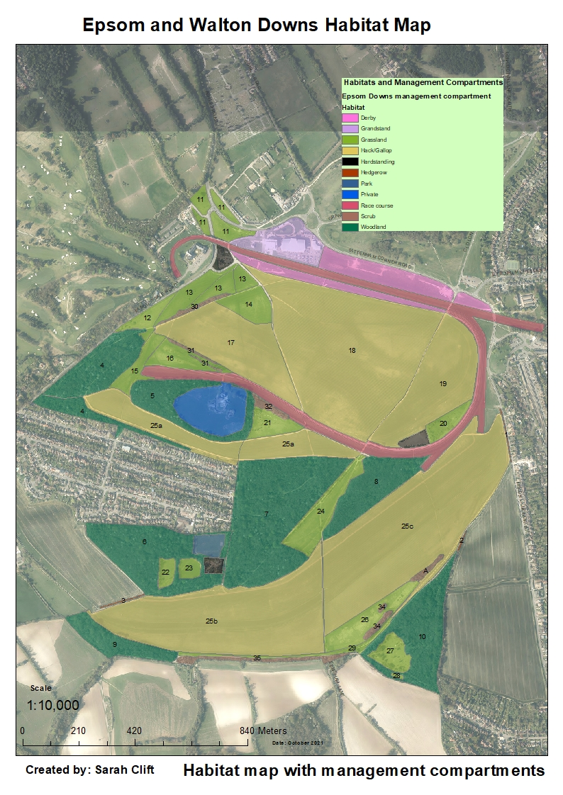
Compartments
Number | Name
1 | Epsom Lane North Hedge
2 | Juniper Hill North Hedge
3 | Langley Vale to Warren Hedge
4 | Beech Wood
5 | Sherwood Woodland
6 | The Warren Woodland (Ancient Woodland)
7 | The Warren Woods
8 | Top Woods
9 | Langley Bottom Copse
10 | Juniper Hill Woodland
11 | Derby Stables Grassland
12 | Butterfly Field
13 | Traveller Grassland
14 | Skylark Nesting Area/Traveller Overflow
15 | Epsom Downs West Grassland
16 | Mitchell’s Grassland (AKA Pony Hill Grassland)
17 | Mitchell’s Hack (AKA Pony Hill)
18 | Middle Hill
19 | The D
20 | Gorse Area
21 | Sherwood Grassland
22 | The Warren Flower Meadow West (EEBC Owned)
23 | The Warren Flower Meadow East (EEBC owned)
24 | The Triangle
25 a, b, c | Sherwood Gallop, Summer Gallops, Six Mile Hill
26 | Walton Downs Grassland
27 | Juniper Hill
28 | Juniper Hill Glade
29 | Southern Bridleway
30 | Beech Wood to Walton Rd Linear Scrub
31 | Mitchell’s Scrub (AKA Pony Hill Scrub)
32 | Sherwood Scrub
33 | Walton Downs Scrub A
34 | Walton Downs Scrub B
35 | Southern Boundary Strip

Map 2
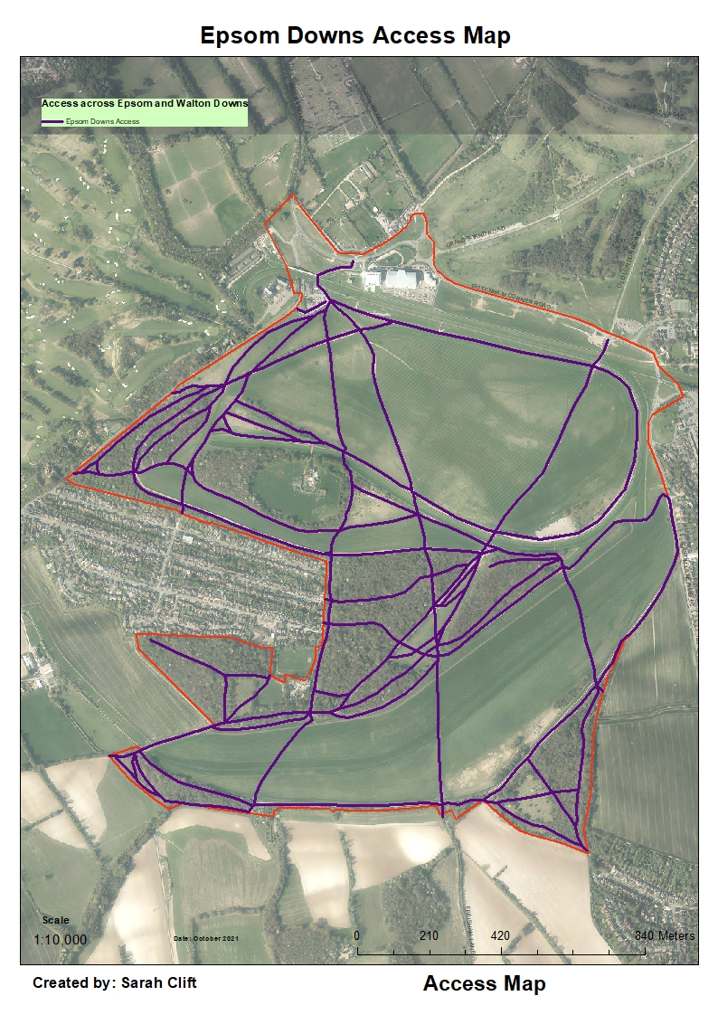

Map 3
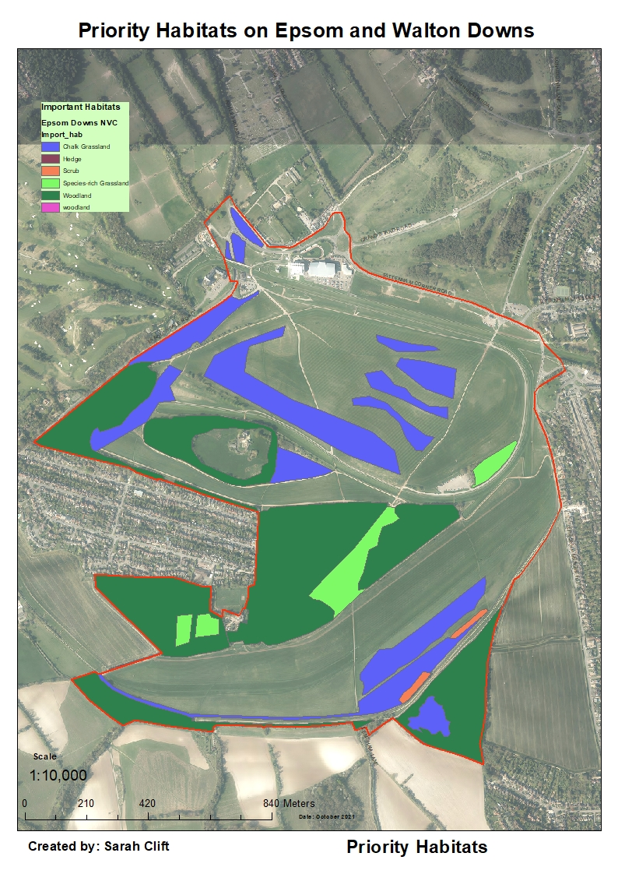

Map 4
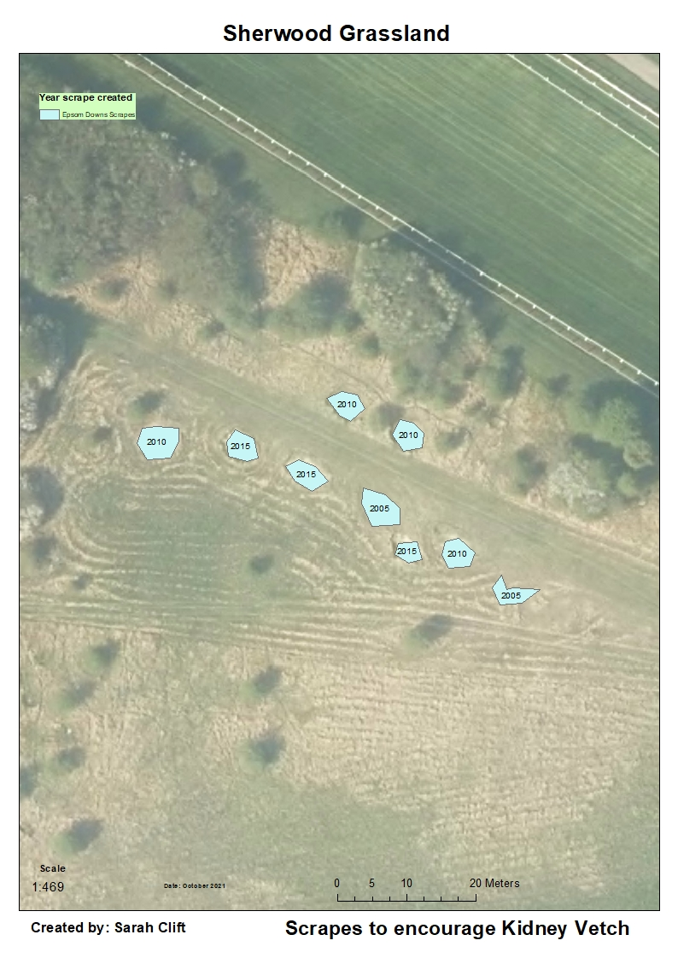

Map 5
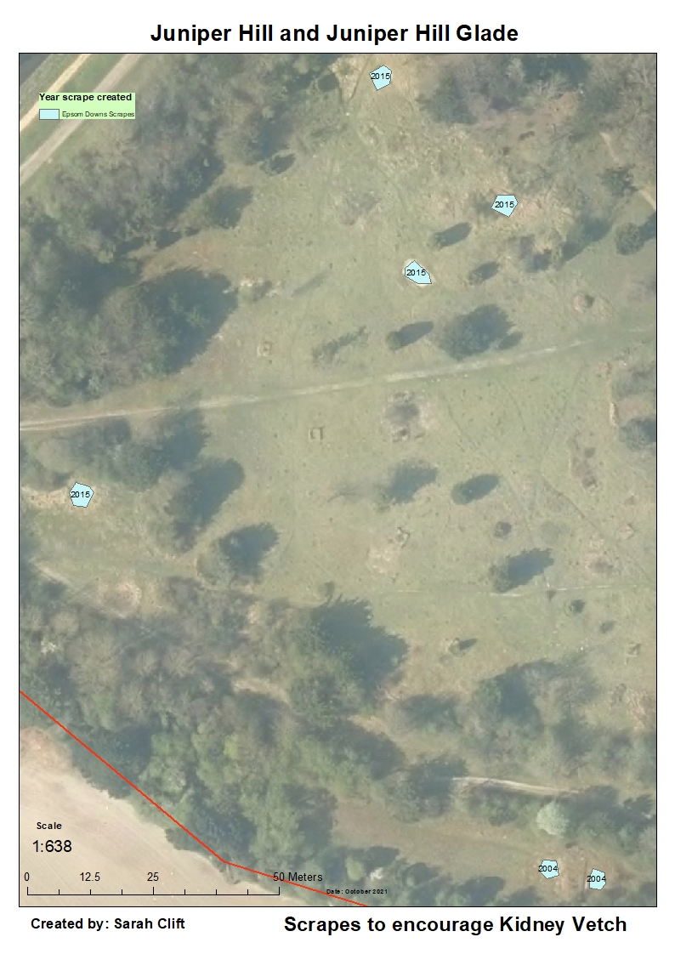

Map 6
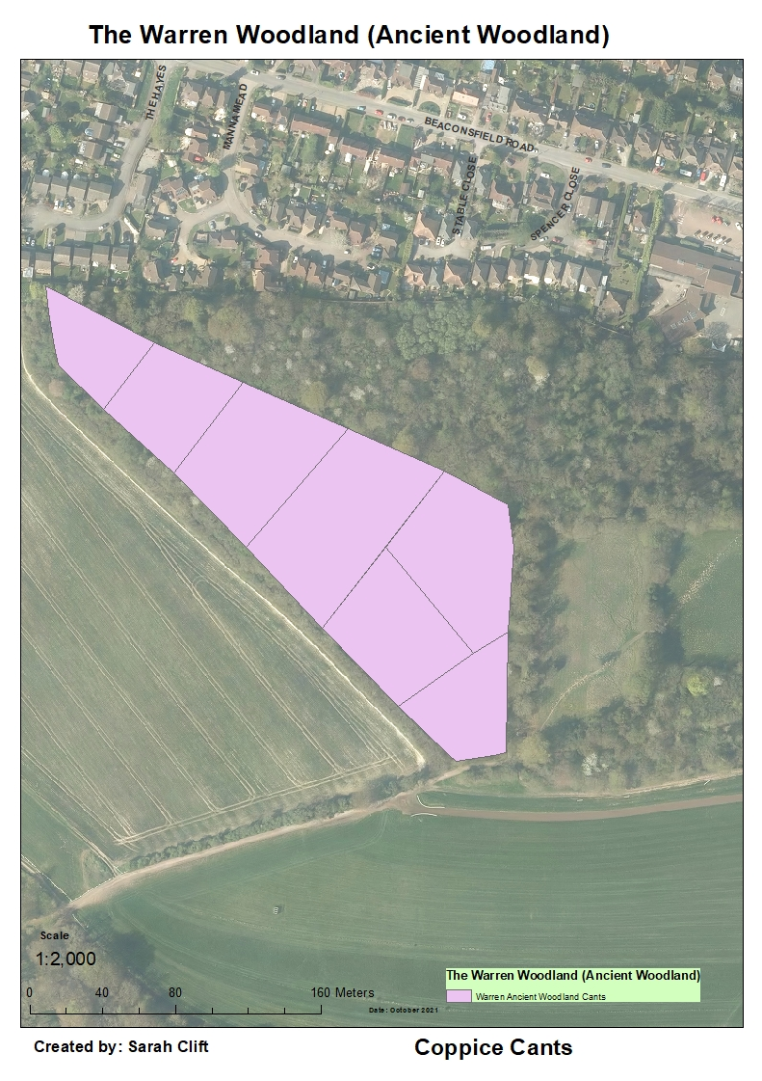

REFERENCES AND BIBLIOGRAPHY
Epsom and Walton Downs Management Plan 2008-12 – Isobel Girvan, Surrey Wildlife Trust
Epsom and Walton Downs Management Pan 2015-20 – Pete Howarth, Epsom and Ewell Brough Council
Epsom and Ewell Biodiversity Action Plan 2020-30 – Sarah Clift, Epsom and Ewell Borough Council
SNP
The State of Surrey's Nature - Surrey Wildlife Trust
SNCI Report 2013 – Pete Howarth
Monitoring the condition of lowland grassland SSSIs: Pt 1 English Nature’s rapid assessment method (ENRR315)

APPENDICES
  - SNCI report
  - Species Records

1). SNCI Report
Site name: Epsom Downs
Current status: SNCI (three areas, Walton Downs A, Walton Downs B and Epsom Downs West)
Grid ref: Epsom Downs- TQ218582, Walton Downs- TQ220574
Area: 177ha
Date of previous survey: 22/07/1998
Date of current survey: 23/08/2013
Surveyor: P Howarth

Site description
Epsom & Walton Downs are situated on the dip slope of the North Downs just south of Epsom town on the southern boundary of the Borough of Epsom and Ewell in Surrey. It is included in the OS Explorer 146 covering Dorking, Box Hill and Reigate. The site is managed by the Epsom and Walton Downs Conservators. The geological map relevant for this area is Sheet 286 Reigate, printed in 1978. The entire area is Upper Chalk. The 1983 Soil Survey of England and Wales ‘Soils of England and Wales Sheet 6 – South East England soil map’, published 1983, describes the resulting soil type as a brown rendzina called Andover 1. This is a shallow well drained calcareous silty soil over chalk and found on slopes and crests.
Previous reason for selection
Walton Downs A, Good remnant of unimproved calcareous grassland. Supports a Nationally Scarce species. Walton Downs B also a good remnant of unimproved calcareous grassland and supports a County rarity Epsom Downs West, Northern part selected because of valuable unimproved calcareous grassland habitat of three hectares. Southern area not included because scrubbed over, but with sympathetic management could be considered,
Reason for selection:
Presence of species rich chalk grassland CG3 Bromus erectus grassland, CG4 bryachypodium pinnatum grassland, CG2a Festuca ovina-Avenula pratensis grassland. Ancient woodland, there is an area of ancient woodland as outlined the review of ancient woodland inventory for Surrey. Juniper, this is found in the area of Juniper Hill Grassland. Butterflies, the site has a population of the Small Blue which is on list A of butterflies of importance in Surrey. The existing three SNCI covered only a small amount of the site, due to the more extensive areas of calcareous grassland found, it is suggested that the whole of the site be included within the SNCI.
Habitat description:
Abundance is based on the DAFOR scale and refers to the specific section of the site. The overall abundance across the site is provided in the Species List
DAFOR ratings for certain species, notably annual, can change throughout the year.
The DAFOR scale uses the following key:- Dominant; Abundant; Frequent; Occasional; Rare : Nomenclature follows Stace (2010) for vascular plants.
Target note 1:- Grassland nr car park, contains a diverse mix of plants including the county rarity, Rounded Headed Rampion, Agrimony, Black knapweed, Common Sorrel, Lady’s Bedstraw, abundant False Oat grass, Gorse, Perennial Rye Grass, Salad Burnet, locally abundant Upright Brome, Restharrow, occasional Dropwort, Burnet Saxifrage, Wild Basil, Marjoram, Common Rock Rose, Chalk False Brome, Cypress Spurge,
Target note 2:- Walton Downs B grassland, Area of sloping calcareous grassland forming a tall sward with rare hawthorn scrub encroachment. The sward was composed of frequent Upright Brome, False Oat Grass, occasional Cocksfoot, and Quaking Grass. Also found are Round Headed Rampion, Lady’s Bedstraw, Agrimony, rare Salad burnet.
Target note3:- Juniper Hill grassland. This is an area of very diverse calcareous grassland with a low rabbit grazed sward. Grasses include Sheep’s fescue, Crested Hairgrass, and some areas of locally dominant Chalk False Brome. Herbs include Harebell, Bastard Toadflax, Round headed Rampion, Autumn Gentian, Clustered Bellflower, Squinancywort, Eyebright, Marjoram, Wild Basil. In amongst the turf and in the scrapes are found chalk specialist bryophytes including Fissedens dubious, Trichostomum crispulum, Wessia brachycarpa, Wessia longifolia, Microbryum curvicolle and Ctenidium molluscum. In areas there is scattered scrub encroachment including Dogwood, Hawthorn, Blackthorn. In the grassland and the surrounding woodland there are a number of young Juniper bushes
Target note 4:- Juniper Hill Woodland. This is a mixed area of woodland with areas dominated by Beech, Ash, and Pedunculate Oak with some Whitebeam. The scrub layer is dominated locally by Hawthorn and Blackthorn. Some of the trees and shrubs had Orthotrichum affine, Zygodon Conoides, Cryphaea heteromalla and uncommon Metzeria temperate on them. The herb layer is composed of abundant Ivy. Areas of ground flora are dominated by the moss Eurhynchium striatum.
Target note 5:- Small blue scrape grassland. This is an area of calcareous grassland forming a tall sward, with frequent Upright Brome and occasional Quaking Grass. Also found here is Salad Burnet, Agrimony and the Small Blue’s larval food plant Kidney Vetch.
Target note 6:- Epsom Downs West grassland. This is an area of calcareous grassland forming a tall sward, with frequent Upright Brome and occasional Quaking Grass and patches of locally abundant Chalk False Brome. Herbs include Lady’s bedstraw, Salad burnet and Dropwort
Target note7:- Epsom Downs West scrub. This area is a mosaic of woodland and scrub. The scrub areas include areas of dense Blackthorn with a herb layer dominated by Dogs Mercury, Ivy and Ground Elder. Mixed scrub made up of Hazel, Blackthorn, Crab Apple, Dogwood, Elder, Buckthorn and Wayfaring tree. The herb layer was also dominated by Dogs Mercury and Ivy with rare Lords and Ladies. Throughout the areas of scrub were scattered taller trees including Ash and Turkey Oak. Also within the scrub were open areas with abundant Common Nettle, Bramble and Large Bindweed. Alongside the path was a grassy margin made up of Chalk False Brome, Cocksfoot and False Oat Grass with Burnet Saxifrage, Wild Basil, Rest Harrow, Common Field Scaboius, Yarrow, Wood False Brome, Hoary Ragwort. There are areas of more developed woodland with large Oaks, Ash and Beech. The scrub layer is made up of Elder, Spindle, Dogwood and local dominant Holly and Privet. The Elders support abundant epiphytic bryophytes including Orthotrichum affine, Zygodon Conoides, Cryphaea heteromalla and uncommon Metzeria temperata. The herb layer is made up abundant Dogs Mercury and Ivy with occasional Wood Melick.
Target note 8:- Calcareous grassland, nr above, This is an area of calcareous grassland forming a tall sward, with frequent Upright Brome and occasional Quaking Grass and patches of locally abundant Chalk False Brome. Herbs include Lady’s bedstraw, Salad burnet and Dropwort
Target note 9:- Warren woodland. The woodland here is secondary broad-leaved woodland. The canopy layer is made up of Pedunculate Oak, with Ash, Sycamore, Whitebeam and Beech. The scrub layer is composed of Hazel including old and recent coppice stools, Holly, Buckthorn, Privet, Dogwood and Bramble. The field layer is made up of Hogweed, Cow Parsley, Hairy St John’s Wort, Nettle, Wood false brome, Wood sedge, Dog’s Mercury, Wood Avens, Bearded Couch and Sanicle. The ground layer was sparse dominated by Kindbergia praelonga. In the updated inventory of ancient woodland in Surrey this woodland is included as an ‘ancient’ woodland.
Target note10:- Warren grassland. Mesothrophic grassland, with abundant False Oat grass, Cocksfoot, Creeping Bent and herbs including Hogweed, Agrimony, Black Knapweed and Birds foot Trefoil.
Target note 11:- Short mown grass areas nr Grandstand, calcareous grassland, with Sheep’s Fescue, Upright Brome, Wild Thyme, Small Scaboius, Salad Burnet, Burnet Saxifrage, rare Autumn Lady’s Tresses.
Target note 12:- Grassland general. The large areas of the grassland across Epsom Downs is improved grassland with in places abundant Perennial rye grass. However, there are also numerous areas across the site,, some extensive of Upright Brome. Although these area are dominated by the grasses there are rare herbs including Salad burnet, Burnet Saxifrage, Sainfoin, Lady’s Bedstraw, Agrimony, Small Scaboius, Birdsfoot trefoil and Quaking Grass. This is also true of Walton Downs with areas scattered with Upright Brome and a large area towards the lower half of the sloping site dominated by Upright Brome with scattered herbs including Lady’s Bedstraw, Common Field Scabious, Bird’s foot trefoil, Black Knapweed isolated but extensive patches of Common Rock Rose, Salad Burnet.
NVC types
CG2a Festuca ovina-Avenula pratensis grassland, Cirsium acaule-Asperula cynachica
CG3 Bromus erectus grassland
CG4 Brachypodium pinnatum grassland
MG1a Arrhenatheretum elatioris grassland, Festuca rubra sub-community
W22 Prunus spinosa-Rubus fruticosus scrub
W21 Crataegus monogyna-Hedera helix
W10c Quercus robur-Pteridium aquilinum-Rubus fruticosus, Hedera helix sub-community
W8a/W8d Fraxinus excelsior-Acer campestre-Mercurialis perennis woodland, Primula vulgaris-Glechoma hederacea sub community/Hedera helix sub-community
W8a Fraxinus excelsior-Acer campestre-Mercurialis perennis woodland, Primula vulgaris-Glechoma hederacea sub community
Current management:
The grassland areas are cut on different rotations depending on their location and use. Some are left long, and other frequently mown. There is evidence of the creation of scrapes
Management advice:
Some of the highest value grassland at Juniper Hill suffers from scrub encroachment. This needs to be cleared and the area managed to prevent further encroachment. The enclosed nature of this site would be make it an ideal site for grazing. In addition some of the areas that are left long are not cleared when they are cut, this is detrimental to the long term health of the grasslands and cut material should be removed.
Photographs:
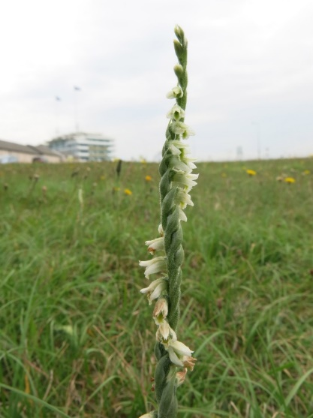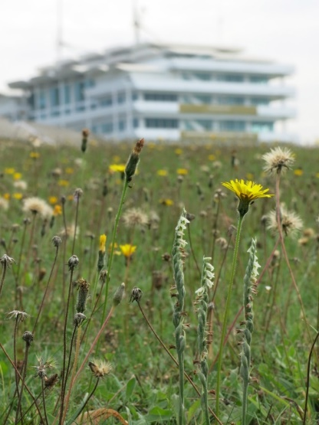
Autumn Ladies Tresses
Autumn Lady’s Tresses
General view of calcareous
grassland September 2013
Species lists:
Common name | Scientific name | Abundance
Agrimony | Agrimonia eupatoria | r
Annual meadow grass | Poa annua | r
Ash | Fraxinus excelsior | r
Autumn Gentian | Gentianella amarella | r
Autumn hawkbit | Scorzoneroides autumnalis | r
Autumn Lady's-tresses | Spiranthes spiralis | r
Barren Brome | Anisantha sterilis | r
Bastard toadflax | Thesium humifusum | r
Beech | Faggus sylvatica | r
Black bryony | Tamus communis | r
Black horehound | Ballota nigra | r
Black medick | Medicago lupulina | r
Blackthorn | Prunus spinosa | o
Bramble | Rubus spp | r
Broad leaved dock | Rumex obtusifolius | r
Buckthorn | Rhamnus cathartica | r
Bugle | Ajuga reptans | r
Bulbous buttercup | Ranunculus bulbosus | r
Burnet saxifrage | Pimpinella saxifraga | r
Butterfly-bush | Buddleja davidii | r
Cats-ear | Hypochaeris radicata | r
Cleavers | Galium aparine | r
Clustered Bellflower | Campanula glomerata | r
Clustered Dock | Rumex conglomeratus | r
Cock's-foot | Dactylis glomerata | o
Common Bent | Agrostis capillaris | r
Common Bird's-foot-trefoil | Lotus corniculatus | r
Common Chickweed | Stellaria media | r
Common Couch | Elytrigia repens | r
Common Eyebright | Euphrasia nemorosa | r
Common Figwort | Scrophularia nodosa | r
Common Knapweed | Centaurea nigra | r
Common Mallow | Malva sylvestris | r
Common Mouse-ear | Cerastium fontanum | r
Common Nettle | Urtica dioica | r
Common Ragwort | Senecio jacobaea | r
Common Restharrow | Ononis repens | r
Common Rockrose | Helianthemum nummularium | r
Common Sorrel | Rumex acetosa | r
Common Spotted Orchid | Dactylorhiza fushsii | r
Common Toadflax | Linaria vulgaris | r
Common Twayblade | Listera cordata | r
Common Vetch | Vicia sativa | r
Cow Parsley | Anthriscus sylvestris | r
Crab Apple | Malus sylvestris | r
Creeping Bent | Agrostis stolonifera | r
Creeping Buttercup | Ranunculus reptans | r
Creeping Thistle | Cirsium arvense | r
Crested Dog's-tail | Cynosurus cristatus | r
Crested Hairgrass | Koeleria macrantha | r
Curled Dock | Rumex crispus | r
Cypress Spurge | Euphorbia cyparissias | r
Daisy | Bellis perennis | r
Dandelion | Taraxacum spp | r
Dog-rose | Rosa canina | r
Dog's Mercury | Mercurialis perennis | r
Dogwood | Cornus sanguinea | r
Downy Oat-grass | Avenula pubescens | r
Dropwort | Filipendula vulgaris | r
Elder | Sambucus nigra | r
Enchanter's-nightshade | Circaea lutetiana | r
English Elm | Ulmus procera | r
English oak | Quercus robur | o
Fairy Flax | Linum catharticum | r
False Brome | Brachypodium sylvaticum | r
False Oat-grass | Arrhenatherum elatius | o
Field Maple | Acer campestre | r
Field Scabious | Knautia arvensis | r
Field-rose | Rosa arvensis | r
Fragrant Orchid | Gymnadenia conopsea | r
Garlic Mustard | Alliaria petiolata | r
Germander Speedwell | Veronica chamaedrys | r
Giant Fescue | Schedonorus giganteus | r
Glaucous Sedge | Carex flacca | r
Goatsbeard | Tragopogon pratensis | r
Gorse | Ulex europaeus | o
Greater Burdock | Arctium lappa | r
Greater Knapweed | Centaurea scabiosa | r
Greater Plantain | Plantago major | r
Greater Stitchwort | Stellaria holostea | r
Green Alkanet | Pentaglottis sempervirens | r
Ground Elder | Aegopodium podagraria | r
Ground Ivy | Glechoma hederacea | r
Hairbell | Campanula rotundifolia | r
Hairy-brome | Bromopsis ramosa | r
Hawthorn | Crataegus monogyna | o
Hazel | Corylus avellana | o
Hedge Mustard | Sisymbrium officinale | r
Hemlock | Conium maculatum | r
Hoary Mustard | Hirschfeldia incana | r
Hoary Ragwort | Senecio erucifolius | r
Honeysuckle | Lonicera periclymemum | r
Hop Trefoil | Trifolium campestre | r
Horse Chestnut | Aesculus hippocastanum | r
Horseshoe Vetch | Hippocrepis comosa | r
Juniper | Jupiperus communis | r
Kidney Vetch | Anthyllis vulneraria | r
Lady's Bedstraw | Galium verum | r
Lesser Hawkbit | Leontodon saxatilis | r
Lesser Trefoil | Trifolium dubium | r
Meadow Foxtail | Alopecurus pratensis | r
Meadow Oat-grass | Avenula pratense | r
Meadow vetchling | Lathyrus pratensis | r
Mouse-ear-hawkweed | Pilosella officinarum | r
Oxeye daisy | Leucanthemum vulgare | r
Perennial Rye-grass | Lolium perenne | o
Quaking grass | Brizia media | r
Red Bartsia | Odontites vernus | r
Red clover | Trifolium pratense | o
Red Dead-nettle | Lamium purpureum | r
Red fescue | Festuca rubra | r
Ribwort plantain | Plantago lanceolata | r
Round headed rampion | Phyteuma orbiculare | r
Sainfoin | Onobrychis viciifolia | r
Salad burnet | Sanguisorba minor | r
Scarlet pimpernel | Anagallis arvensis | r
Sheeps Fescue | Festuca ovina | o
Shepherd's-purse | Capsella bursa-pastoris | r
Silver Birch | Betula pendula | o
Silverweed | Potentilla anserina | r
Small scabious | Scabiosa columbaria | r
Smaller Cat's-tail | Phleum bertolonii | r
Smooth Hawk's-beard | Crepis cappillaris | r
Smooth stalked meadow grass | Poa pratensis | r
Soft brome | Bromus hordeaceus | r
Spear thistle | Cirsium vulgare | r
Spindle | Euonymus europaeus | r
Squinancywort | Asperula cynanchica | r
Sweet vernal grass | Anthoxanthum odoratum | r
Sweet-briar | Rosa rubiginosa | r
Tor-grass | Brachypodium pinnatum | o
Tormentil | Potentilla erecta | r
Traveller's-joy | Clematis vitalba | r
Upight hedge parsley | Torilis japonica | r
Upright Brome | Bromopsis erecta | f
Wall Barley | Hordeum murinum | r
White Clover | Trifolium repens | r
White Dead-nettle | Lamium album | r
Whitebeam | Sorbus aria | r
Wild Basil | Clipopodium vulgare | r
Wild Carrot | Daucus carota | r
Wild Cherry | Prunus avium | r
Wild Marjoram | Origanum vulgare | r
Wild Mignonette | Resda luteola | r
Wild Privet | Ligustrum vulgare | r
Wild Service Tree | Sorbus torminalis | r
Wood Dock | Rumex sanguineus | r
Wych Elm | Ulmus glabra | r
Yarrow | Achillea millefolium | r
Yellow Oatgrass | Trisetum flavescens | r
Yew | Taxus baccata | r
Yorkshire-fog | Holcus lanatus | o

2). Species list
Species highlighted in red indicate priority species as defined in the Natural Environment and Rural Communities Act (NERC).

Bryophyte records
Scientific Name | Common Name | Date Last Recorded
Atrichum undulatum | a moss | 2014
Barbula sardoa | a moss | 2014
Barbula unguiculata | a moss | 2014
Brachythecium rutabulum | a moss | 2014
Calliergonella cuspidata | a moss | 2014
Cryphaea heteromalla | a moss | 2014
Ctenidium molluscum | a moss | 2014
Dicranella varia | a moss | 2014
Eurhynchium praelongum | a moss | 2014
Eurhynchium striatum | a moss | 2014
Fissidens bryoides | a moss | 2014
Frullania dilatata | a moss | 2014
Hypnum cupressiforme sens. lat. | a moss | 2014
Kindbergia praelonga | a moss | 2014
Metzgeria temperata | a moss | 2014
Microbryum curvicolle | a moss | 2014
Neckera complanata | a moss | 2014
Orthotrichum affine | a moss | 2014
Oxyrrhynchium hians | Swartz's Feather-moss | 2020
Pseudoscleropodium purum | Neat Feather-moss | 2020
Radula complanata | a moss | 2014
Rhynchostegium confertum | a moss | 2014
Trichostomum crispulum | a moss | 2014
Wessia brachycarpa | a moss | 2014
Wessia longifolia | a moss | 2014
Zygodon conoides | a moss | 2014

Vascular plant records
Species in Bold are characteristic of unimproved grassland in Surrey.
Acer campestre | Field Maple | 2014
Acer cappadocicum | Cappadocian Maple | 1998
Acer platanoides | Norway Maple | 2014
Acer pseudoplantanus | Sycamore | 2014
Achillea millefolium | Yarrow | 2020
Adoxa moschatellina | Moschatel | 2002
Aegopodium podagraria | Ground-elder | 2014
Aesculus hippocastanum | Horse-chestnut | 2014
Agrimonia eupatoria | Common Agrimony | 2020
Agrostis capillaris | Common Bent | 2014
Agrostis stolonifera | Creeping Bent | 2014
Agrostis vinealis | Brown Bent | 1986
Ajuga reptans | Bugle | 2014
Alliaria petiolata | Garlic Mustard | 2014
Alopecurus pratensis | Meadow Foxtail | 2013
Anacamptis pyramidalis | Pyramidal Orchid | 2020
Anagallis arvensis | Scarlet Pimpernel | 2013
Anemone nemorosa | Wood Anemone | 2014
Anisantha sterilis | Barren Brome | 2014
Anthoxanthum odoratum | Sweet Vernal Grass | 2014
Anthriscus sylvestris | Cow Parsley | 2014
Anthyllis vulneraria | Kidney Vetch | 2020
Antirrhinum majus | Snapdragon | 1998
Aquilegia vulgaris | Columbine | 2007
Arabis hirsuta | Hairy Rock-cress | 1968
Arctium lappa | Greater Burdock | 2013
Arctium minus | Lesser Burdock | 2014
Arenaria serpyllifolia | Thyme-leaved Sandwort | 2007
Arrhenatherum elatius | False Oat-grass | 2014
Artemisia vulgaris | Mugwort | 2014
Arum maculatum | Lords-and-ladies | 2014
Asperula cynanchica | Squinancywort | 2020
Asplenium scolopendrium | Hart's-tongue | 2014
Avenula pratense | Meadow Oat-grass | 2013
Avenula pubescens | Downy Oat-grass | 2013
Ballota nigra | Black Horehound | 2014
Barbarea vulgaris | Winter-cress | 2004
Bellis perennis | Daisy | 2014
Betula pendula | Silver Birch | 2014
Blackstonia perfoliata | Yellow-wort | 1998
Brachypodium pinnatum | Tor-grass | 2020
Brachypodium sylvaticum | Wood False-Brome | 2020
Brassica napus | Rape | 2002
Brassica rapa | Turnip | 2021
Briza media | Quaking Grass | 2020
Bromopsis erecta | Upright Brome | 2020
Bromopsis ramosa | Hairy-brome | 2013
Bromus hordeaceus | Soft-brome | 2014
Bryonia dioica | White Bryony | 2014
Buddleja davidii | Butterfly Bush` | 2014
Buxus sempervirens | Box | 2014
Calystegia sepium | Hedge Bindweed | 2014
Calystegia silvatica | Large Bindweed | 2021
Campanula glomerata | Clustered Bellflower | 2020
Campanula rotundifolia | Harebell | 2020
Campanula trachelium | Nettle-leaved Bellflower | 1998
Capsella bursa-pastoris | Shepherd's-purse | 2020
Cardamine hirsuta | Hairy Bitter-cress | 2004
Carex caryophllyea | Spring-sedge | 2007
Carex flacca | Glaucous Sedge | 2020
Carex hirta | Hairy Sedge | 2014
Carex sylvatica | Wood-sedge | 2014
Carpinus betulus | Hornbeam | 1998
Castanea sativa | Sweet Chestnut | 2014
Centaurea nigra | Common Knapweed | 2020
Centaurea scabiosa | Greater Knapweed | 2020
Cephalanthera damasonium | White Helleborine | 2006
Cerastium arvense | Field Mouse-ear | 2018
Cerastium fontanum | Common Mouse-ear | 2014
Cerastium glomeratum | Sticky Mouse-ear | 2004
Cerastium x maueri | C. arvense x tomentosum | 1985
Chaerophyllum temulum | Rough Chervil | 2014
Chamerion angustifolium | Rosebay Willowherb | 2014
Chelidonium majus | Greater Celandine | 2004
Chenopodium album agg. | Fat Hen | 1998
Cichorium intybus | Chicory | 2014
Circaea lutetiana | Enchanter's-nightshade | 2013
Cirsium acaule | Dwarf Thistle | 2020
Cirsium arvense | Creeping Thistle | 2020
Cirsium palustre | Marsh Thistle | 2007
Cirsium vulgare | Spear Thistle | 2020
Clematis vitalba | Traveller's Joy | 2020
Clinopodium vulgare | Wild Basil | 2020
Cochlearia danica | Danish Scurvygrass | 2015
Comandra umbellata | Bastard Toadflax | 2020
Conium maculatum | Hemlock | 2013
Convolvulus arvensis | Field Bindweed | 2014
Conyza canadensis | Canadian Fleabane | 2014
Cornus sanguinea | Dogwood | 2020
Corylus avellana | Hazel | 2014
Cotoneaster frigidus | Tree Cotoneaster | 1997
Cotoneaster lacteus | Late Cotoneaster | 2007
Crataegus monogyna | Hawthorn | 2020
Crepis biennis | Rough Hawk's-beard | 2016
Crepis capillaris | Smooth Hawksbeard | 2020
Crepis vesicaria | Beaked Hawk's-beard | 2004
Cynosurus cristatus | Crested Dog's-tail | 2014
Cytisus scoparius | Broom | 2004
Dactylis glomerata | Cock’ s-foot | 2014
Dactylorhiza fuchsii | Common Spotted-orchid | 2014
Dactylorhiza praetermissa | Southern Marsh-orchid | 2004
Daucus carota | Wild Carrot | 2014
Deschampsia caespitosa | Tufted Hair-grass | 1998
Diplotaxis muralis | Annual Wall-rocket | 2004
Dryopteris dilatata | Broad Buckler-fern | 2014
Dryopteris filix-mas agg. | Male Fern | 1998
Echinops bannaticus | Blue Globe-thistle | 2018
Elymus caninus | Bearded Couch | 2014
Elytrigia repens | Common Couch | 2015
Epilobium ciliatum | American Willowherb | 2020
Epilobium hirsutum | Great Willowherb | 2014
Epilobium montanum | Broad-leaved Willowherb | 2007
Epilobium parviflorum | Hoary Willowherb | 2007
Epipactis purpurata | Violet Helleborine | 1993
Erodium cicutarium | Common Stork's-bill | 2004
Erophila verna | Common Whitlowgrass | 2004
Euonymus europaeu | Spindle | 2014
Eupatorium cannabinum | Hemp-agrimony | 1914
Euphorbia cyparissias | Cypress Spurge | 2014
Euphorbia helioscopia | Sun Spurge | 2021
Euphorbia x pseudovirgata | Twiggy Spurge | 2013
Euphrasia nemorosa | Common eyebright | 2014
Euphrasia pseudokerneri | Chalk Eyebright | 2020
Fagus sylvatica | Beech | 2014
Fallopia baldschuanica | Russian-vine | 2004
Festuca arundinacea | Tall Fescue | 2002
Festuca gigantea | Giant Fescue | 2014
Festuca ovina | Sheep's Fescue | 2020
Festuca rubra | Red Fescue | 2014
Ficaria verna | Lesser Celandine | 2014
Filipendula ulmaria | Meadowsweet | 1905
Filipendula vulgaris | Dropwort | 2020
Fragaria vesca | Wild Strawberry | 2014
Fraxinus excelsior | Ash | 2020
Fumaria officinalis | Common Fumitory | 2004
Galega officinalis | Goat's-rue | 2004
Galium aparine | Cleavers | 2014
Galium mollugo | Hedge Bedstraw | 2020
Galium odoratum | Woodruff | 2014
Galium verum | Lady's Bedstraw | 2020
Gentianella amarelle | Autumn Gentian | 2014
Gentianella anglica | Early Gentian | 1976
Geranium dissectum | Cut-leaved Crane's-bil | 2014
Geranium lucidum | Shining Crane's-bill | 2004
Geranium molle | Dove's-foot Crane's-bill | 2014
Geranium pratense | Meadow Crane's-bill | 2006
Geranium pusillum | Small-flowered Crane's-bill | 2004
Geranium pyrenaicum | Hedgerow Crane's-bill | 2021
Geranium robertianum | Herb Robert | 2014
Geranium rotundifolium | Round-leaved Crane's-bill | 2004
Geum urbanum | Wood Avens | 2014
Glechoma hederacea | Ground Ivy | 2014
Gymnadenia conopsea | Fragrant Orchid | 2013
Hedera helix | Ivy | 2021
Helianthemum nummularium | Common Rock Rose | 2020
Helictotrichon pratense | Meadow Oat-grass | 2014
Helminthotheca echioides | Bristly Oxtongue | 2008
Heracleum mantegazzianum | Giant Hogweed | 2002
Heracleum sphondylium | Hogweed | 2020
Hesperis matronalis | Dame's Violet | 2002
Hippocrepis comosa | Horseshoe Vetch | 2020
Hirschfeldia incana | Hoary Mustard | 2013
Holcus lanatus | Yorkshire Fog | 2020
Hordeum murinum | Wall Barley | 2014
Hyacinthoides hispanica x non- scripta | a bluebell | 2002
Hyacinthoides non-scripta | Bluebell | 2014
Hyacinthoides x massartiana | Hybrid Bluebell (H. non-scripta x hispanica) | 2014
Hypericum androsaemum | Tutsan | 2007
Hypericum hirsutum | Hairy St John’s-wort | 2014
Hypericum perforatum | Perforate St John's-wort | 2020
Hypochaeris radicata | Cat's-ear | 2013
Ilex aquifolium | Holly | 2014
Inula conyzae | Ploughman's-spikenard | 2020
Iris foetidissima | Stinking Iris | 2002
Jacobaea erucifolia | Hoary Ragwort | 2013
Jacobaea vulgaris | Common Ragwort | 2020
Juglans regia | Walnut | 2021
Juniperus communis | Juniper | 2021
Kerria japonica | Kerria | 1999
Kickxia elatine | Sharp-leaved Fluellen | 2009
Knautia arvensis | Common Field Scabious | 2020
Koeleria macrantha | Crested Hairgrass | 2020
Laburnum anagyroides | Laburnum | 2004
Lactuca serriola | Prickly Lettuce | 2007
Lactuca virosa | Greater Prickly Lettuce | 2007
Lamiastrum galeobdolon | Yellow Archangel | 2014
Lamium album | White dead nettle | 2014
Lamium purpureum | Red Dead-nettle | 2014
Lapsana communis | Nipplewort | 2014
Lathyrus nissolia | Grass Vetchling | 2014
Lathyrus pratensis | Meadow Vetchling | 2014
Leontodon autumnalis | Autumn Hawkbit | 2014
Leontodon hispidus | Rough Hawkbit | 2020
Leontodon saxatilis | Lesser Hawkbit | 2020
Lepidium draba | Hoary Cress | 2004
Leucanthemum vulgare | Ox-eye Daisy | 2013
Ligustrum ovalifolium | Garden Privet | 2002
Ligustrum vulgare | Wild Privet | 2014
Linaria vulgaris | Common Toadflax | 2020
Linum catharticum | Fairy Flax | 2020
Listera cordata | Common Twayblade | 2013
Listera ovata | Twayblade | 2007
Lolium perenne | Perennial Ryegrass | 2020
Lonicera periclymenum | Honeysuckle | 2014
Lotus corniculatus | Common Bird’s-foot Trefoil | 2020
Lunaria annua | Honesty | 2020
Luzula campestris | Field Wood-rush | 2014
Mahonia aquifolium | Oregon- grape | 2007
Malus domestica | Apple | 2014
Malus pumila | Apple | 2014
Malus sylvestris | Crab Apple | 2014
Malva sylvestris | Common Mallow | 2014
Matricaria discoidea | Pineapple Weed | 2014
Meconopsis cambrica | Welsh Poppy | 2014
Medicago lupulina | Black Medick | 2020
Medicago sativa nothosubsp. varia | Sand Lucerne | 2018
Medicago sativa subsp. falcata | Sickle Medick | 2021
Medicago sativa ssp. sativa | Lucerne | 2014
Melica uniflora | Wood Melick | 2014
Melilotus officinalis | Ribbed Melilot | 2014
Mentha arvensis | Corn Mint | 2007
Mercurialis perennis | Dog's Mercury | 2014
Moehringia trinervia | Three-nerved Sandwort | 2014
Myosotis arvensis | Field Forget-me-not | 2007
Myosotis laxa | Tufted Forget-me-not | 1998
Myosotis sylvatica | Wood Forget-me-not | 2014
Narcissus agg. | a garden daffodil | 2004
Neotinea ustulata | Burnt Orchid | 1966
Nepeta cataria | Cat-mint | 1958
Odontites vernus | Red Bartsia | 2020
Oenanthe pimpinelloides | Corky-fruited Water-dropwort | 2009
Onobrychis viciifolia | Sainfoin | 2021
Ononis repens | Common Rest Harrow | 2020
Orchis mascula | Early Purple Orchid | 2018
Origanum vulgare | Majoram | 2020
Origanum vulgare | Wild Marjoram | 2020
Papaver argemone | Prickly Poppy | 1998
Papaver dubium | Long-headed Poppy | 2021
Papaver hybridum | Rough Poppy | 1990
Papaver rhoeas | Corn/common Poppy | 2007
Papaver somniferum | Opium Poppy | 1998
Pastinaca sativa | Wild Parsnip | 2014
Pentaglottis sempervirens | Green Alkanet | 2013
Persicaria maculosa | Redshank | 2004
Petasites fragrans | Winter Heliotrope | 2014
Phleum bertolonii | Smaller Cat’s-tail | 2014
Phleum pratense | Timothy | 2007
Phyllitis scolopendrium | Hart's-tongue | 2002
Phyteuma orbiculare | Round-headed Rampion | 2020
Picris echioides | Bristly Ox-tongue | 2014
Pilosella officinarum | Mouse-ear-hawkweed | 2014
Pimpinella saxifraga | Burnet Saxifrage | 2020
Pinus sylvestris | Scots Pine | 2002
Plantago coronopus | Buck's-horn Plantain | 2008
Plantago lanceolata | Ribwort Plantain | 2020
Plantago major | Greater Plantain | 2015
Plantago media | Hoary Plantain | 2008
Poa annua | Annual Meadow-grass | 2014
Poa nemoralis | Wood Meadow-grass | 2002
Poa pratensis | Smooth Meadow-grass | 2014
Poa trivialis | Rough Meadow-grass | 2014
Polygala calcarea | Chalk Milkwort | 2014
Polygala vulgaris | Common Milkwort | 2020
Polygonum aviculare | Knotgrass | 2014
Populus alba | White Poplar | 2002
Populus tremula | Aspen | 2014
Potentilla anserina | Silverweed | 2014
Potentilla erecta | Tormentil | 2013
Potentilla reptans | Creeping Cinquefoil | 2014
Potentilla sterilis | Barren | 2002
Primula veris | Cowslip | 2021
Primula vulgaris | Primrose | 2014
Prunella vulgaris | Selfheal | 2020
Prunus avium | Wild Cherry | 2014
Prunus cerasifera | Cherry Plum | 2014
Prunus cerasus var. pisardii | Cherry Plum | 2007
Prunus domestica | Wild Plum | 2002
Prunus domestica ssp. domestica | Plum | 2002
Prunus domestica x spinosa ( | P. x a cherry | 2002
Prunus laurocerasus | Cherry Laurel | 2014
Prunus spinosa | Blackthorn | 2020
Pteridium aquilinum | Bracken | 2014
Pulicaria dysenterica | Common Fleabane | 2007
Quercus cerris | Turkey Oak | 2014
Quercus ilex | Evergreen Oak | 2015
Quercus robur | Pedunculate Oak | 2020
Ranunculus acris | Meadow buttercup | 2014
Ranunculus auricomus | Goldilocks Buttercup | 2004
Ranunculus bulbosus | Bulbous Buttercup | 2014
Ranunculus repens | Creeping Buttercup | 2014
Reseda lutea | Wild Mignonette | 2020
Reseda luteola | Weld | 2004
Rhamnus cathartica | Buckthorn | 2014
Ribes rubrum | Red Currant | 2007
Ribes uva-crispa | Gooseberry | 2002
Rosa arvensis | Field Rose | 2013
Rosa canina | Dog Rose | 2014
Rosa rubiginosa | Sweet-briar | 2013
Rosmarinus officinalis | Rosemary | 2007
Rubus caesius | Dewberry | 2007
Rubus fructicosus spp. | Bramble | 2020
Rubus idaeus | Raspberry | 2007
Rumex acetosa | Common Sorrel | 2014
Rumex conglomeratus | Clustered Dock | 2013
Rumex crispus | Curled Dock | 2014
Rumex obtusifolius | Broad-leaved Dock | 2014
Rumex sanguineus | Wood Dock | 2014
Salix caprea | Goat Willow | 2007
Sambucus nigra | Common Elder | 2014
Sanguisorba minor | Salad Burnet | 2020
Sanicula europaea | Sanicle | 2014
Saponaria officinalis | Soapwort | 2021
Sasa sp. | a bamboo | 2002
Saxifraga tridactylites | Rue-leaved Saxifrage | 2006
Scabiosa columbaria | Small Scabious | 2014
Schedonorus giganteus | Giant Fescue | 2014
Scorzoneroides autumnalis | Autumn hawkbit | 2021
Scrophularia nodosa | Common Figwort | 2014
Senecio vulgaris | Groundsel | 2014
Silene dioica | Red Campion | 2004
Silene latifolia | White Campion | 2014
Silene vulgaris | Bladder Campion | 2014
Sinapis arvensis | Hoary Mustard | 2020
Sisymbrium officinale | Hedge Mustard | 2014
Solanum dulcamara | Bittersweet | 2007
Solanum nigrum | Black Nightshade | 2014
Solidago canadensis | Canadian Goldenrod | 2007
Sonchus arvensis | Perennial Sow-thistle | 1986
Sonchus asper | Prickly Sow-thistle | 2014
Sonchus oleraceus | Smooth Sow-thistle | 2014
Sorbus aria | Whitebeam | 2014
Sorbus aucuparia | Rowan | 2014
Sorbus intermedia | Swedish Whitebeam | 1985
Sorbus x thuringiaca | S. aria x aucuparia | 1997
Sorbus torminalis | Wild Service Tree | 2013
Spiranthes spiralis | Autumn Lady's-tresses | 2020
Stachys sylvatica | Hedge Woundwort | 2014
Stellaria graminea | Lesser Stitchwort | 2014
Stellaria holostea | Greater Stitchwort | 2013
Stellaria media agg. | Chickweed | 2014
Symphororicarpos albus | Snowberry | 2014
Symphytum x uplandicum | Russian Comfrey (S. asperum x officinale) | 2004
Tamus communis | Black Bryony | 2014
Tanacetum vulgare | Tansy | 2014
Taraxacum officinale | Dandelion | 2014
Taxus baccata | Yew | 2014
Teucrium scorodonia | Wood Sage | 2014
Thesium humifusum | Bastard-toadflax | 2015
Thymus polytrichus | Wild Thyme | 2020
Tilia cordata x platyphyllos | (T. x Lime | 2002
Tilia x europaea | Lime | 2014
Torilis japonica | Upright Hedge-parsley | 2013
Tragopogon pratensis | Goat's-beard | 2014
Trifolium campestre | Hop Trefoil | 2013
Trifolium dubium | Lesser Trefoil | 2014
Trifolium pratense | Red Clover | 2021
Trifolium repens | White Clover | 2014
Tripleurospermum inodorum | Scentless Mayweed | 2004
Trisetum flavescens | Yellow Oatgrass | 2013
Tussilago farfara | Colt's-foot | 2014
Ulex europaeus | Gorse | 2014
Ulmus glabra | Wych Elm | 2014
Ulmus procera | English Elm | 2013
Urtica dioica | Common Nettle | 2021
Valeriana officinalis | Common Valerian | 2014
Verbascum nigrum | Dark Mullein | 2014
Verbascum thapsus | Great Mullein | 2020
Verbena officinalis | Common Verbena | 2014
Veronica arvensis | Wall Speedwell | 2014
Veronica chamaedrys | Germander Speedwell | 2014
Veronica filiformis | Slender Speedwell | 2004
Veronica hederifolia | Ivy-leaved Speedwell | 2014
Veronica officinalis | Heath Speedwell | 2014
Veronica persica | Common Field-speedwell | 2014
Veronica serpyllifolia | Thyme-leaved Speedwell | 2002
Viburnum lantana | Wayfaring Tree | 2020
Viburnum opulus | Guelder Rose | 2014
Vicia cracca | Tufted Vetch | 2014
Vicia sativa | Common Vetch | 2014
Vicia sepium | Bush Vetch | 2014
Vinca major | Greater Periwinkle | 2014
Viola arvensis | Field Pansy | 2004
Viola hirta | Hairy Violet | 2020
Viola odorata | Sweet Violet | 2014
Viola odorata var. dumetorum | Sweet Violet | 1992
Viola odorata var. praecox | Sweet Violet | 1992
Viola reichenbachiana | Early Dog-violet | 2014
Viola riviniana | Common Dog-violet | 2014

Invertebrate records

Molluscs and Oligochates (Slugs, Snails and Earthworms)
Scientific Name | Common Name | Date last recorded
Arion intermedius | Hedgehog Slug | 2002
Candidula intersecta | a snail | 2002
Ceciliodes acicula | a blind snail | 2002
Cepaea hortensis | a snail | 2002
Cepaea nemoralis | Brown Lipped Snail | 2007
Cochlicopa lubricella | a moss snail | 2002
Cochlodina laminata | Plaited Door Snail | 2007
Discus rotundatus | a discus snail | 2007
Ena obscura | a bulin snail | 2002
Helix aspersa | Garden Snail | 2007
Limax maximus | Great Grey Slug | 2002
Lumbricus terrestris | Common Earthworm | 2002
Monacha cantiana | Kentish Snail | 2007
Pomatias elegans | Round-mouthed snail | 2007

Arachnids (Spiders, Mites and Ticks)
Scientific Name | Common Name | Date Last Recorded
Aceria macrochelus | a mite | 2007
Aceria origani | a mite | 2007
Eriophyes (=Phytopus) prunispinosae | a mite | 2007
Eriophyes convolvens | a mite | 2007
Eriophyes viburni | a mite | 2007
Pisaura miribalis | Nursery-web Spider | 2007
Tibellus oblongus | a spider | 2007

Lepidoptera - Butterflies
Scientific name | Common Name | Date last recorded
Aglais urticae | Small Tortoiseshell | 2021
Anthocharis cardamines | Orange Tip | 2021
Aphantopus hyperantus | Ringlet | 2021
Argynnis aglaja | Dark Green Fritillary | 2021
Argynnis paphia | Silver-washed Fritillary | 2021
Aricia agestis | Brown Argus | 2021
Callophrys rubi | Green Hairstreak | 2021
Celastrina argiolus | Holly Blue | 2021
Coenonympha pamphilus | Small Heath | 2021
Colias croceus | Clouded Yellow | 2021
Cupido minimus | Small Blue | 2021
Erynnis tages | Dingy Skipper | 2021
Gonepteryx rhamni | Brimstone | 2021
Hesperia comma | Silver-spotted Skipper | 2019
Inachis io | Peacock | 2021
Lasiommata megera | Wall Brown | 1905
Lycaena phlaeas | Small Copper | 2021
Maniola jurtina | Meadow Brown | 2021
Melanargia galathea | Marbled White | 2021
Ochlodes sylvanus | Large Skipper | 2021
Pararge aegeria | Speckled Wood | 2021
Pieris brassicae | Large White | 2021
Pieris napi | Green-veined White | 2021
Pieris rapae | Small White | 2021
Polygonia c-album | Comma | 2021
Polyommatus bellargus | Adonis Blue | 2020
Polyommatus coridon | Chalkhill Blue | 2021
Polyommatus icarus | Common Blue | 2021
Pyrgus malvae | Grizzled Skipper | 2021
Pyronia tithonus | Gatekeeper | 2021
Quercusia quercus | Purple Hairstreak | 1905
Satyrium w-album | White-letter Hairstreak | 2020
Thecla betulae | Brown Hairstreak | 2019
Thymelicus lineola | Essex Skipper | 2021
Thymelicus sylvestris | Small Skipper | 2021
Vanessa atalanta | Red Admiral | 2021
Vanessa (Cynthia) cardui | Painted Lady | 2021

Lepidoptera – Moths
Scientific Name | Common Name | Date Last Recorded
Adela fibulella | a longhorn moth | 1962
Allophyes oxyacanthae | Green-brindled Crescent | 1986
Callistege mi | Mother Shipton | 1998
Camptogramma bilineata | Yellow Shell | 1994
Cucullia absinthii | Wormwood | 1994
Deilephila elpenor | Elephant Hawk-moth | 2002
Eilema lurideola | Common Footman | 1998
Ematurga atomaria | Common Heath | 1997
Euclidea glyphica | Burnet Companion | 2002
Eupithecia pusillata pusillata | Juniper Pug | 1998
Gastropacha quercifolia | Lappet | 1961
Hadena bicruris | Lychnis | 1905
Hemistola chrysoprasaria | Small Emerald | 1994
Ligdia adustata | Scorched Carpet | 1998
Lygephila pastinum | Blackneck | 1965
Panemeria tenebrata | Small Yellow Underwing | 1998
Philereme transversata | Dark Umber | 1994
Phytometra viridaria | Small Purple-barred | 1967
Pyrausta aurata | a micro moth | 2007
Scotopteryx bipunctaria cretata | Chalk Carpet | 1953
Scotopteryx chenopodiata | Shaded Broad-bar | 1997
Scotopteryx luridata plumbaria | July Belle | 1964
Stigmella aurella | a leaf-mining moth | 2007
Synanthedon andrenaeformis | Orange-tailed Clearwing | 1988
Triphosa dubitata | Tissue | 1905
Tyria jacobaeae | Cinnabar moth | 2007
Zygaena filipendulae stephensi | Six-spot Burnet | 1999

Coleoptera (Beetles)
Scientific Name | Common Name | Date Last Recorded
Abraeus globosus | a carrion beetle | 1995
Acritus homoeopathicus | a carrion beetle | 1995
Acritus nigricornis | a carrion beetle | 1995
Acrotrichis atomaria | a featherwing beetle | 1995
Acrotrichis cognata | a featherwing beetle | 1995
Acrotrichis fascicularis | a featherwing beetle | 1995
Acrotrichis grandicollis | a featherwing beetle | 1995
Acrotrichis insularis | a featherwing beetle | 1995
Acrotrichis montandoni | a featherwing beetle | 1995
Acrotrichis sericans | a featherwing beetle | 1995
Adalia decimpunctata | Ten-spot ladybird | 2007
Agonum fuliginosum | a ground beetle | 1995
Ahasverus advena | Foreign Grain Beetle | 1995
Aleochara lanuginosa | a rove beetle | 1995
Amara familiaris | a ground beetle | 1995
Amischa analis | a rove beetle | 1995
Amischa forcipata | a rove beetle | 1995
Anaspis frontalis | a tumbling flower beetle | 1993 - 1995
Anommatus duodecimstriatus | a cerylonid beetle | 1995
Anotylus sculpturatus | a rove beetle | 1995
Anotylus tetracarinatus | a rove beetle | 1995
Anthicus bifasciatus | an antlike beetle | 1993 - 1995
Anthicus floralis | an antlike beetle | 1993 - 1995
Anthicus formicarius | an antlike beetle | 1993 - 1995
Aphodius fimetarius | a dung beetle or chafer | 1995
Aphodius granarius | a dung beetle or chafer | 1995
Aphodius lividus | a dung beetle or chafer | 1995
Aridius bifasciatus | a mould beetle | 1993 - 1995
Aridius nodifer | a mould beetle | 1993 - 1995
Astenus pulchellus | a rove beetle | 1995
Atheta aterrima | a rove beetle | 1995
Atheta atramentaria | a rove beetle | 1995
Atheta benicki | a rove beetle | 1995
Atheta celata | a rove beetle | 1995
Atheta coriaria | a rove beetle | 1995
Atheta fungi | a rove beetle | 1995
Atheta harwoodi | a rove beetle | 1995
Atheta laticollis | a rove beetle | 1995
Atheta longicornis | a rove beetle | 1995
Atheta luridipennis | a rove beetle | 1995
Atheta nigra | a rove beetle | 1995
Atheta nigricornis | a rove beetle | 1995
Atheta sordidula | a rove beetle | 1995
Atheta subsinuata | a rove beetle | 1995
Atheta trinotata | a rove beetle | 1995
Atholus duodecimstriatus | a carrion beetle | 1995
Athous haemorrhoidalis | a click beetle | 1995
Atomaria atricapilla | a silken fungus beetle | 1995
Atomaria lewisi | a silken fungus beetle | 1995
Atomaria scutellaris | a silken fungus beetle | 1995
Atomaria testacea | a silken fungus beetle | 1995
Autalia rivularis | a rove beetle | 1995
Bembidion gilvipes | a ground beetle | 1995
Bembidion properans | a ground beetle | 1995
Bruchela rufipes | a weevil | 2007
Bruchus rufimanus | Bean Beetle | 1993 - 1995
Bryaxis puncticollis | a short-winged mould beetle | 1995
Calathus melanocephalus sens.str. | a ground beetle | 1995
Calvia 14-guttata | Cream-spot ladybird | 2007
Calyptomerus dubius | an armadillo beetle | 1995
Carabus problematicus | a ground beetle | 1995
Carcinops pumilio | a carrion beetle | 1995
Carpelimus bilineatus | a rove beetle | 1995
Carpelimus fuliginosus | a rove beetle | 1995
Carpelimus pusillus | a rove beetle | 1995
Cassida flaveola | Pale Tortoise Beetle | 1993 - 1995
Cassida viridis | Green Tortoise Beetle | 1993 - 1995
Cephennium gallicum | a small antlike beetle | 1995
Cercyon analis | a scavenger water beetle | 1995
Cercyon atomarius | a scavenger water beetle | 1995
Cercyon atricapillus | a scavenger water beetle | 1995
Cercyon haemorrhoidalis | a scavenger water beetle | 1995
Cercyon lateralis | a scavenger water beetle | 1995
Cercyon melanocephalus | a scavenger water beetle | 1995
Cercyon pygmaeus | a scavenger water beetle | 1995
Cercyon quisquilius | a scavenger water beetle | 1995
Cercyon terminatus | a scavenger water beetle | 1995
Cercyon unipunctatus | a scavenger water beetle | 1995
Cercyon ustulatus | a scavenger water beetle | 1995
Chilocorus bipustulatues | Heather ladybird | 2007
Chilocorus renipustulatus | Kidney-spot ladybird | 2007
Cilea siphoides | a rove beetle | 1995
Clambus armadillo | an armadillo beetle | 1995
Coccinella septempunctata | 7-spot Ladybird | 2007
Cordalia obscura | a rove beetle | 1995
Corticaria elongata | a mould beetle | 1993 - 1995
Cryptocephalus moraei | Pot Beetle | 2007
Cryptophagus distinguendus | a silken fungus beetle | 1995
Cryptophagus pilosus | a silken fungus beetle | 1995
Cryptophagus scanicus | a silken fungus beetle | 1995
Cryptophagus scutellatus | a silken fungus beetle | 1995
Cryptopleurum minutum | a scavenger water beetle | 1995
Cryptopleurum subtile | a scavenger water beetle | 1995
Curtonotos (=Amara) aulica | a ground beetle | 2007
Dienerella elongata | a mould beetle | 1993 - 1995
Dinaraea aequata | a rove beetle | 1995
Enicmus histrio | a mould beetle | 1993 - 1995
Enicmus transversus | a mould beetle | 1993 - 1995
Ephistemus globulus | a silken fungus beetle | 1995
Epilachna argus | Bryony ladybird | 2007
Euplectus karsteni | a short-winged mould beetle | 1995
Euplectus sanguineus | a short-winged mould beetle | 1995
Exochomus quadripustulatus | Pine Ladybird | 2007
Falagria concinna | a rove beetle | 1995
Gabronthus thermarum | a rove beetle | 1995
Gauropterus fulgidus | a rove beetle | 1995
Gyrohypnus fracticornis | a rove beetle | 1995
Halyzia 16-guttata | Orange ladybird | 2007
Harmonia axiridis | Harlequin ladybird | 2007
Holoparamecus caularum | a merophysid beetle | 1993 - 1995
Kissister minimus | a carrion beetle | 1995
Lathridius anthracinus | a mould beetle | 1993 - 1995
Leptacinus intermedius | a rove beetle | 1995
Leptacinus pusillus | a rove beetle | 1995
Lithocharis nigriceps | a rove beetle | 1995
Lithocharis ochracea | a rove beetle | 1995
Lithostygnus serripennis | a mould beetle | 1993 - 1995
Longitarsus luridus | a leaf beetle | 1993 - 1995
Megarthrus affinis | a rove beetle | 1995
Megarthrus denticollis | a rove beetle | 1995
Megarthrus sinuatocollis | a rove beetle | 1995
Megasternum obscurum | a scavenger water beetle | 1995
Meligethes aeneus | Common Pollen Beetle | 1995
Metopsia retusa | a rove beetle | 1995
Micropeplus fulvus | a rove beetle | 1995
Monotoma bicolor | a narrow bark beetle | 1995
Monotoma longicollis | a narrow bark beetle | 1995
Monotoma picipes | a narrow bark beetle | 1995
Monotoma spinicollis | a narrow bark beetle | 1995
Myrmechixenus vaporariorum | a narrow timber beetle | 1993 - 1995
Nebria brevicollis | a ground beetle | 1995
Nehemitropia sordida | a rove beetle | 1995
Nephanes titan | a featherwing beetle | 1995
Nephus quadrimaculatus | a ladybird | 2007
Ocypus olens | Devil's Coach Horse Beetle | 2007
Oedomera lurida | a beetle | 2007
Olibrus aeneus | a smut beetle | 2007
Olibrus coricalis | a beetle | 2006
Olibrus liquidus | a beetle | 2007
Oligota parva | a rove beetle | 1995
Oligota pumilio | a rove beetle | 1995
Omalium caesum | a rove beetle | 1995
Omalium italicum | a rove beetle | 1995
Omalium rugatum | a rove beetle | 1995
Onthophilus striatus | a carrion beetle | 1995
Oomorphus concolor | a beetle | 2007
Oulema sp. (melanopus/rufocyanea) | a leaf beetle | 2007
Oxyomus sylvestris | a dung beetle or chafer | 1995
Oxypoda haemorrhoa | a rove beetle | 1995
Oxypoda opaca | a rove beetle | 1995
Oxypoda sericea | a rove beetle | 1995
Oxytelus sculptus | a rove beetle | 1995
Peranus bimaculatus | a carrion beetle | 1995
Perigona nigriceps | a ground beetle | 1995
Phacophallus parumpunctatus | a rove beetle | 1995
Philonthus albipes | a rove beetle | 1995
Philonthus debilis | a rove beetle | 1995
Philonthus discoideus | a rove beetle | 1995
Philonthus fimetarius | a rove beetle | 1995
Philonthus longicornis | a rove beetle | 1995
Phyllobius pyri | Common Leaf Weevil | 1993 - 1995
Phyllobius viridiaeris | Green Nettle Weevil | 2002
Platystethus nitens | a rove beetle | 1995
Propylea 14-punctata | 14-spot ladybird | 2007
Proteinus ovalis | a rove beetle | 1995
Psyllobora 22-punctata | 22-spot ladybird | 2007
Ptenidium laevigatum | a featherwing beetle | 1995
Ptenidium pusillum | a featherwing beetle | 1995
Pterostichus diligens | a ground beetle | 1995
Pterostichus madidus | Black Clock Ground Beetle | 2007
Ptiliola kunzei | a featherwing beetle | 1995
Ptiliolum marginatum | a featherwing beetle | 1995
Pyrrhalta viburni | a leaf beetle | 2007
Quedius cinctus | a rove beetle | 1995
Quedius cruentus | a rove beetle | 1995
Quedius humeralis | a rove beetle | 1995
Quedius mesomelinus | a rove beetle | 1995
Rhagonycha fulva | a soldier beetle | 2007
Rhyzobius chrysomeloides | a ladybird | 2007
Rhyzobius lopanthae | a ladybird | 2007
Rhizophagus bipustulatus | a narrow bark beetle | 1995
Rugilus orbiculatus | a rove beetle | 1995
Rugilus similis | a rove beetle | 1995
Sciaphilus asperatus | Strawberry Root Weevil | 1995
Scydmaenus rufus | a small antlike beetle | 1995
Scydmaenus tarsatus | a small antlike beetle | 1995
Silvanus unidentatus | a beetle | 1995
Sitona lineatus | Pea and Bean Weevil | 1995
Sphaeridium scarabaeoides | a scavenger water beetle | 1995
Stenus crassus | a rove beetle | 1995
Stenus fuscipes | a rove beetle | 1995
Tachyporus hypnorum | a rove beetle | 2007
Tachyporus nitidulus | a rove beetle | 1995
Tachyporus pusillus | a rove beetle | 1995
Tachyporus solutus | a rove beetle | 1995
Trechus quadristriatus | a ground beetle | 1995
Trichiusa immigrata | a rove beetle | 1995
Tychius picirostris | a weevil | 1995
Typhaea stercorea | Hairy Fungus Beetle | 1993 - 1995
Tytthaspis sedecimpunctata | 16-spot Ladybird | 1995
Variimorda villosa | a tumbling flower beetle | 2007
Xantholinus glabratus | a rove beetle | 1995
Xantholinus linearis | a rove beetle | 1995
Xantholinus longiventris | a rove beetle | 1995
Xylodromus concinnus | a rove beetle | 1995

Diptera (True Flies)
Scientific Name | Common Name | Date Last Recorded
Chaetostomella cylindrica | a picture-winged fly | 2007
Cheilosia illustrata | a hoverfly | 1988
Cheilosia soror | a hoverfly | 1985
Cheilosia vernalis | a hoverfly | 2007
Chirosia albitarsis | a fly | 1988
Chromatomyia aprilina | a leaf mining fly | 2007
Chrysotoxum bicinctum | a hoverfly | 2007
Coremacera marginata | a snail-killing fly | 2007
Dasineura urticae | a gall midge | 2007
Dasysyrphus venustus | a hoverfly | 1999
Dioctria rufipes | a robber fly | 1998
Epistrophe eligans | a hoverfly | 1999
Epistrophe grossulariae | a hoverfly | 1988
Episyrphus balteatus | Marmalade Hoverfly | 2007
Eristalis arbustorum | a hoverfly | 1988
Eristalis intricarius | a hoverfly | 1988
Eristalis pertinax | a hoverfly | 1999
Eristalis tenax | a hoverfly | 1985
Eristalis tenax | a hoverfly | 1998
Helophilus pendulus | a hoverfly | 2007
Jaapiella veronicae | a gall midge | 2007
Leptarthrus brevirostris | a robber fly | 1997
Limnia unguicornis | a snail-killing fly | 2007
Machimus atricapillus | Kite-tailed Robberfly | 2007
Melanastoma mellinum | a hoverfly | 2007
Melangyna cincta | a hoverfly | 1999
Melangyna labiatarum | a hoverfly | 1999
Melanostoma scalare | a hoverfly | 2007
Merodon equestris | Greater Bulb-fly | 1998
Myathropa florea | a hoverfly | 2007
Myopa tessellatipennis | a fly | 1998
Neocnemodon latitarsis | a hoverfly | 1999
Nowickia ferox | a parasitic fly | 2007
Phytomyza agromyzina | a leaf mining fly | 2007
Phytomyza angelicastri | a leaf mining fly | 2007
Phytomyza ilicis | a leaf mining fly | 2007
Phytomyza sphondylii | a leaf mining fly | 2007
Phytomyza vitalbae | a leaf mining fly | 2007
Platycheirus albimanus | a hoverfly | 1988
Sarcophaga sp. | a flesh fly | 2007
Scaeva pyrastri | a hoverfly | 1988
Sicus ferrugineus | a parasitic fly | 2007
Sphaerphoria scripta | a hoverfly | 2007
Syritta pipiens | a hoverfly | 1988
Syrphus ribesii | a hoverfly | 1988
Taxomyia taxi | Yew Artichoke Gall | 2007
Urophora stylata | a picture-winged fly | 2007
Volucella bombylans | a hoverfly | 1988
Volucella zonaria | a hoverfly | 2007
Xanthogramma pedissequum | a hoverfly | 2007

Hemiptera (True Bugs)
Scientific Name | Common Name | Date Last Recorded
Aphrophora alni | a leaf-hopper | 2007
Neophilaneus lineatus | a leaf-hopper | 2007
Philaenus spumarius | Cuckoo-spit Insect | 2007
Cyphostethus (=Elasmosthesus) tristriatus | Juniper Shieldbug | 2007
Closterotomus norwegicus [=Calocoris norvegicus] | a mirid bug | 2007
Lygus rugulipennis | Tarnished Plant Bug | 2007
Phytocoris varipes | a mirid bug | 2007
Notostira elongata | a grass bug | 2007
Himacerus apterus | Tree Damsel Bug | 2007
Himacerus mirmicoides | Ant Damsel Bug | 2007
Nabis rugosus | a damsel bug | 2007
Palomena prasina | Green Shieldbug | 2007
Pentatoma rufipes | Forest Shieldbug | 2007
Rhopalus subrufus | a bug | 2007
Trichochermes (=Trichopsylla) walkeri | a jumping plant louse (bug) | 2007

Hymenoptera (Bees, Wasps and Ants)
Scientific Name | Common Name | Date Last Recorded
Ancistrocerus trifasciatus | a potter wasp or mason wasp | 1999
Andrena bicolor | Gwynne's Mining Bee | 1999
Andrena dorsata | a mining bee | 2007
Andrena haemorrhoa | Early Mining Bee | 1999
Andrena minutuloides | a mining bee | 2007
Andrena scotica | a solitary bee | 1999
Andrena subopaca | a solitary bee | 1999
Andricus quercuscalicis | Knopper Gall | 2007
Anoplius nigerrimus | a spider-hunting wasp | 2007
Apis mellifera | Honey Bee | 2007
Arge ustulata | a sawfly | 2007
Bombus hortorum | Small Garden Bumble Bee | 2002
Bombus lapidarius | Large Red Tailed Bumble Bee | 1999
Bombus lapidarius | a bumblebee | 2007
Bombus lucorum | White-tailed Bumble Bee | 1999
Bombus pascuorum | Common Carder Bee | 2007
Bombus terrestris | Buff-tailed Bumble Bee | 1999
Cerceris rybyensis | Ornate Tailed Digger Wasp | 2007
Chelostoma campanularum | Harebell Carpenter Bee | 2002
Chelostoma campanularum | Bellflower Bee | 2007
Crossocerus annulipes | a digger wasp | 2007
Diplolepis rosae | Bedeguar Gall | 2007
Ectemnius continuus | a solitary digger wasp | 2007
Ectemnius lituratus | a solitary digger wasp | 2007
Entomognathus brevis | a solitary wasp | 2007
Halictus tumulorum | a mining bee | 2007
Hoplitus spinulosa | a solitary bee | 2007
Hylaeus annularis | a solitary bee | 2007
Hylaeus communis | a solitary bee | 2007
Hylaeus confusus | a solitary bee | 2007
Hylaeus signatus | Large Yellow-faced Bee | 2007
Lasioglossum morio | a mining bee | 2007
Lasioglossum pauxillum | a mining bee | 2007
Lasioglossum albipes | a solitary bee | 1999
Lasioglossum fulvicorne | a solitary mining bee | 2007
Lasioglossum leucozonium | a solitary bee | 1998
Lasius flavus | Yellow Meadow Ant | 2007
Megachile ligniseca | Wood-carving Leaf-cutter Bee | 2007
Melitta haemorrhoidalis | a solitary bee | 1999
Melitta tricincta | a solitary bee | 2007
Myrmica ruginodis | an ant | 2007
Nomada flavoguttata | a cleptoprasitic bee | 2007
Nomada fucata | a nomad or mason bee | 1999
Nomada ruficornis | Red-horned Nomad Bee | 1998
Osmia bicolor | Two Coloured Mason Bee | 1998
Osmia rufa | Red Mason Bee | 1999
Pachyprotasis variegata | a sawfly | 1994
Pemphredon lugubris | Mournful Wasp | 1999
Psithyrus rupestris | Hill Cuckoo Bee | 1999
Psithyrus sylvestris | Four Coloured Cuckoo Bee | 1999
Sphecodes geoffrellus | a cleptoprasitic bee | 2007
Tenthredo schaefferi | a sawfly | 1997
Tenthredo thomsonii | a sawfly | 2007
Tiphia femorata | a parasitic wasp | 2007
Vespula vulgaris | Common Wasp | 2007

Orthoptera (Grasshoppers and Crickets)
Scientific Name | Common Name | Date Last Recorded
Chorthippus brunneus | Common Field Grasshopper | 2007
Chorthippus parallelus | Meadow Grasshopper (Purple form) | 2007
Chorthippus parallelusf.explicatus | Meadow Grasshopper (Long-winged form) | 2007
Conocephalus discolor | Long-winged Conehead | 2002
Leptophyes punctatissima | Speckled Bush Cricket | 1998
Metrioptera roeselii | Roesel's Bush Cricket | 2007
Omocestus viridulus | Common Green Grasshopper | 2002

Odonata (Dragonflies and Damselflies)
Scientific Name | Common Name | Date Last Recorded
Aeshna cyanea | Southern Hawker | 1905
Aeshna mixta | Migrant Hawker | 1905
Coenagrion puella | Azure Damselfly | 1905
Erythromma najas | Red-eyed Damselfly | 1905
Ischnura elegans | Blue-tailed Damselfly | 1905
Sympetrum striolatum | Common Darter | 2007

Other Invertebrates
Dermaptera (Earwigs)
Scientific Name | Common Name | Date Last Recorded
Dermaptera (Earwigs)
Forficula auricularia | Common Earwig | 2007
Isopods (Woodlice)
Armadillidium vulgare | Common Pill Woodlouse | 2007
Platyarthrus hoffmannseggi | Ant Woodlouse | 2007
Mecoptera (Scorpion Flies)
Panorpa cognata | a scorpion fly | 1998
Panorpa germanica | a scorpion fly | 2007
Neuroptera (Lacewings)
Chrysopa carnea | a green lacewing | 1998
Hemerobius humulinus | a brown lacewing | 1998
Hemerobius stigma | a brown lacewing | 1998

Reptiles
Scientific Name | Common Name | Date Last Recorded
Lacerta vivipara | Viviparous Lizard | 2002

Birds
Scientific Name | Common Name | Date Last Recorded
Aegithalos caudatus | Long-tailed Tit | 2002
Alauda arvensis | Skylark | 2002
Anthus pratensis | Meadow Pipit | 2002
Apus apus | Swift | 2000
Athene noctua | Little Owl | 2002
Carduelis cannabina | Linnet | 2002
Carduelis carduelis | Goldfinch | 2002
Carduelis chloris | Greenfinch | 2002
Columba livia (feral) | Feral Pigeon | 2002
Columba palumbus | Woodpigeon | 2002
Corvus corone corone | Carrion crow | 2002
Corvus frugilegus | Rook | 2002
Corvus monedula | Jackdaw | 2002
Cuculus canorus | Cuckoo | 2000
Dendrocopos major | Great Spotted Woodpecker | 2002
Emberiza citrinella | Yellowhammer | 2000
Erithacus rubecula | Robin | 2002
Falco tinnunculus | Kestrel | 2002
Fringilla coelebs | Chaffinch | 2002
Garrulus glandarius | Jay | 2002
Hirundo rustica | Swallow | 2000
Larus argentatus | Herring Gull | 2002
Larus ridibundus | Black-headed Gull | 2002
Motacilla alba | White/Pied Wagtail | 2002
Motacilla alba yarrellii | Pied Wagtail | 2002
Oenanthe oenanthe | Wheatear | 2002
Parus caeruleus | Blue Tit | 2002
Parus major | Great Tit | 2002
Passer domesticus | House Sparrow | 2002
Passer montanus | Tree Sparrow | 2002
Phasianus colchicus | Pheasant | 2002
Phylloscopus collybita | Chiffchaff | 2002
Phylloscopus trochilus | Willow Warbler | 2002
Pica pica | Magpie | 2002
Picus viridis | Green Woodpecker | 2002
Prunella modularis | Dunnock | 2002
Pyrrhula pyrrhula | Bullfinch | 2002
Saxicola torquata | Stonechat | 2002
Sitta europaea | Nuthatch | 2000
Streptopelia decaocto | Collared Dove | 2002
Sturnus vulgaris | Starling | 2002
Sylvia atricapilla | Blackcap | 2002
Sylvia borin | Garden Warbler | 2002
Sylvia communis | Whitethroat | 2000
Tringa totanus | Redshank | 1998
Troglodytes troglodytes | Wren | 2002
Turdus merula | Blackbird | 2002
Turdus philomelos | Song Thrush | 2002
Turdus viHscivorus | Mistle Thrush | 2002
Vanellus vanellus | Lapwing | 2002

Mammals
Scientific Name | Common Name | Date Last Recorded
Apodemus sylvaticus | Wood mouse | 2020
Microtus agrestis | Field Vole | 2002
Mustela nivalis | Weasel | 2015
Myodes glareolus | Bank Vole | 2015
Oryctolagus cuniculus | Rabbit | 2002
Sciurus carolinensis | Grey Squirrel | 2002
Sorex araneus | Common Shrew | 2002
Talpa europaea | Mole | 2002
Vulpes vulpes | Fox | 2002

